

**FTC # 2007**

**White Hat Hackers**

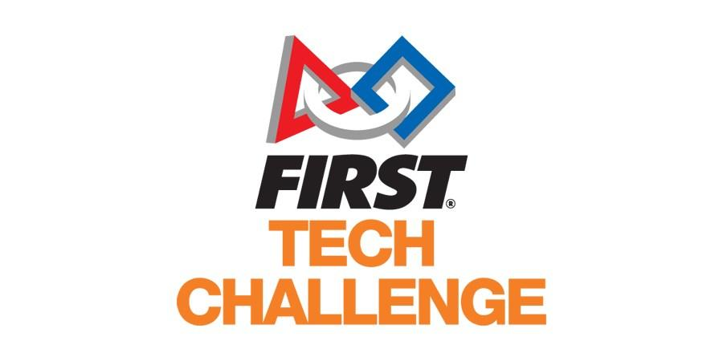

**Table of contents:**

1. Team members 3
2. Team summary 8
3. Business plan
   1. Action plan 10
   2. Team goal 13
   3. Sustainability goal 13
   4. Budgeting 15
   5. Sponsorship options 16
   6. Our sponsorship journey 18
   7. Email screenshots 19
4. Outreach
   1. Our social media 21
   2. Examples of outreach in our meetings
      1. Abu Dhabi TV interview 30
      2. Our visit to FLL 35
      3. Meeting other teams while practicing in Curtin 44
5. Design and building process
   1. Robot base 48
   2. Robot movement 49
   3. Arm mechanism 53
   4. CAD and fusion 360 55
6. Programming
   1. Teleop 57
   2. Autonomous 60

**Team members**

**Mhd Adnan Kassoumeh**

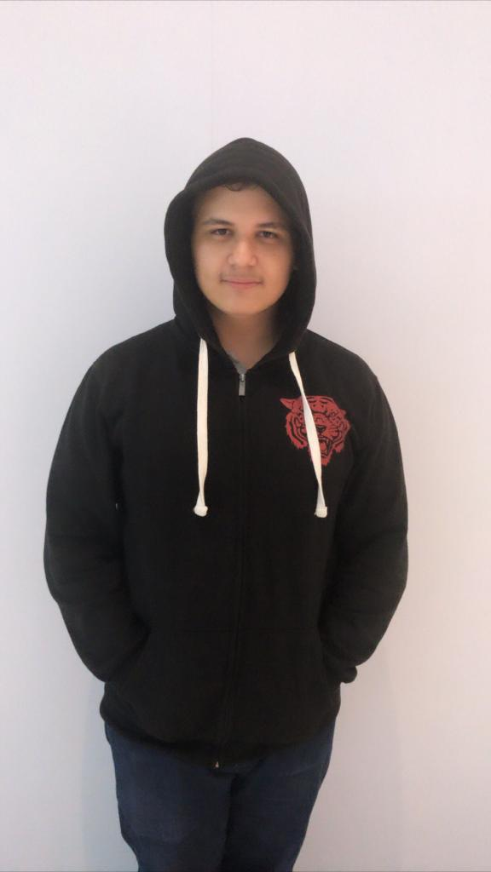

| Mohmad Adnan is From the Syrian Arab Republic, he is 18 years old and passionate about programming, Robotics, and everything related to technology. He is looking forward to achieving the incoming dream in life. |
| --- |

**Kareem Essam Fahmy**

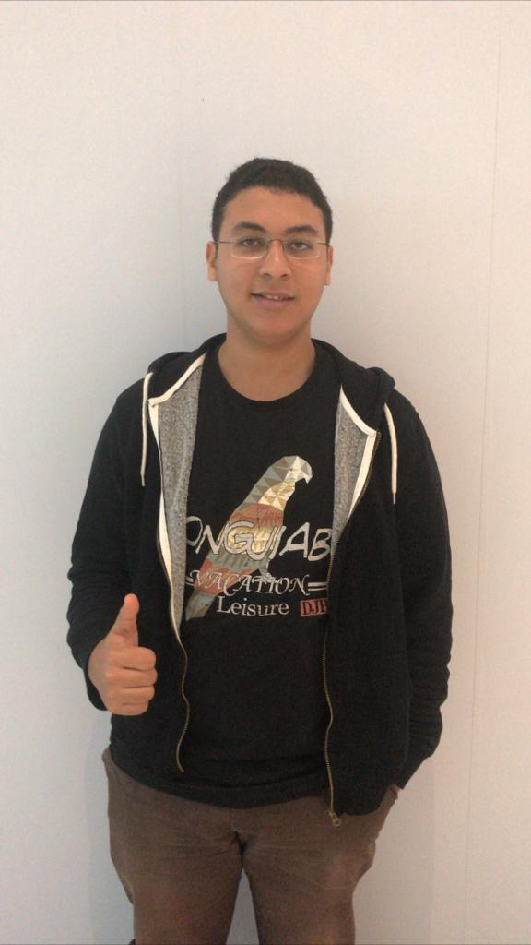

| Kareem Essam is a 15-year-old Egyptian student, being his second year of participating in FTC. He has some experience in programming and marketing and has read the FTC awards manual. He was our main marketing leader and was doing the job of searching for sponsorship and the budgeting of the team. |
| --- |

**Omar Al Jaljuli**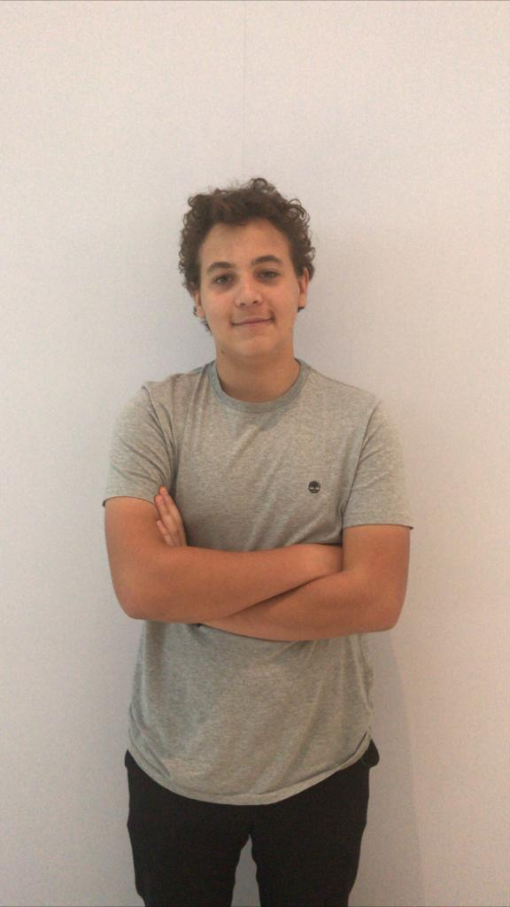

| Omar Al Jaljuli is a 16-year-old student. He has a particular interest in robotics and engineering. He has been participating in robotics competitions since he was 10 years old, however, this is his first season participating in FTC. He has previously represented the UAE in the international FLL competition and now he would like to do the same in FTC. |
| --- |

**Pranav Jain**

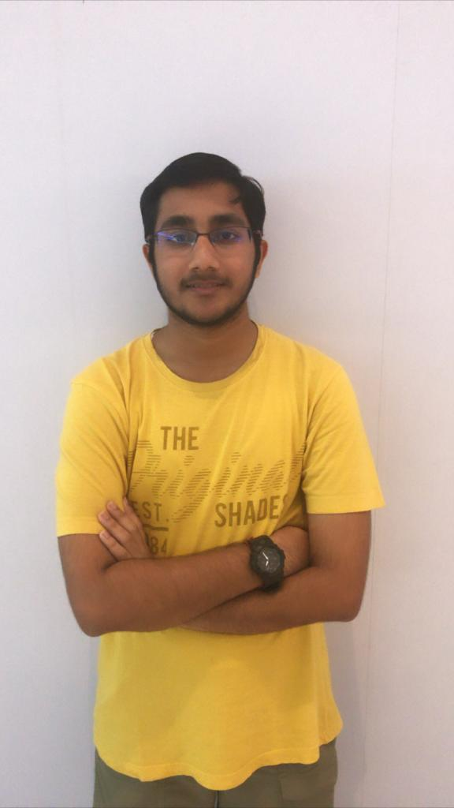

| Pranav Jain is a 16-year-old private schooled student. He has a lot of experience in WRO and is beginning his first year in FTC. Out of interest in robotics, he attended a meeting and decided to join. Designing, building & programming are his work preferences. He has represented UAE for WRO and would now like to represent UAE for FTC. |
| --- |

**Omar Jihad Alattar**

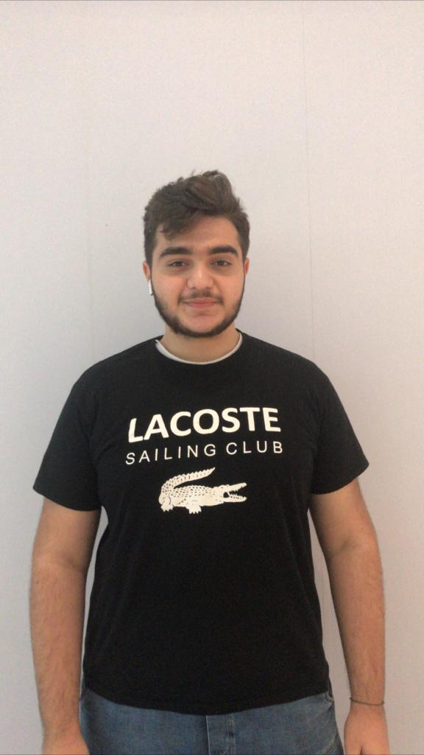

| Omar Al attar is a 16-year-old student. He is interested in engineering, photography and filmography since he was child. He has experience in building drones and other inventions. He likes to help other people and has more than 10 Voluntary certificates. This is the first season in the FTC challenge. |
| --- |

**Moustafa Mohammed Ahmed**

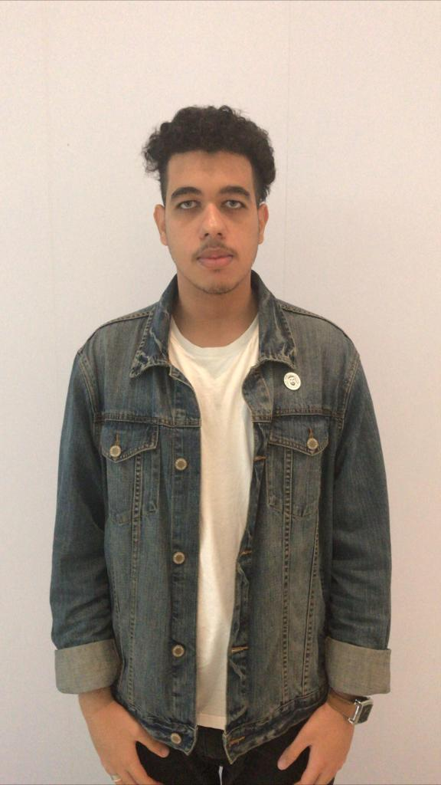

| Moustafa Mohammed is a 17-year-old  Egyptian student, being his second year of participating in FTC. He has some experience in the robotics field, including FTC rules. He has interests in both engineering and programming, but he is more into engineering and designing. |
| --- |

**Abdulelah Ayman Almokahl**

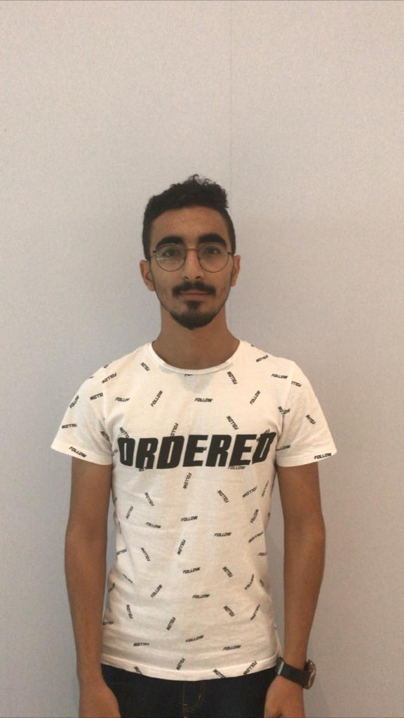

| Abdulelah Ayman is 17 years old. His hobbies are playing football, swimming, parkour, and horse riding. This is his second season in the FTC competition and he continues to do it because of his love for engineering. |
| --- |

**Mohammed Ayesh Alrefaie**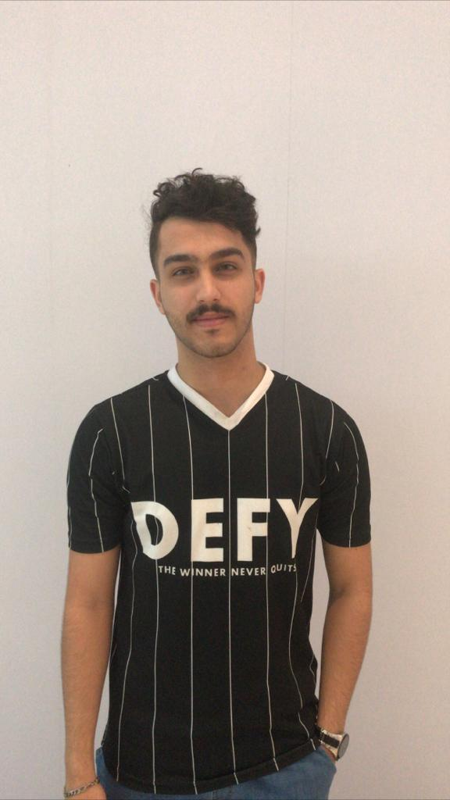

| Mohammed Ayesh is 18 years old. His hobbies are playing football and riding horses. His favorite color is black. This is his first season participating in the FTC competition and he has been enjoying it so far. |
| --- |

**Nathaniel Sybico**

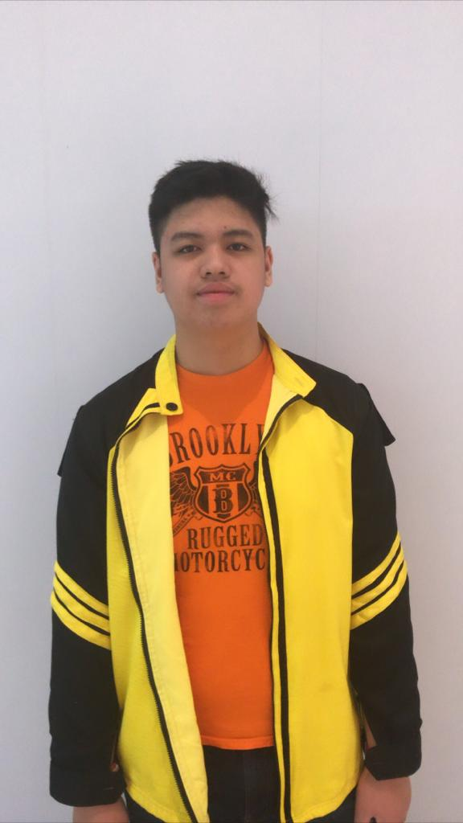

| Nathanial Sybico is a 16-year-old homeschooled student. He enjoys engineering immensely to the point that he has his own personal toolkit that he carries around everywhere. He is extremely excited about the FTC competition. |
| --- |

**Team Coach:**

**Baraa Hamdy Al Jilani**



| Baraa Jilani is a 29-year-old electrical engineer from Fun robotics. This is his fifth year coaching in robotics competitions, however, it is only his second season coaching in FTC. |
| --- |

**Team summary**

The white hat hackers team is made up of 9 participants and 1 coach. They are Mhd Adnan Kssoumeh (team leader and programmer), Nathanial Sybico (design), Omar Al Attar (photographer and in charge of social media), Pranav Jain (flexible member), Abdulelah Almokahal (design team), Kareem Fahmy (sponsor management and awards), Moustafa Abubakr (engineering notebook team), Mohammad Ayesh (design team), Omar Al Jaljuli (engineering notebook team), and Baraa Al Jilani (coach). Although each of our team members focuses mainly on one area of the competition we still all try to aid each other where help is needed and asked for. For example, people working on the engineering notebook help in the design of the robot as well, not only does this help the design team in improving the quality of the robot and attachments it also helps the engineering notebook team in writing about the design since after helping their understanding of the robot and attachments will increase significantly, therefore, the quality of the design analysis will also increase.

Our team felt that reaching out and being involved in our community is one of the best ways to benefit people. On more than one occasion our team reached out to the community by directly speaking to them. The first time was when Abu Dhabi TV came and interviewed Mhd Adnan about the competition and the second time was when We went to the local FLL competition in Dubai to share the FTC competition with current FLL participants.

We felt it was very important to enjoy what we were doing at all times and that we actually learn from this experience and not just go through this competition solely for the purpose of winning.

The White hat hackers are a team whose participants attend many different schools, however, they were all united in the Fun Robotics. Fun robotics is a center that provides children with continuous fun and interactive learning experience in a safe and healthy environment using robotics along with other supporting programs. They provide schools and teachers with the opportunity to utilize robotics in the educational process through a series of TOT programs and specialized consultancy. They provide children, parents, teachers, schools and all interested parties with an interactive network utilizing their established relations with highly recognized institutions in the region and the world. Fun robotics students have participated in (and WON) many competitions in the past. These competitions include ‘WRO’ (World Robot Olympiad), ‘FLL’ (First Lego League), and the ‘UAE AI & Robotics Award for Good’.

Eight recommended pages: (Outreach: 30, 35, 44), (Design: 48, 49, 54), (Program: 57, 60).

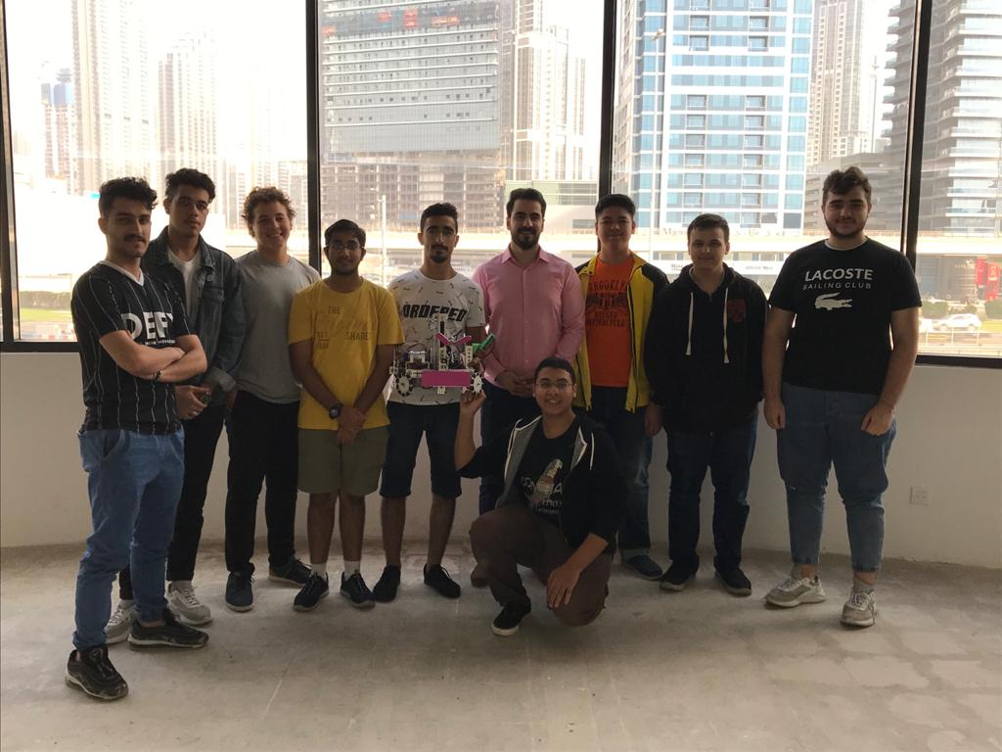

**Business and strategy plan**

**Action plan:**

| 1. Task | Task Description | Date | Resources needed |
| --- | --- | --- | --- |
| Meet up and assign team roles + Brainstorming | Gather the whole team and meet up. Assign team roles for all the team participants. Learn about the competition, and brainstorm team names. | October 10th | Whiteboard |
| Design robot | The design team should have finished gathering ideas online and designing the robot. | October 30th | Paper, Pencil, Laptop |
| Build a robot | The design team should have built the robot that was previously designed (with needed adjustments) | November 28th | Tetrix kit |
| Program the robot to be controlled by a controller | The program team should have synchronized the robot with the controller. | December 11th | Laptop, Controller, Robot |
| Finish all robot attachments and synchronize them with the controller | The design team should have finished building the designed attachments, and the programming team should have synchronized it to the controller. | January 5th | Tetrix kit, Controller |
| Finish autonomous program | The programming team should have finished the autonomous program using the mission mat provided. | February 3rd | Laptop, Robot |
| Adjust robot base, attachments, and program while trying it out on the mat | The design and programming team should have finished any needed adjustments. | February 17th | Robot, Laptop, Tetrix kit |
| Finish the Engineering notebook (with some room for adjustment and addition) | The team working on the engineering notebook should have finished a draft and printed it (there will be some room for addition since the team will never stop on developing) | February 22nd | Laptop |
| Participate and win the competition | We will participate and hopefully win the competition | 23-24 February | Robot, extra Tetrix parts, laptop |

**Team goal** :

The team aims to inspire young adults to take action in the STEM community, making it move forward. We would like them to express their ideas through their innovation and creativity and for their dreams to become a reality by physically modeling, building, and programming different kinds of technology. The team inspires to become better individuals by helping society solve real-life problems. Our team will achieve this by working together to find solutions without full reliance on our mentors and coaches. We will make sure to act competitively but cooperatively with other teams to ensure that we showcase sportsmanship throughout the competition. Our team believes that in order for us to do that we need to work our hardest and aim to achieve the first place award (inspiration award) and that in order to truly make a difference we need to try to inspire people on a global scale by competing in Houston, USA.

Sustainability:

This is White hat hackers second season in the FTC competition. Our team is funded through our sponsor and school which is Fun robotics.

Our team is reaching out to possible sponsors and trying to build stronger relationships with them for future projects. We are offering to put their logos on our shirts and banners for a certain monetary input.

Each year older students leave and newer students join. The new students come from different schools with a variety of different cultures.

The newer students learn from older students and give their own creative solutions to different problems. That way the team will forever be growing and improving.



**Budgeting:**

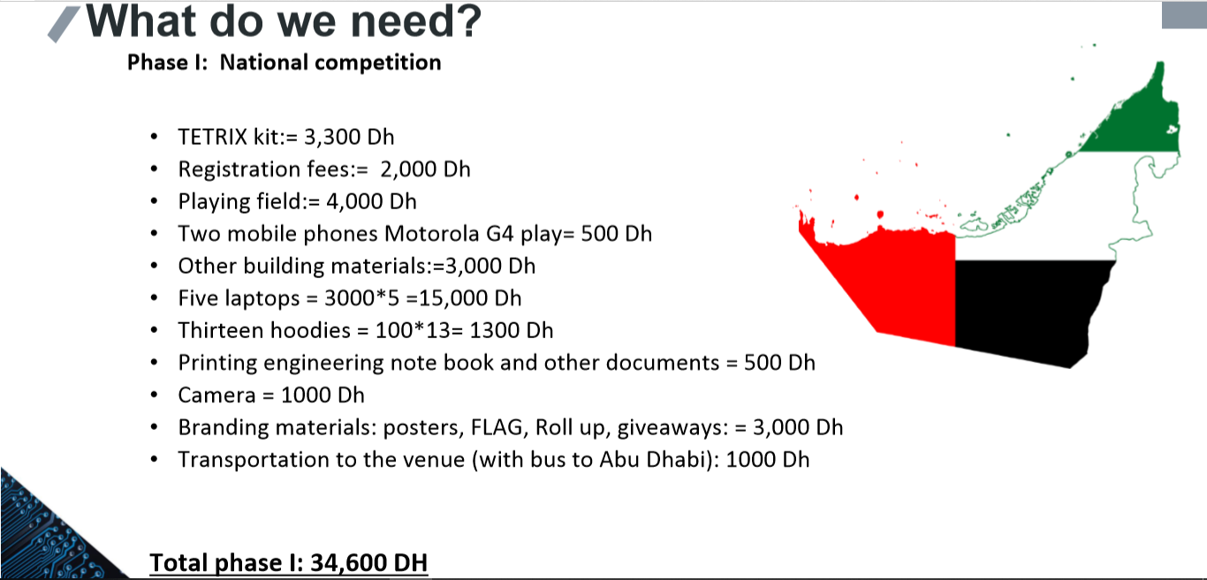

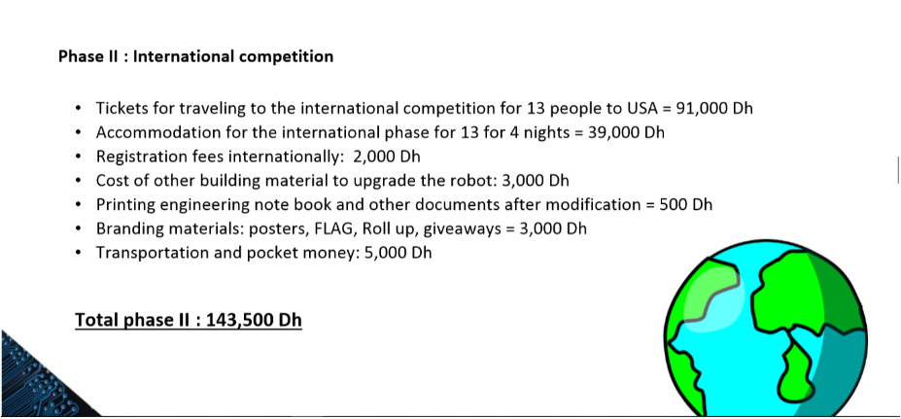

**Our sponsorship options:**

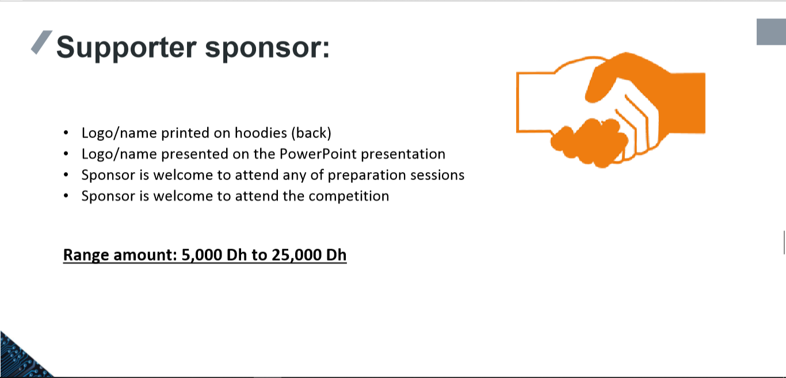

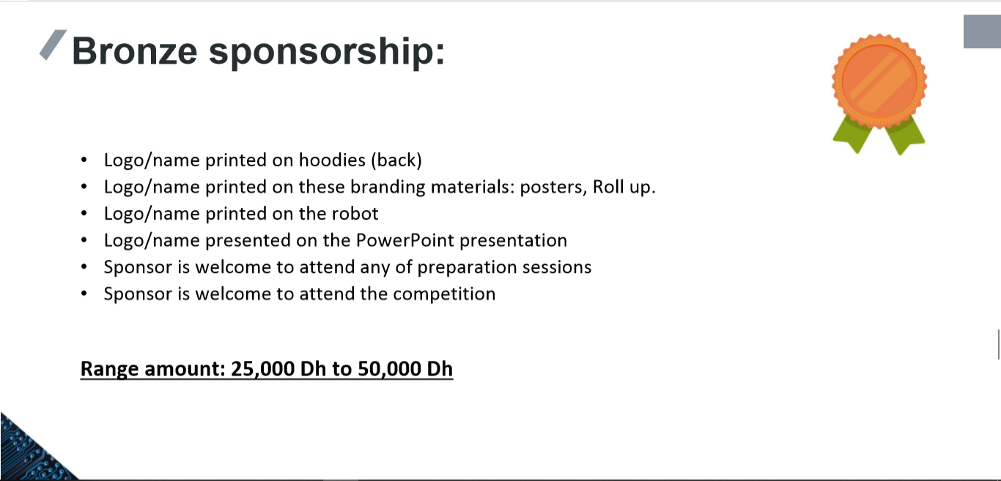

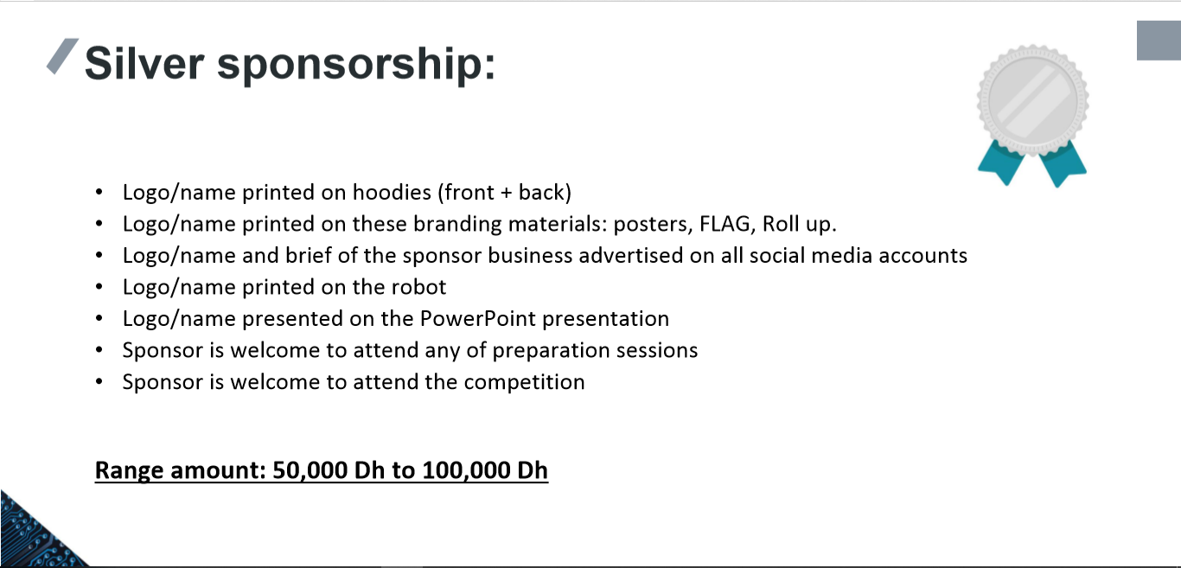

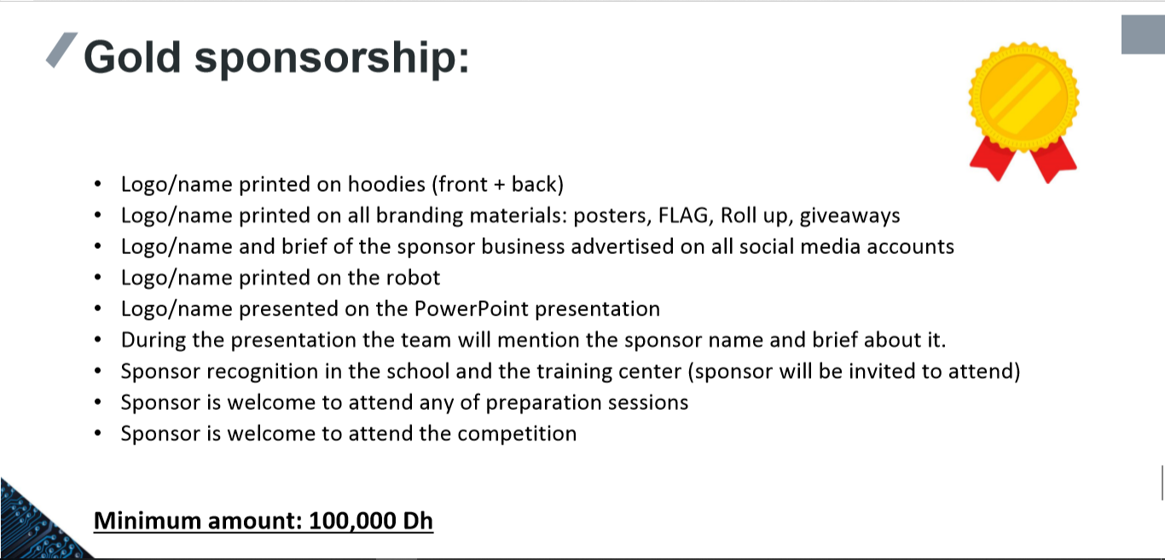

**Our sponsorship journey:**

Getting sponsors wasn't an easy mission. First of all, one of our team members was in contact with Dr. Luigi, the director of the SAP ERP in Dubai. We sent dr.Luigi an email expressing our need for a sponsor so he directed us to an associate, who to our regret did not reply to our emails. The team had little experience with looking for sponsors and due to that, it was hard for us to acquire sponsors. Our team did not feel discouraged by that fact but instead, we decided to never give up and keep trying to contact companies such as Google, IBM, Google, Pepsico, Redbull, RIT University, HTC, Huawei, Samsung, DHA (Dubai Health Association) and even the Dubai police. The furthest we got was our attempt with DHA. We were able to have a meeting with their marketing team. However, to our dismay, we were not able to acquire them as sponsors. Although we were unable to gain sponsorship through this journey we were still able to gain something very important which is experience and new knowledge. In the end, the team was sponsored and fully funded by Fun robotics teaching center that provided us with most of the resources that we needed.

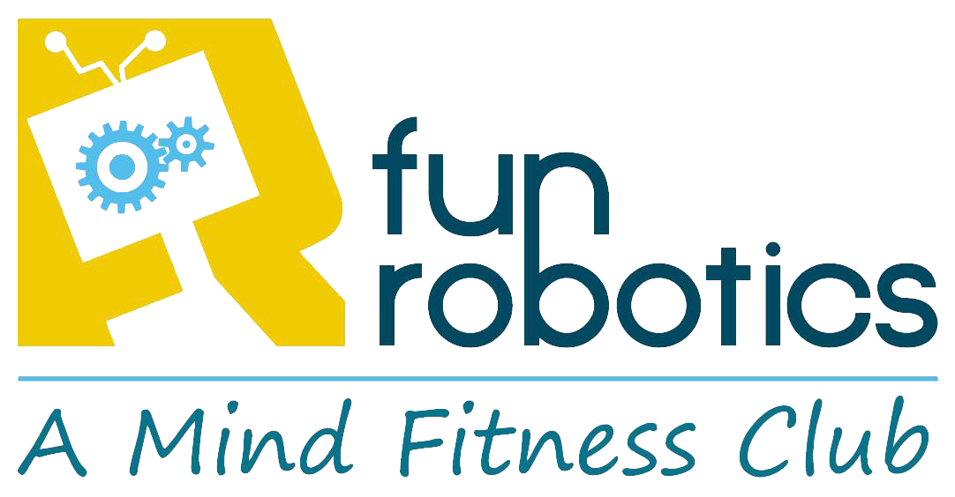

**Emails screenshots:**

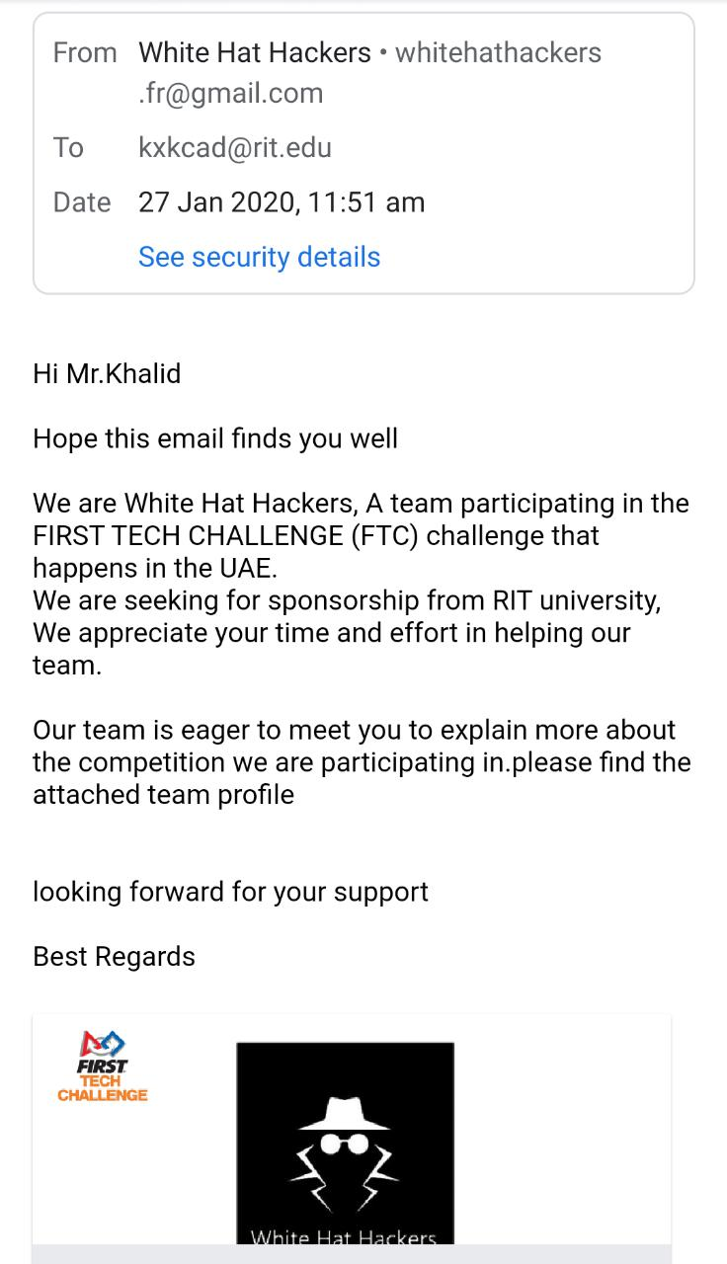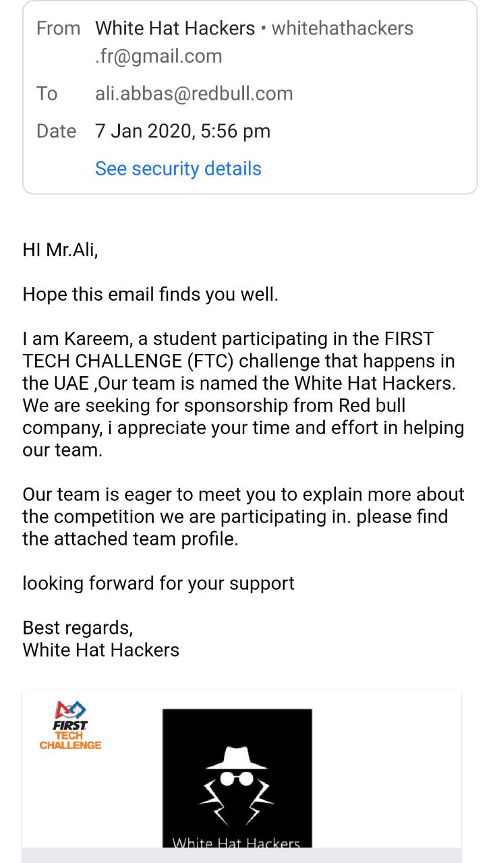

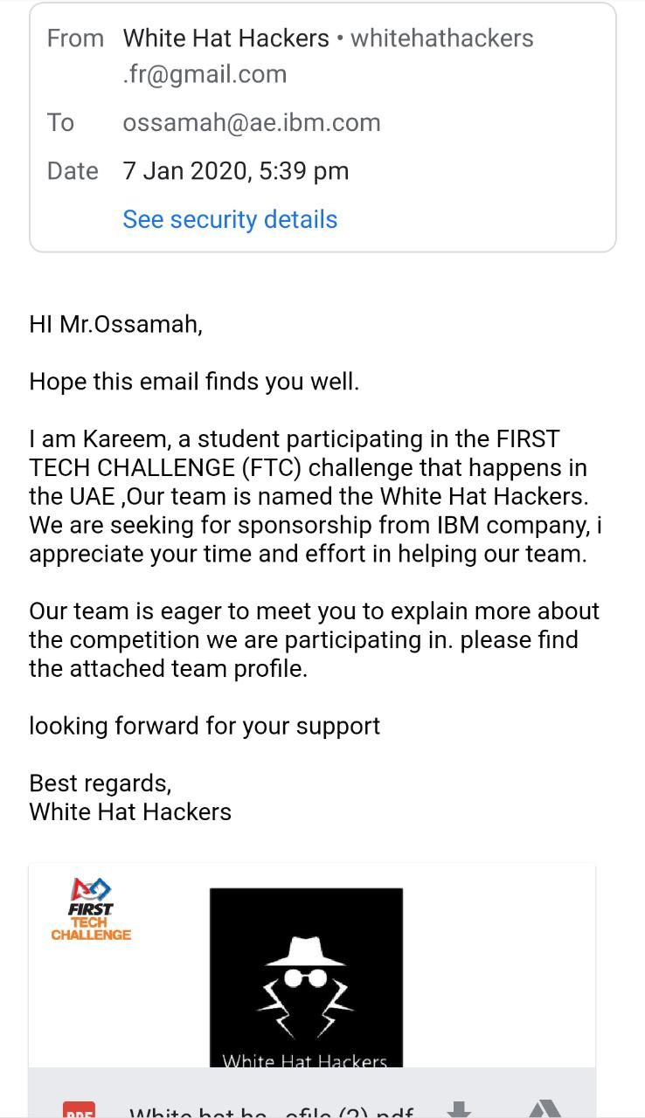 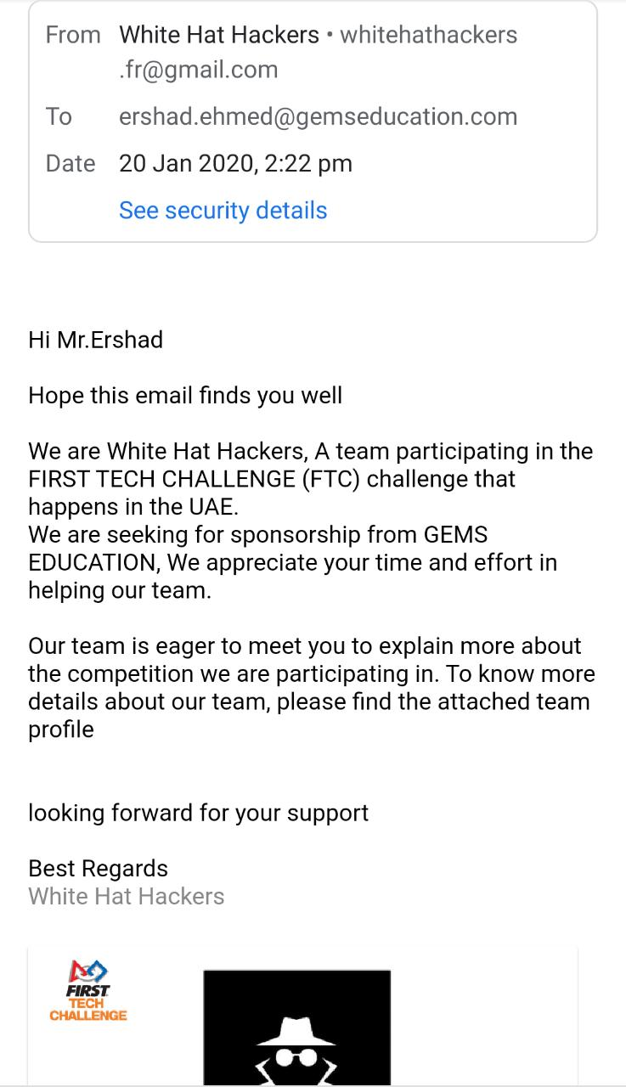

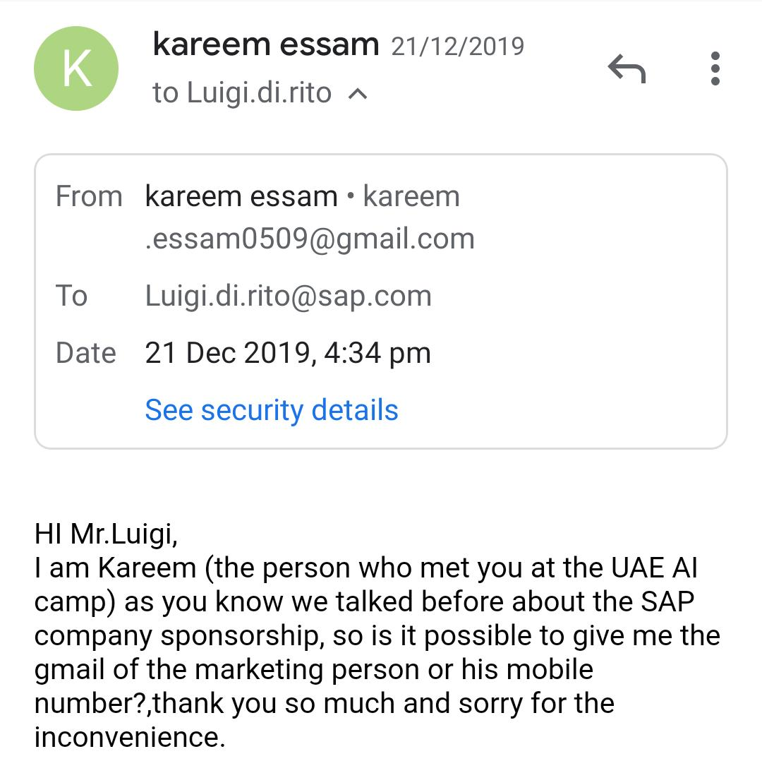

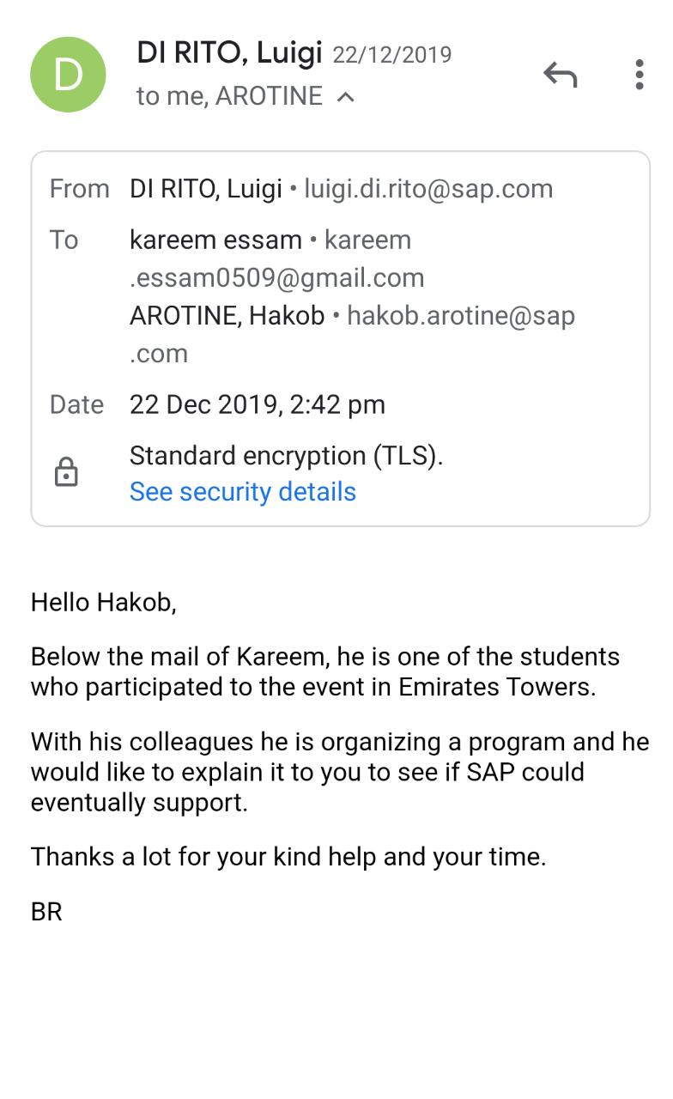

**Our social media accounts:**

We have two social media accounts in order to reach out to a larger audience of people. Our more busy account is the Instagram profile which we update each meeting with a story.

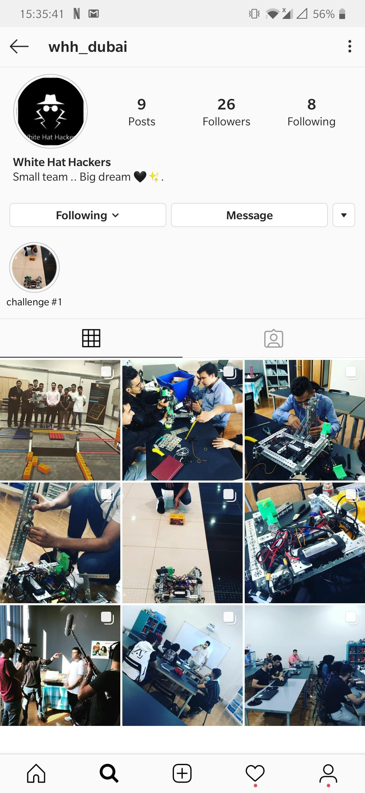

However, we also have a twitter account which we also try to update frequently.





**October 10th, 2019**

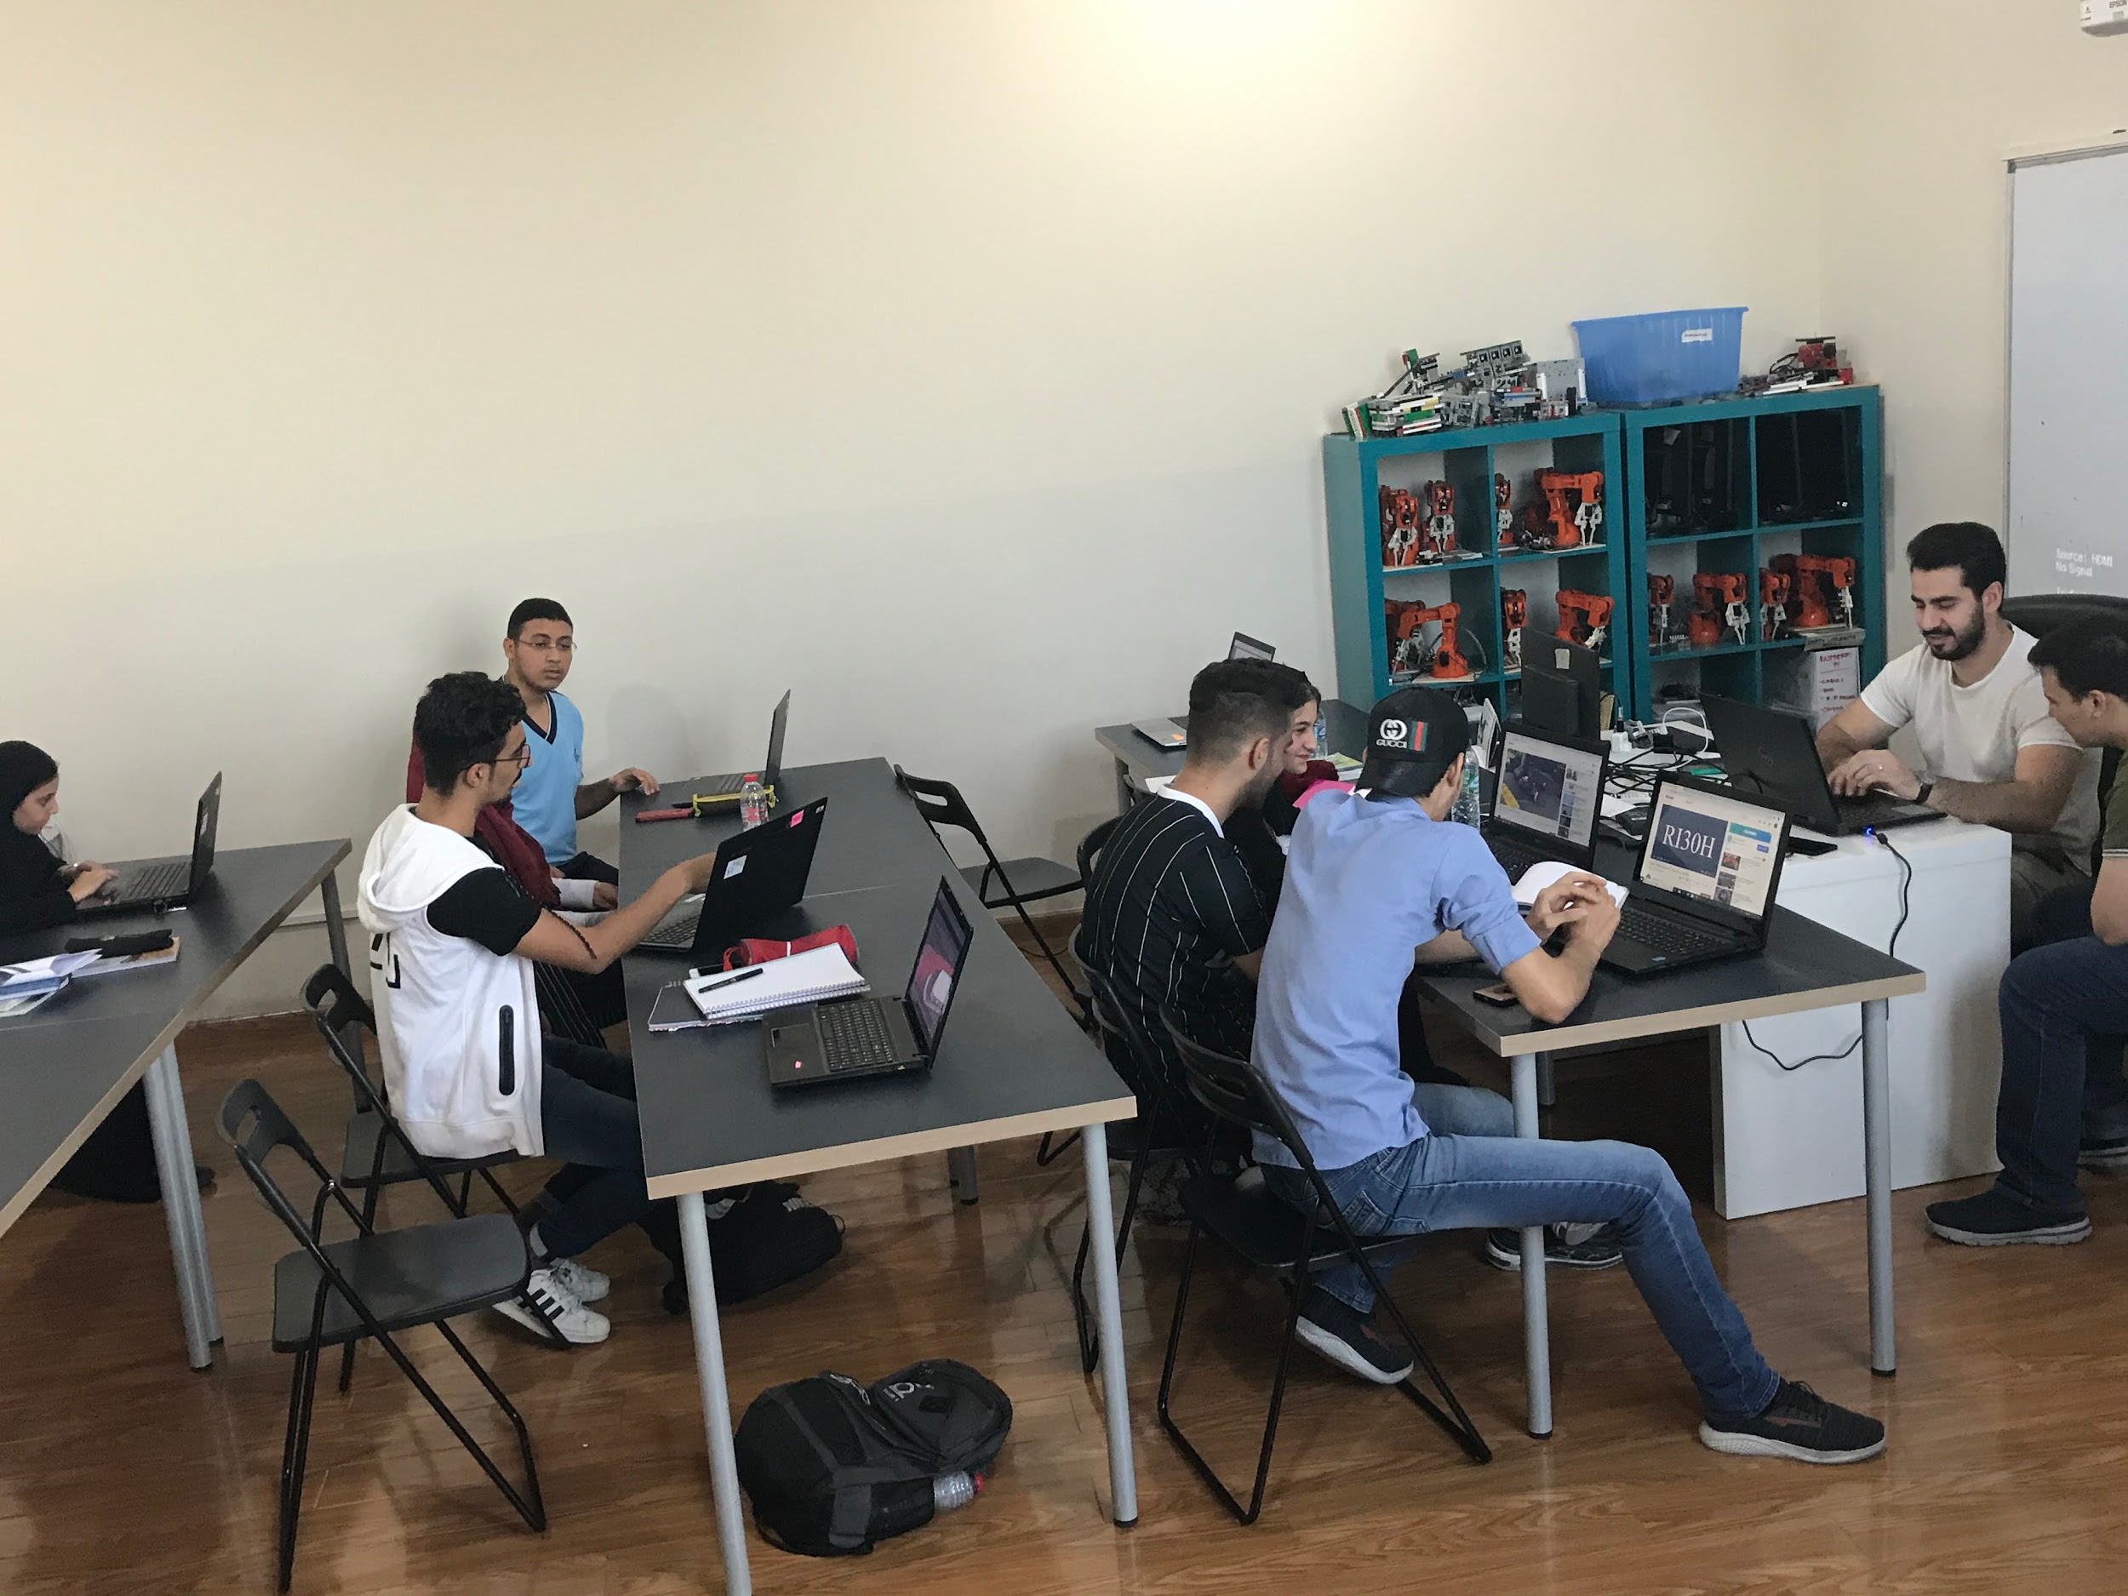

| Tasks :  -learning how to use  Gears.  -rebuilding our robot.  -researching ways to  Build arm mechanisms.  -contacting Motorola  support to fix the phone  updating problem.  -earning about the new  format of 2019-2020  FTC competition. | Attendance :  -Mhd Adnan  -Kareem Essam  -Moustafa Mohammed  -Abdulelah Ayman  -Mohammed Ayesh  -Mahmoud Abdulmonem  -Omar Jihad |
| --- | --- |

| Summary: Our first meeting after the summer holiday, friends have finally come together, and a new season has begun. We were very interested in the new challenge and we decided to meet at the Fun Robotics center to discuss the challenge of the new season, after watching the official challenge video we started to Rebuild our robot again to cope with the new challenge and we started to think of using gears for too many reasons, one of them is for collecting stones and to build a skyscraper. |
| --- |

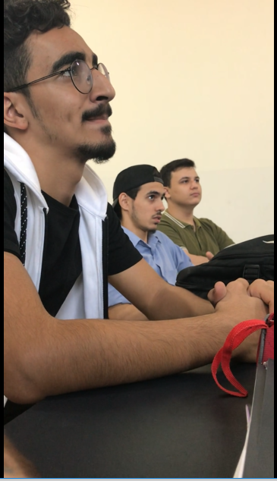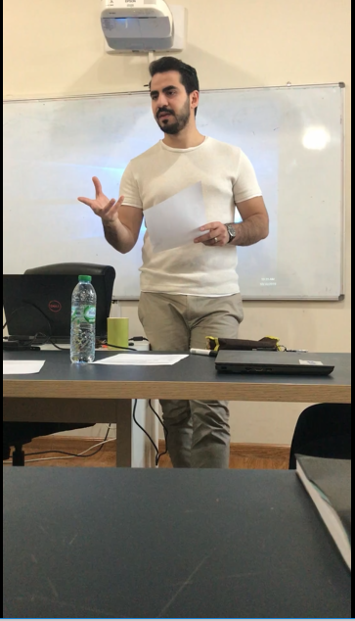

| Our mentor Mr. Baraa telling us about the steps we should go through to succeed. |
| --- |

**October 16th, 2019**

| Tasks:   * splitting the manual   Between the team.   * For each team member to understand the rules and regulations * Types of competition * Legal and illegal parts * Engineering notebook * Red and yellow cards | Attendance:  -Mhd Adnan  -Kareem Essam  -Moustafa Mohammed  -Abdulelah Ayman  -Mohammed Ayesh  -Mahmoud Abdulmonem  -Omar Jihad |
| --- | --- |

| Summary: Our second meeting, first we had a look at the scoring system and we watched some videos also from the FIRST channel on youtube which is important for us to understand the competition then we decided to start our work by reading the game manuals and understanding every word and every rule, then we split the game manuals every person in the team had about 20 pages from the game manual to read and explain to the rest of the team. |
| --- |

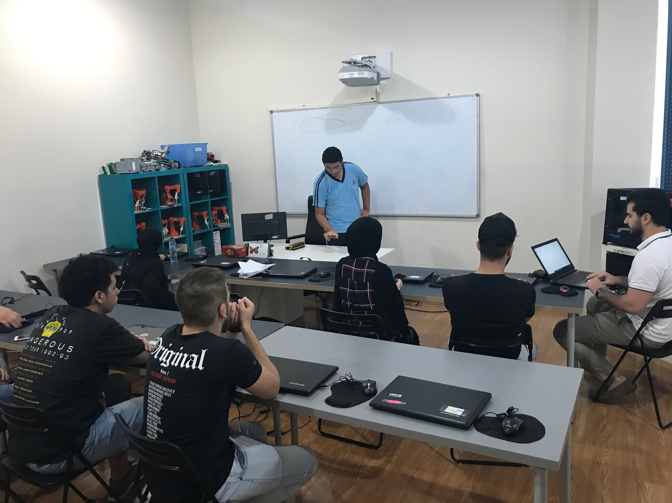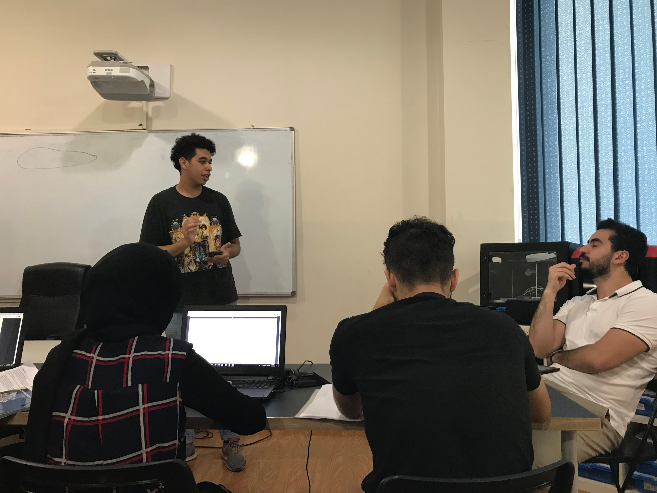

| Each team member presenting his part to the rest of the team to improve every member’s understanding of the competition’s rules and regulations. |
| --- |

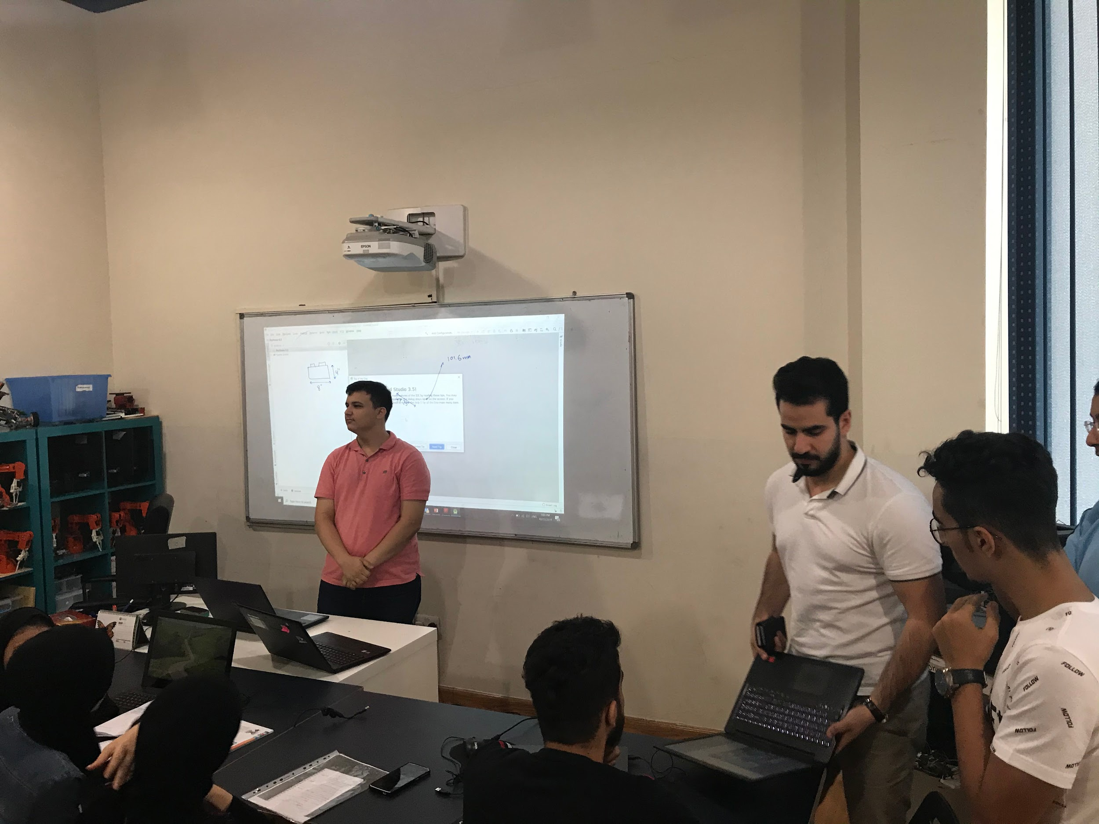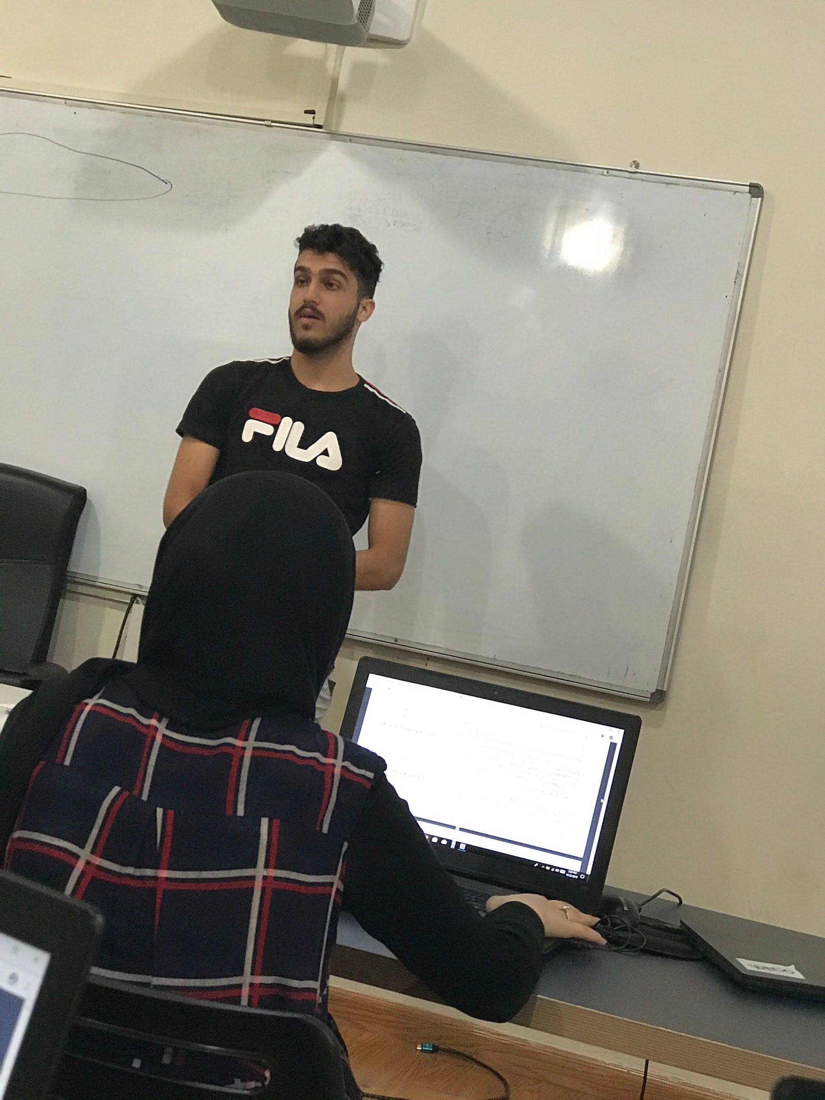

| Kareem, Moustafa, Mhd Adnan, and Mohammad Ayesh |
| --- |

**October 30th, 2019**

| Tasks:  - Making different teams  for every mission.  -finding a new innovative and creative arm ideas  -learning about the Android studio.  -writing code to test  -looking for past engineering notebook winners. | Attendance:  -Mhd Adnan  -Kareem Essam  -Moustafa Mohammed  -Abdulelah Ayman  -Mohammed Ayesh  -Mahmoud Abdulmonem  -Omar Jihad |
| --- | --- |

| Summary: This meeting was quite different, we all sat together, started collecting every single information we read. The Designing team watched videos to take ideas for the design as they aim to make innovative and inspiring designs. They started rebuilding the previous robot because of the problem with the balance, checking lengths and width as well as the mechanism. They also wrote down all the parts needed to purchase as the Mecanum Wheels, rubber bands, and EV3 components…etc. We selected two of the teammates to summarize the awards section. Also, they are responsible to communicate with other participants to keep a strong relationship with them. One of the teammates Kareem can assist us and find a sponsor, he suggested some companies in case the request was declined. The engineering notebook team took ideas from the winners to make a professional design and original content. We mainly focused on the mistakes we did last competition. The team photographer gathered pictures and videos from the first meeting to make it as one video including all accomplishments. The programing team set up the new phones “ Moto G4 Play” and checked the latest update, configured the expansion Hub and started testing the autonomous programming. Some of us were working in multiple teams ceaselessly, analyzing materials, techniques. When the summery time came, everyone talked about his part and Mr Baraa gave his recommendation as reducing the height of the robot, the balance problem is finally solved and we apply maths and physics. |
| --- |

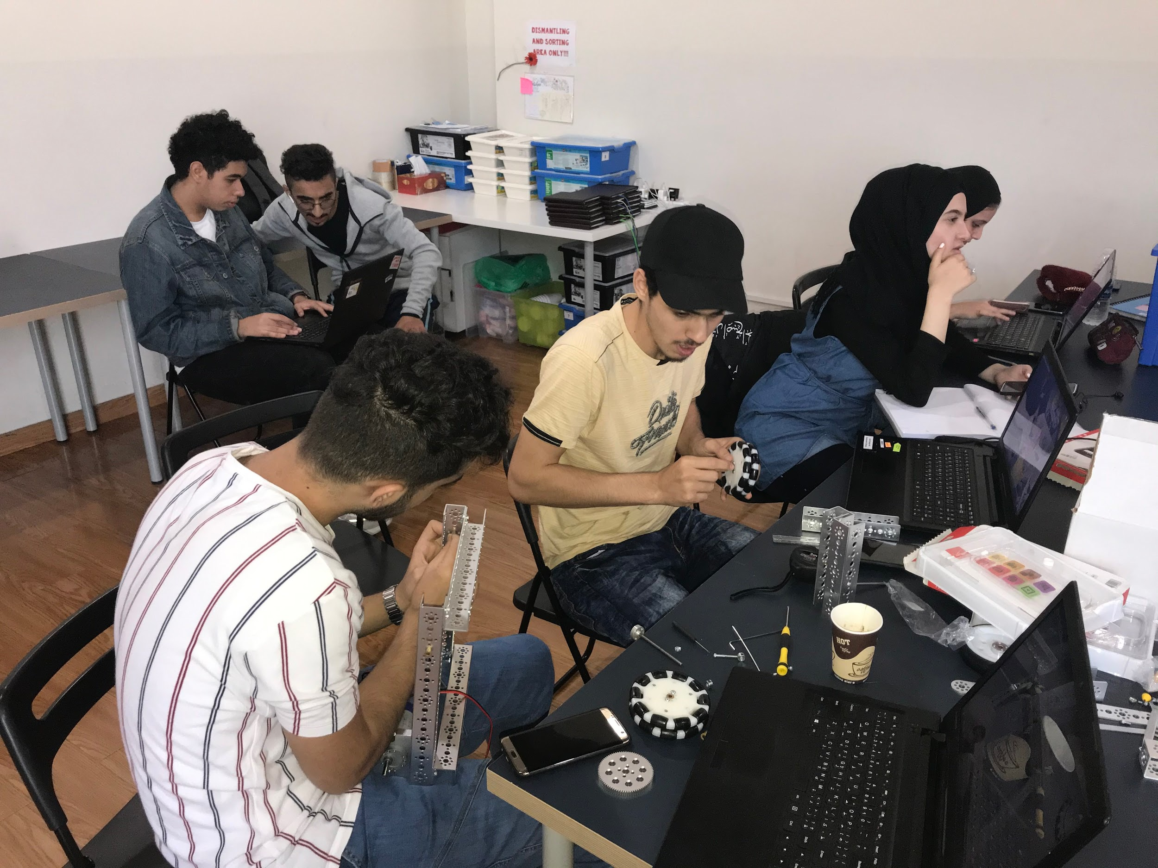

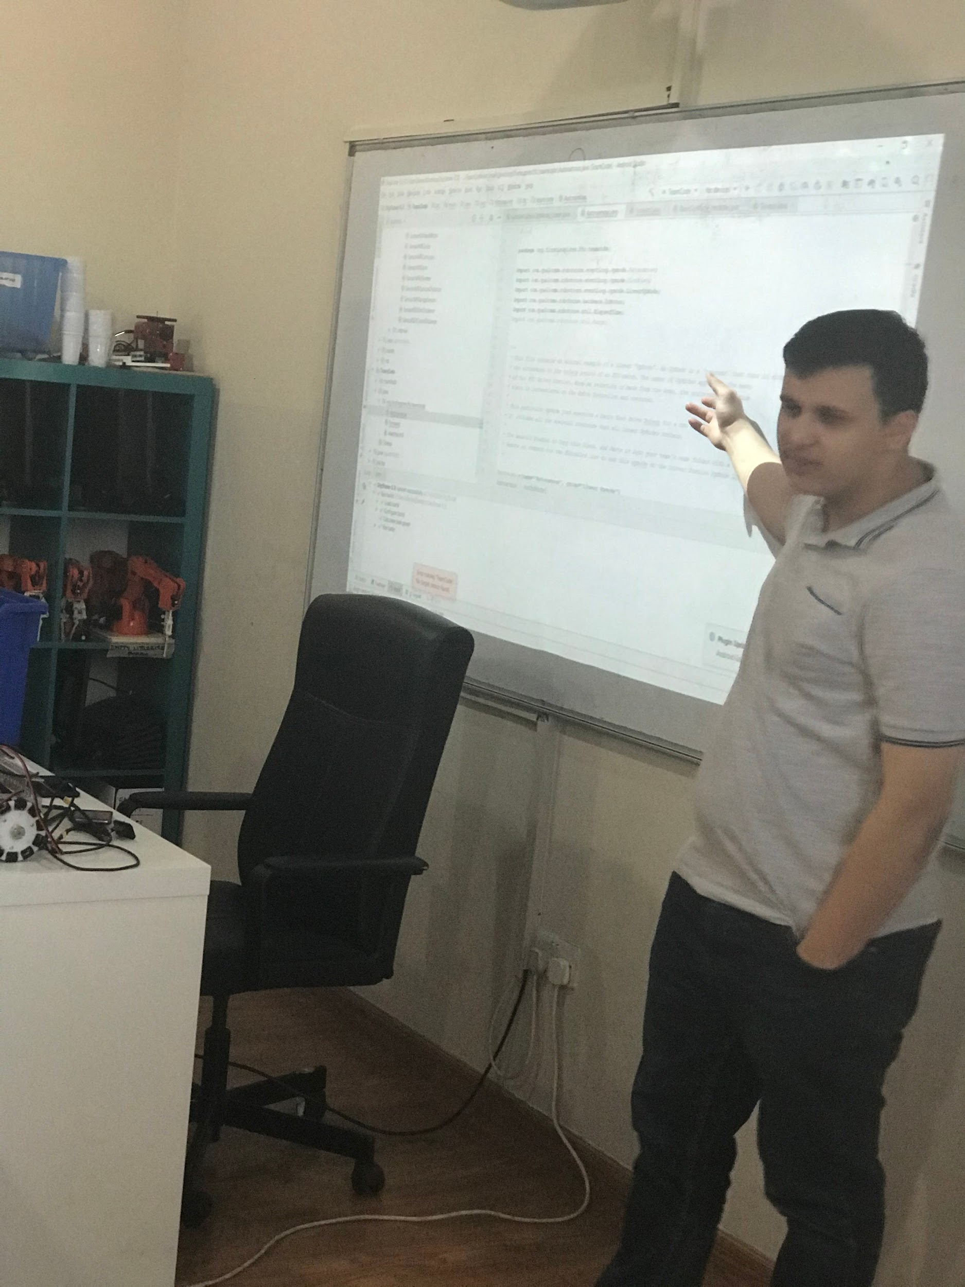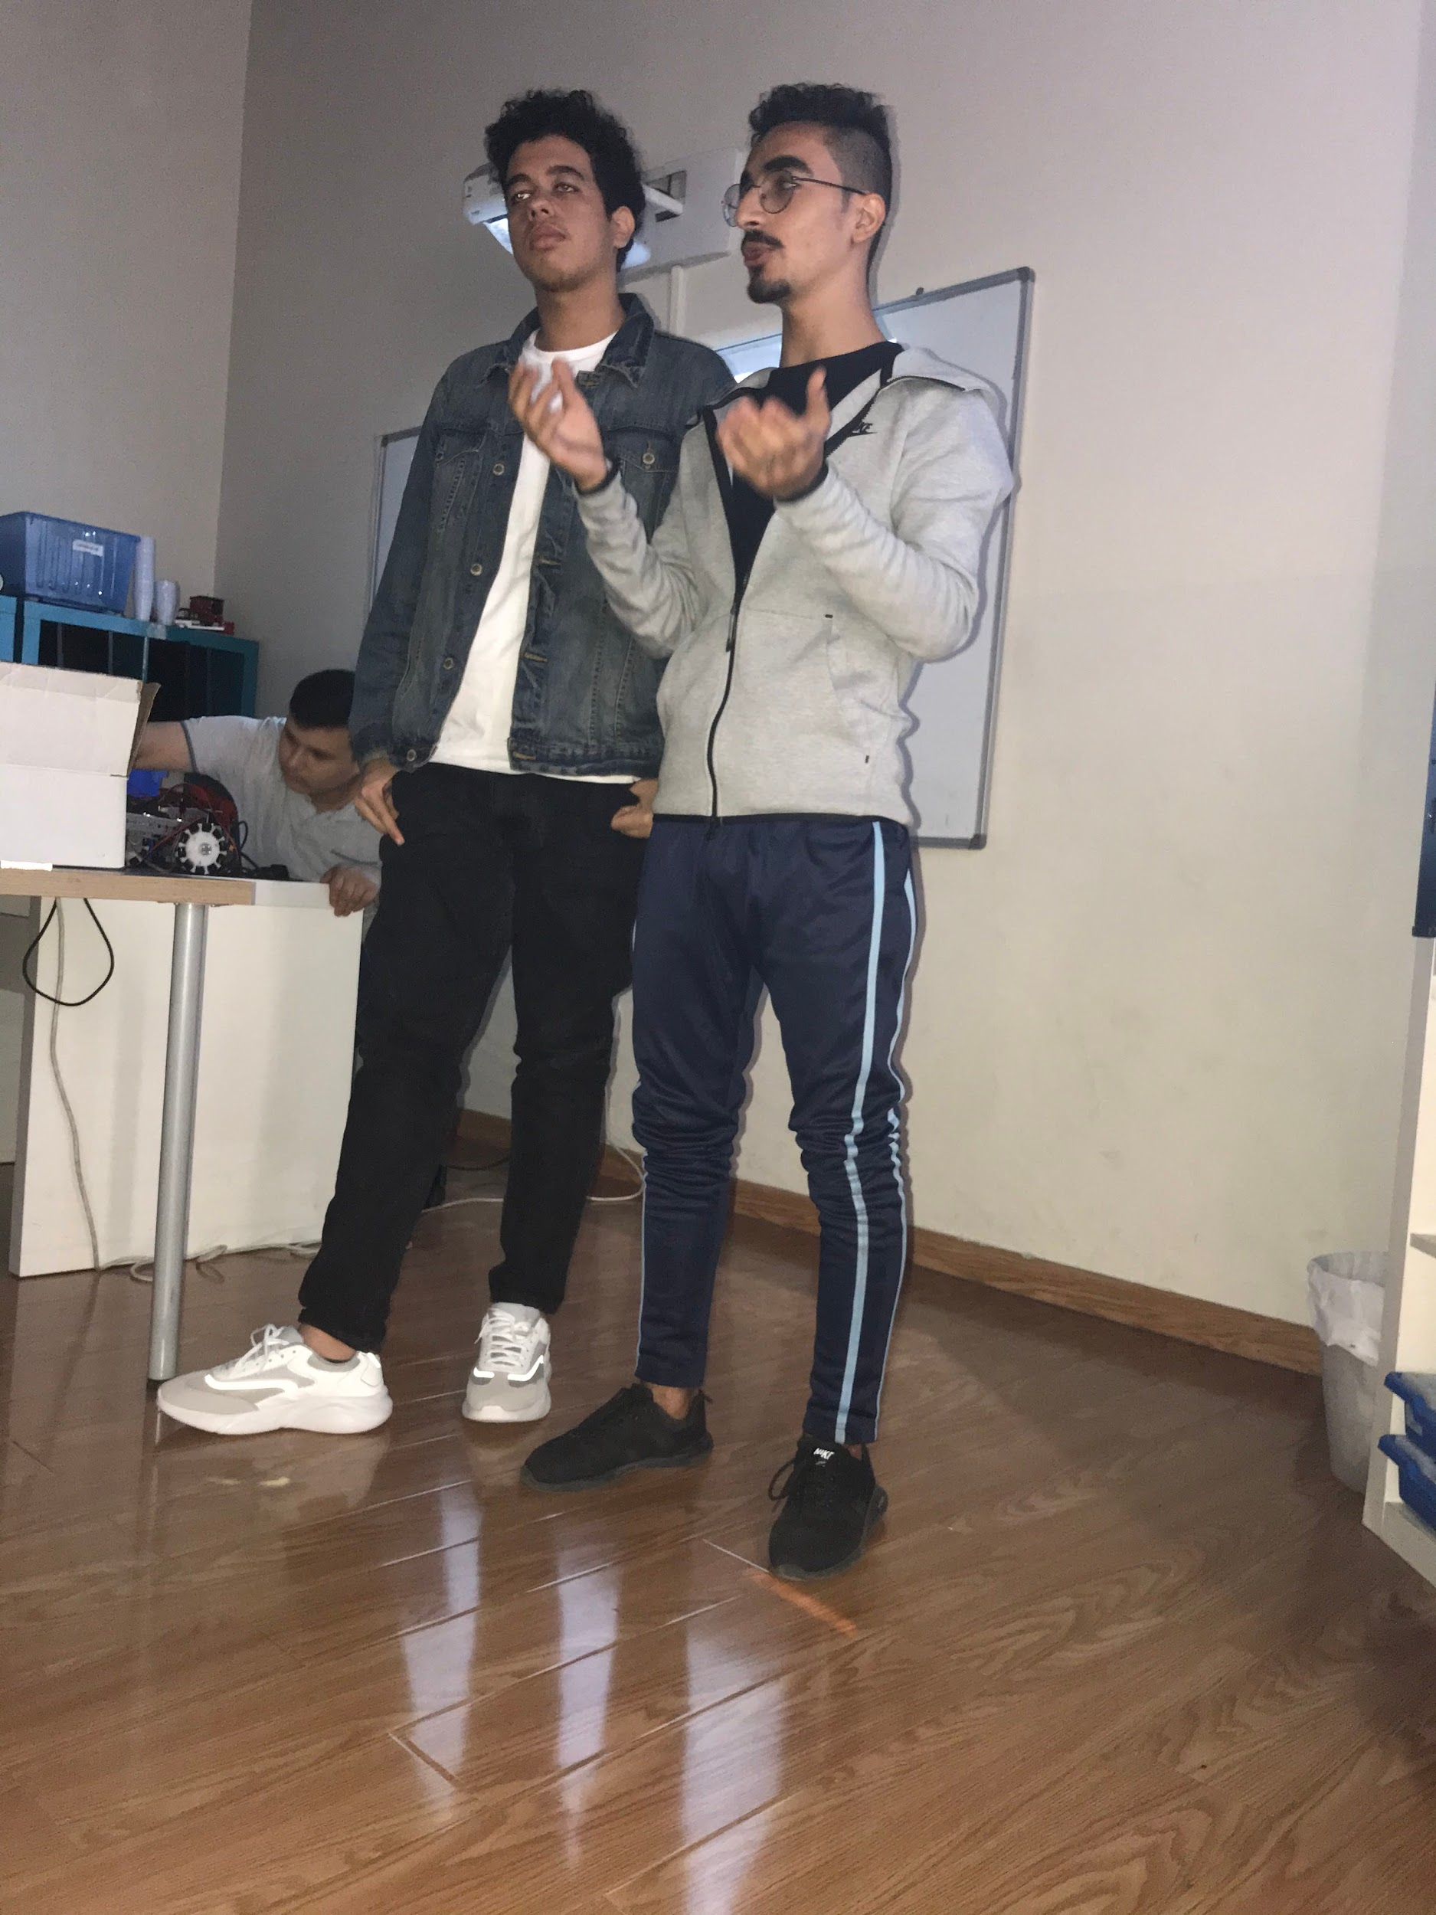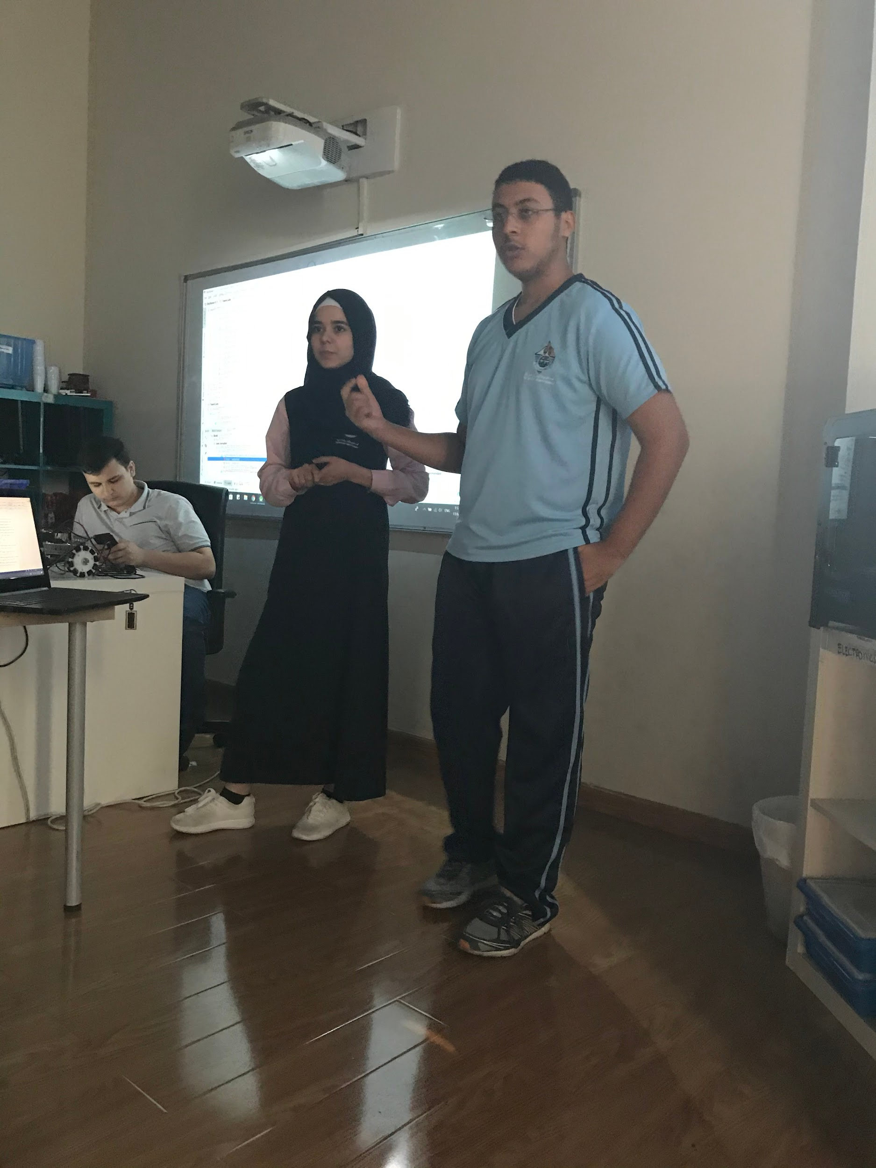

| each team presenting what they learned by the end of the meeting |
| --- |

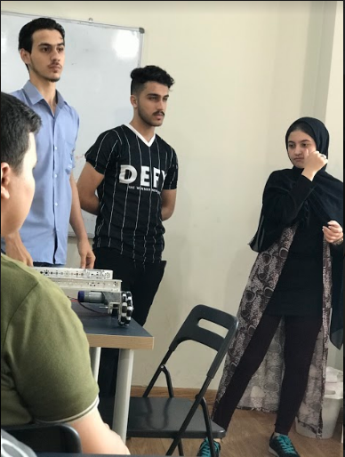

**November 2nd, 2019**

| Tasks: -contacting possible  sponsors.  -ordering new parts for the designing team. | Attendance:  -Mhd Adnan  -Kareem Essam  -Moustafa Mohammed  -Abdulelah Ayman  -Mohammed Ayesh  -Mahmoud Abdulmonem  -Omar Jihad |
| --- | --- |

| Summary: with the last meeting before the finals, everybody gathered around and we wrote numerous team names on the board until we chose the white hat hackers, which was the best one we found, we furthermore were interested in a design that used mecanum wheels, seeing how good it performed we ordered two pairs of mecanum wheels which cost us about 200 AED while brainstorming for arm ideas we all agreed that a gear rack would be best given that we were lectured about gears by a past winning team mentor so we can hold our own in gear calculation, at the same time we needed a sponsor for the team’s expenses, our teammate Omar contacted the DHA (Dubai Health Association) they responded and said they would like to have a meeting for us to present our team but the date was not mentioned, soon later we concluded our meeting. |
| --- |

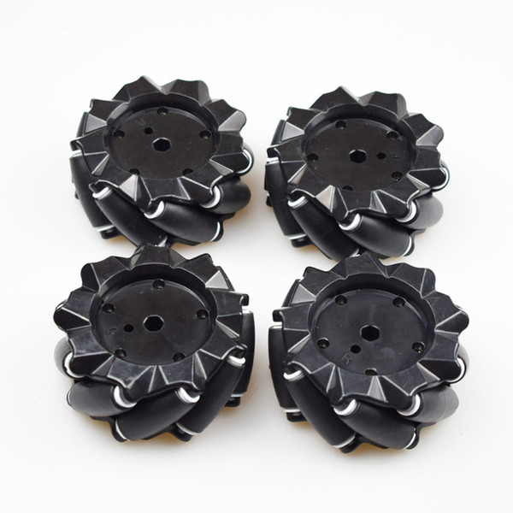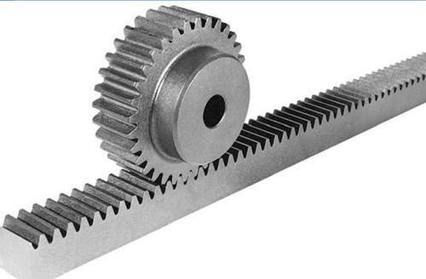

**November 6th, 2019**

| Task: -get interviewed by Abu  Dhabi TV program  - brainstorming for arm  ideas  -building a new drive  system | Attendance:  -Mhd Adnan  -Kareem Essam  -Moustafa Mohammed  -Abdulelah Ayman  -Mohammed Ayesh  -Mahmoud Abdulmonem  -Omar Jihad |
| --- | --- |

| Summary: before the start of this meeting we got news about Abu Dhabi TV interviewing our center Fun robotics, we all agreed that Mhd Adnan should be our representative as he has the most knowledge of the FTC competition between us, the interview took about twenty minutes, then we immediately started the meeting, we welcomed in both of Kareem’s brothers Ziad and Ahmed, they are experienced in math and calculations, afterward, we got together to think about an idea for the arm, a bunch of sketches were drawn we took all of them and choose the best, later in the meeting all agreed on an idea, that because the mecanum wheels were too small we can switch to holonomic drive which gives us the same movement with our current wheelset, holonomic drive is made by putting the four wheels in a cross formation to give us the same effect of the mecanum wheels, it took about thirty minutes to make it at was a great success. |
| --- |

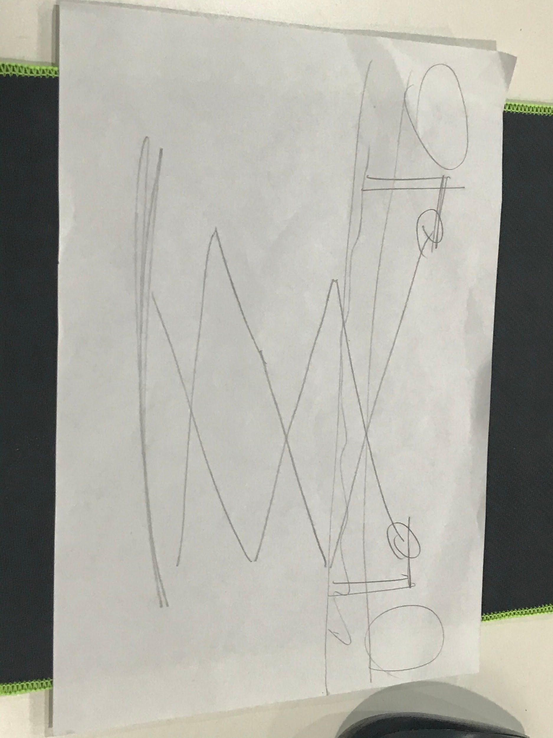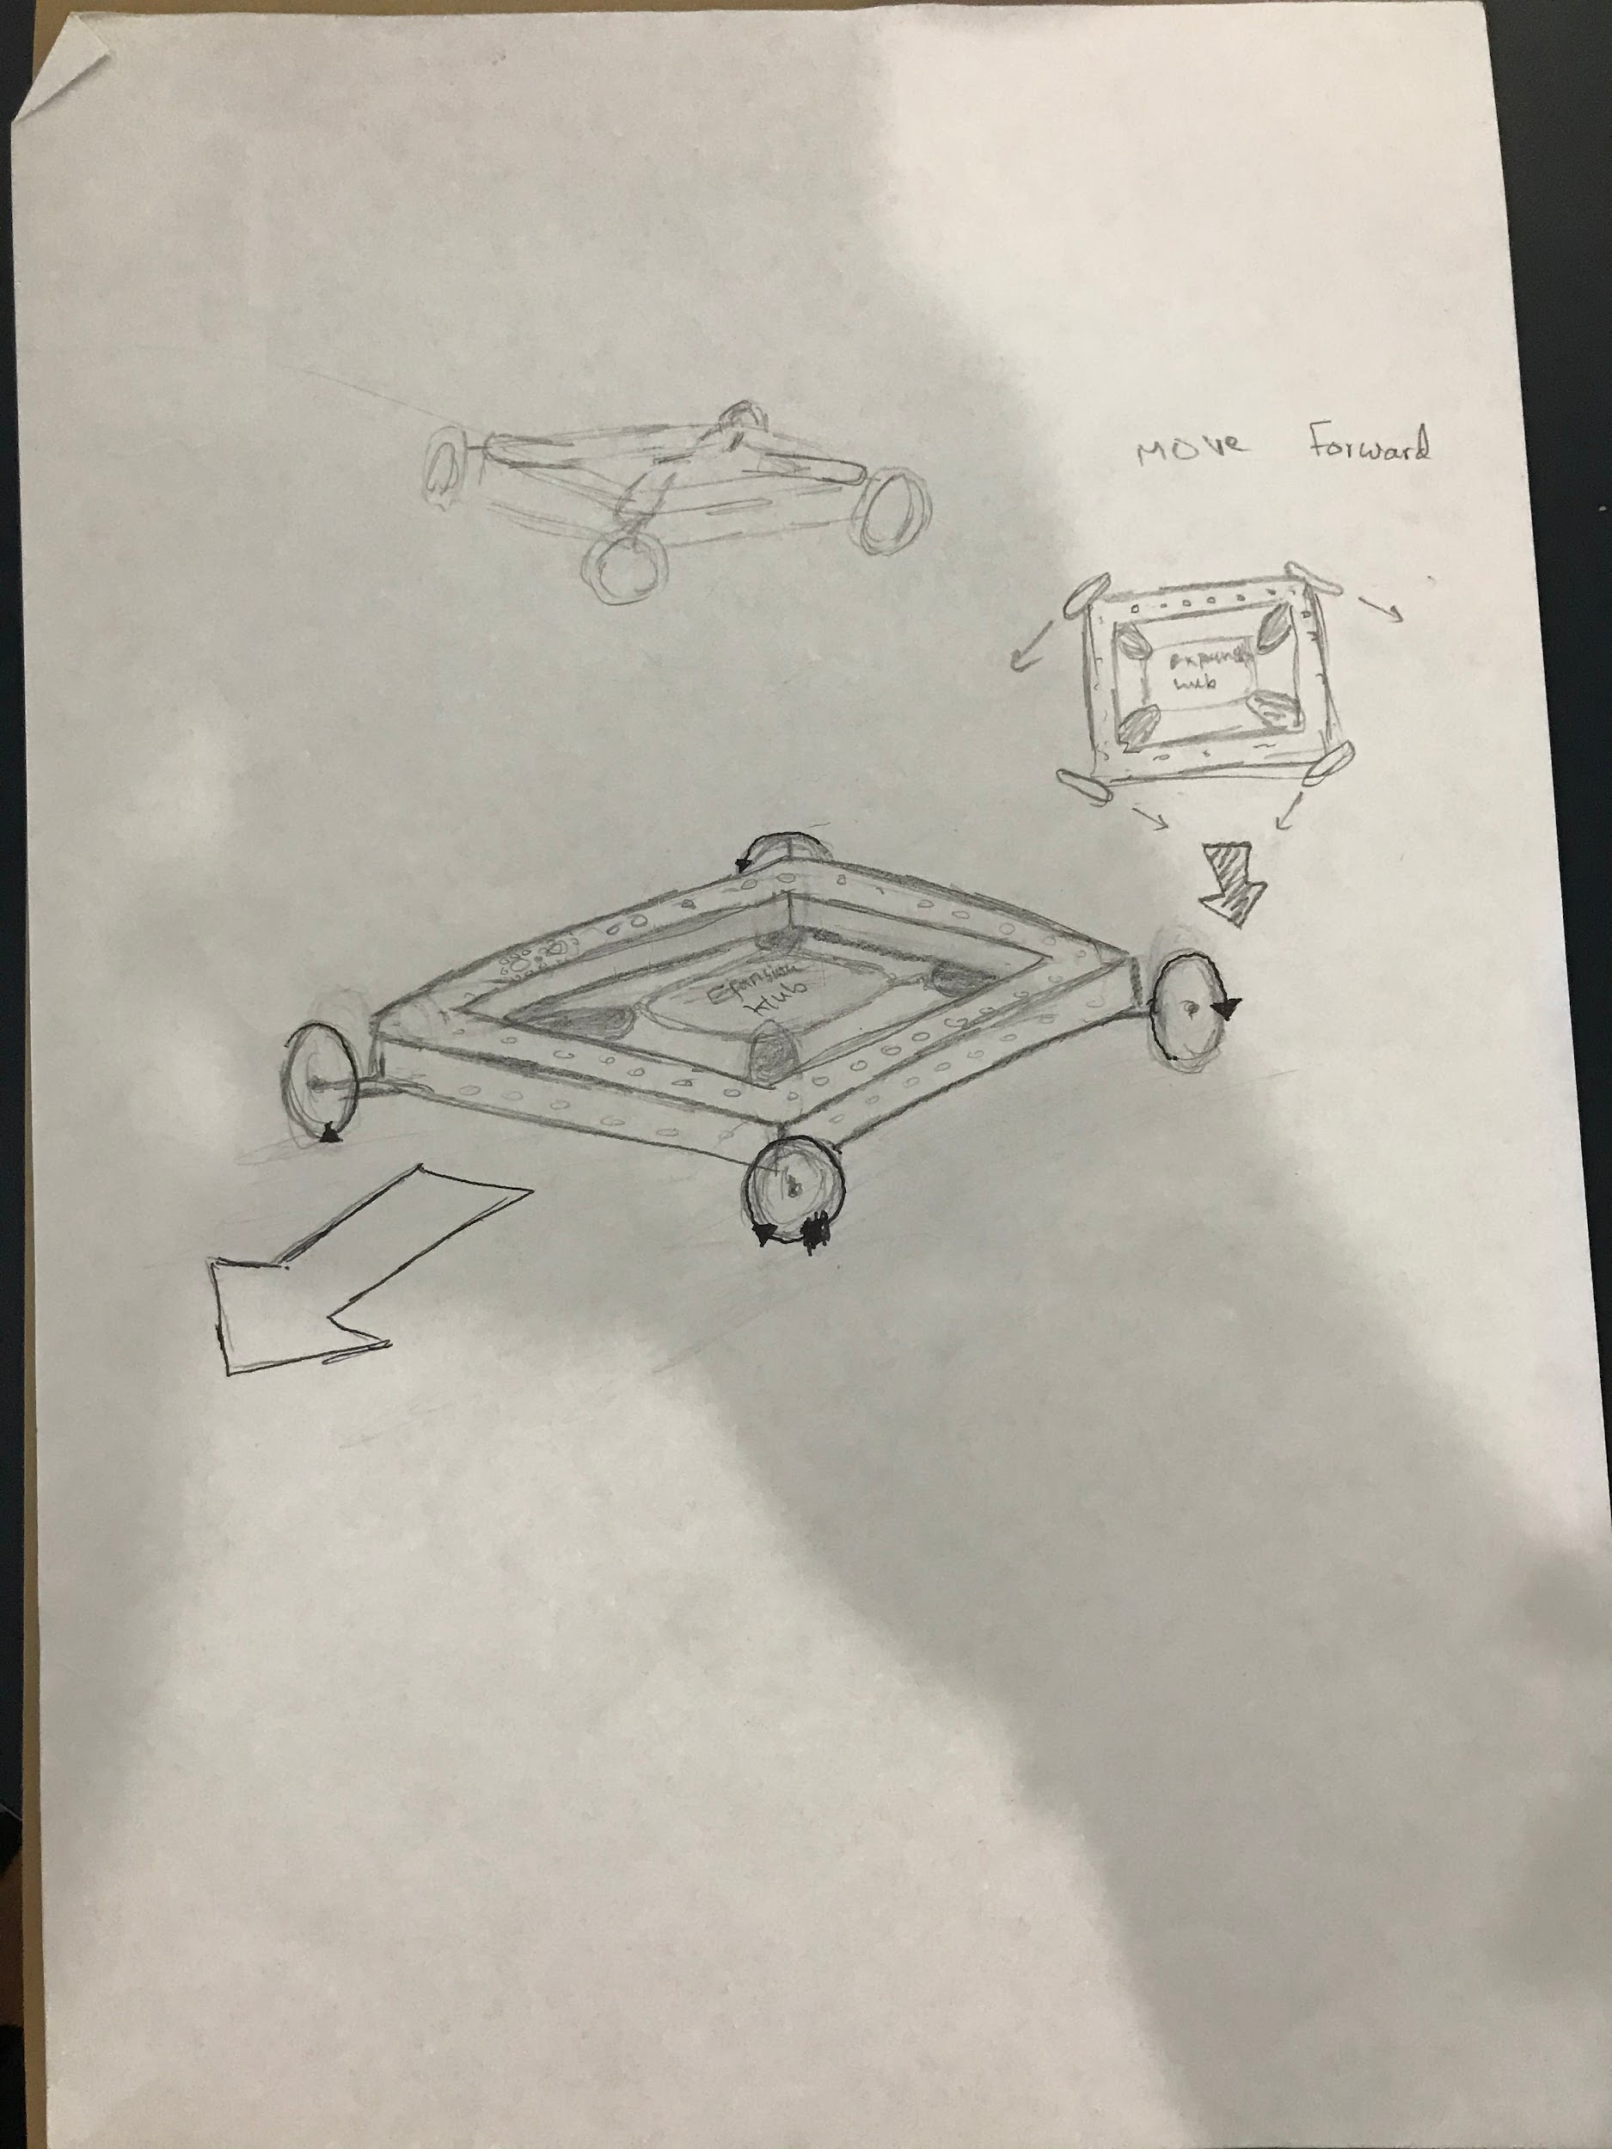

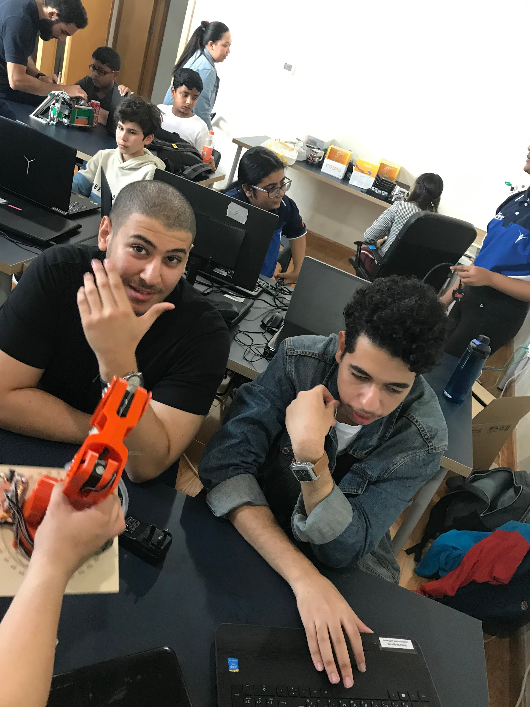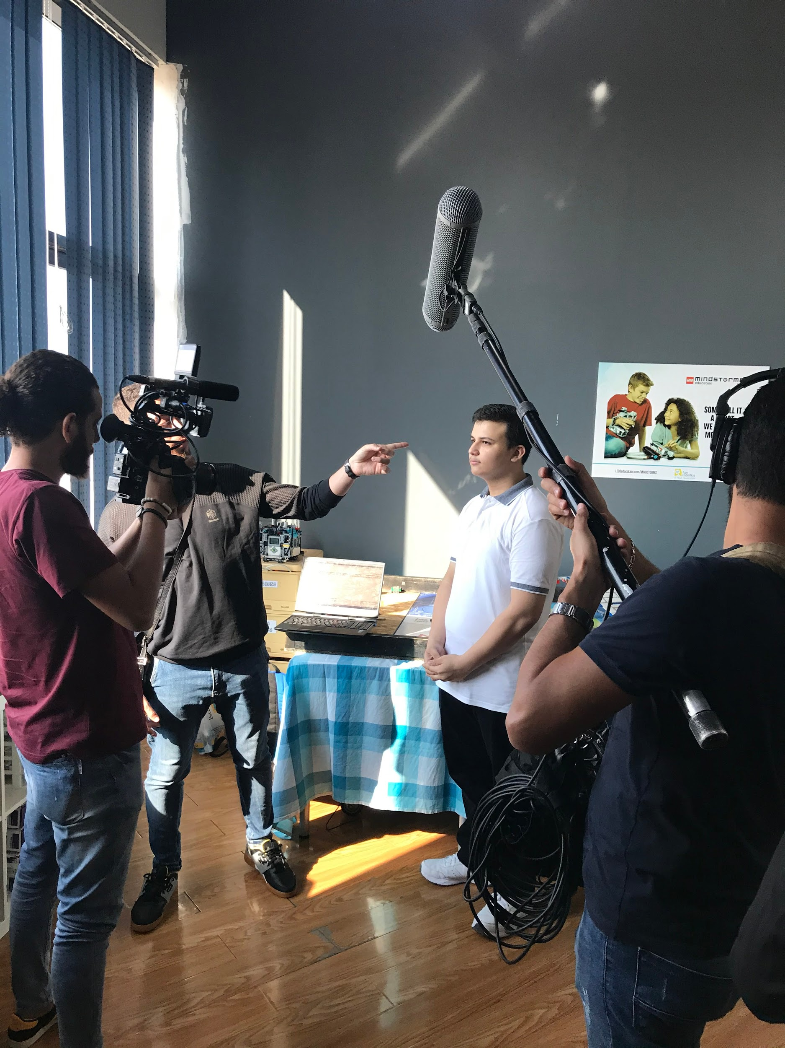

**December 11th, 2019**

| Tasks: get Nathanial familiar with the competition. | Attendance:  -Mhd Adnan  -Moustafa Mohammed |
| --- | --- |

| Summary: in this meeting, we got introduced to a new team member, his name is Nathanial he is skilled in many fields mainly Cad, it was decided then that he will join the design team, Moustafa and Mhd Adnan gave Nathanial a brief summary about the competition, moreover our mecanum wheels arrived, we tried fitting them to our robot, but the wheel holder was not wide enough, we drilled the four pieces until we found the right width for the motor shaft, once we drilled all of them they mounted but one wheel had an off angel, later Nathanial took measurements to 3d print it, it was successful, we then thought about the size of the wheel when in perspective it looked smaller than what we intended to buy, but it can do the job, our team member shatha decided to leave the team due to personal reasons, we later said goodbye to her as she was from the team’s original members, then we concluded the meeting, |
| --- |

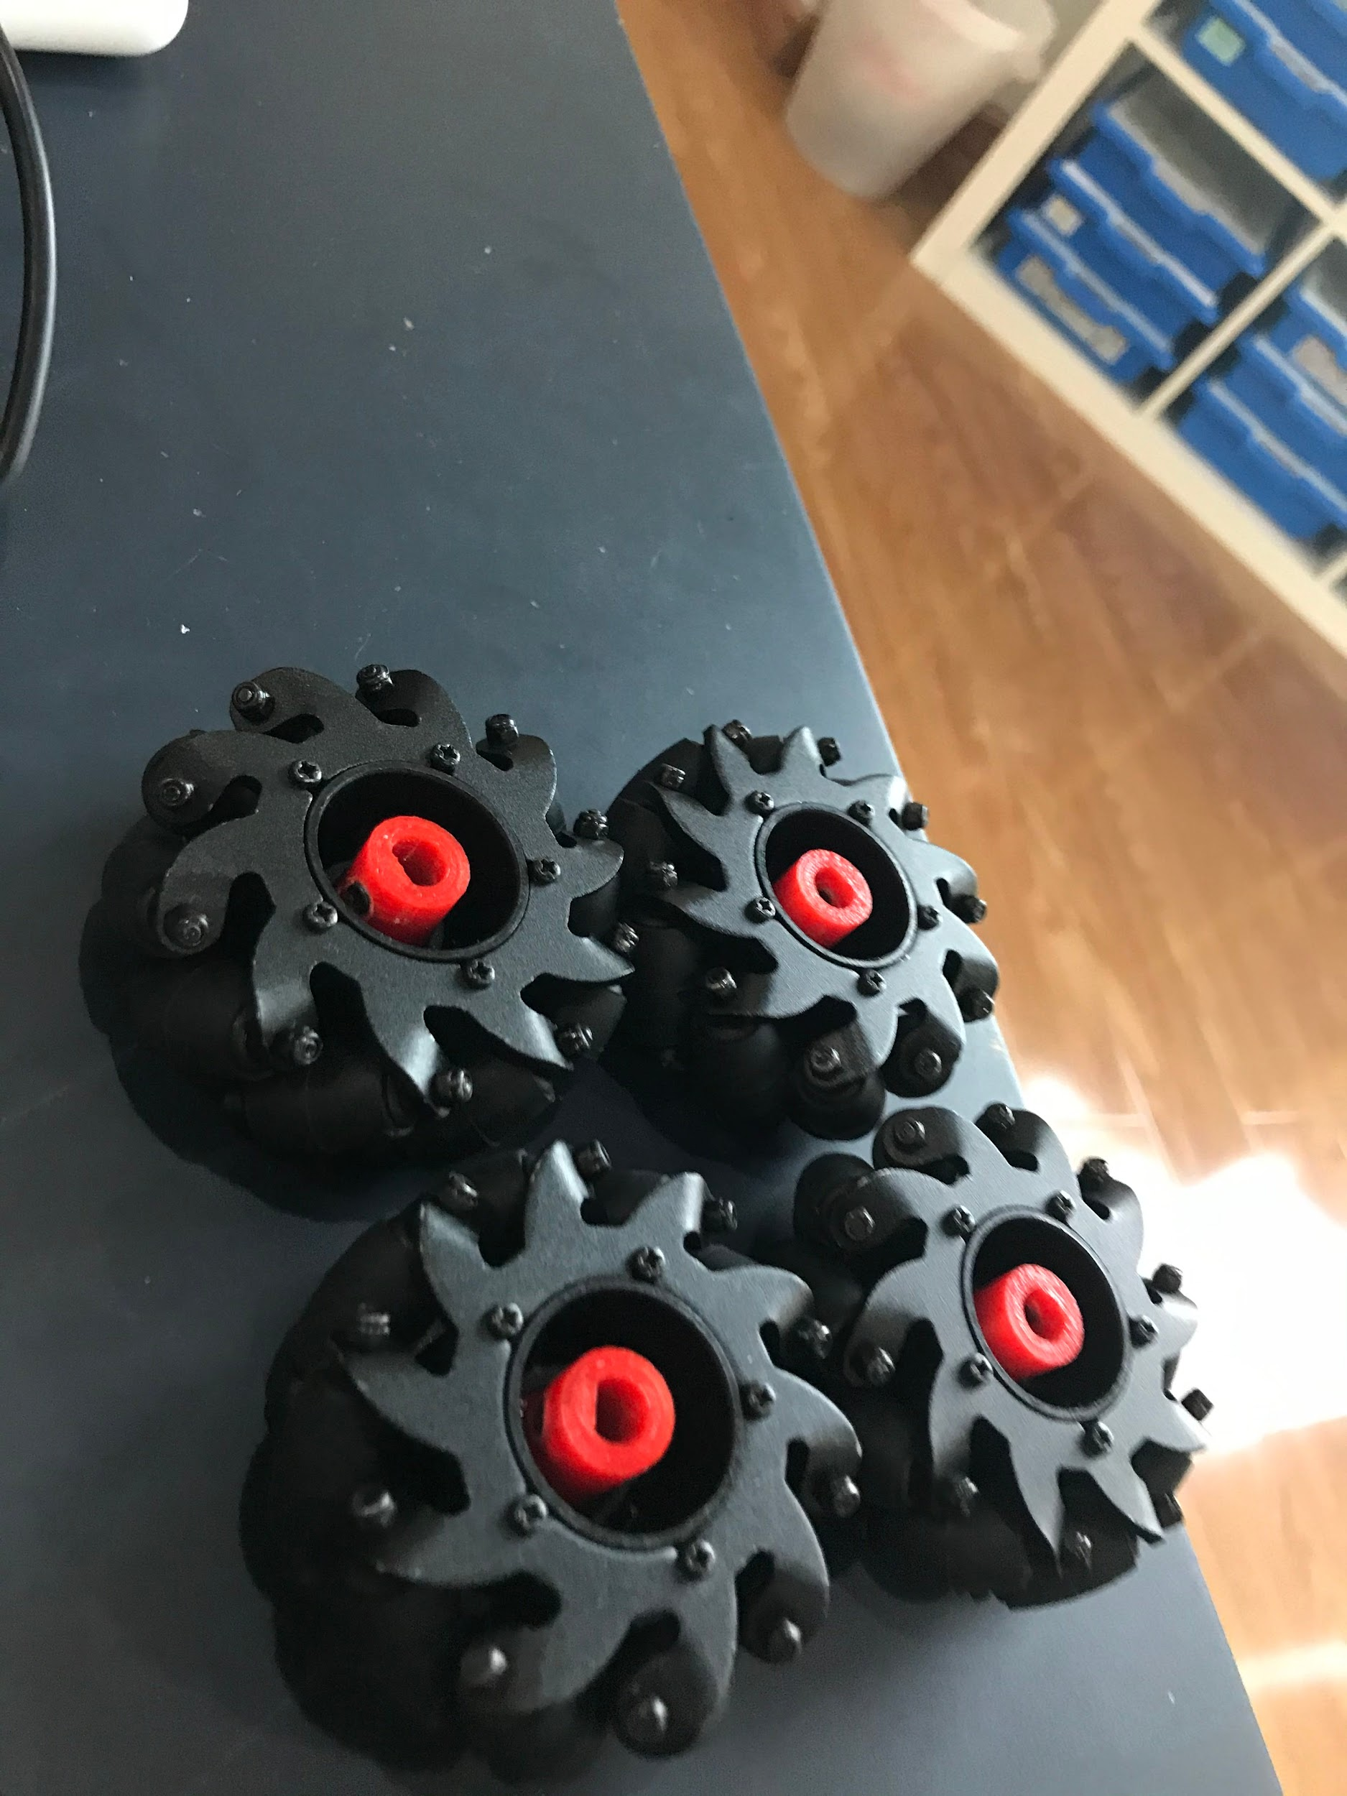

**December 25th, 2019**

| Task: -Introducing a new member to the competition | ٌAttendance:  -Mhd Adnan  -Kareem Essam  -Moustafa Mohammed  -Abdulelah Ayman  -Omar Jihad  -Omar Al Jaljuli |
| --- | --- |

| Summary: Today our coach gathered us to welcome a new member to our team (Omar Al Jaljuli). After that, some members of the team asked to switch positions in order to try something new and in order to fully take advantage of their skills and benefit the team. Our coach decided to give Omar Al Jaljuli the role of working on the engineering notebook as his English is slightly better than the rest of the team. He also decided to utilize his knowledge and experience in Fusion 360 and asked him to assist Nathanial in the design area of the robot. Kareem and Mhd Adnan sat with Omar to explain to him the fundamentals of the competition and the main factors that he will be working on. Abdulelah decided to reposition the motor mounts and put them at an angle so that we can use old mecanum wheels that we found lying around in the center. We had to use the old mecanum wheels since the new ones proved to be too small. |
| --- |

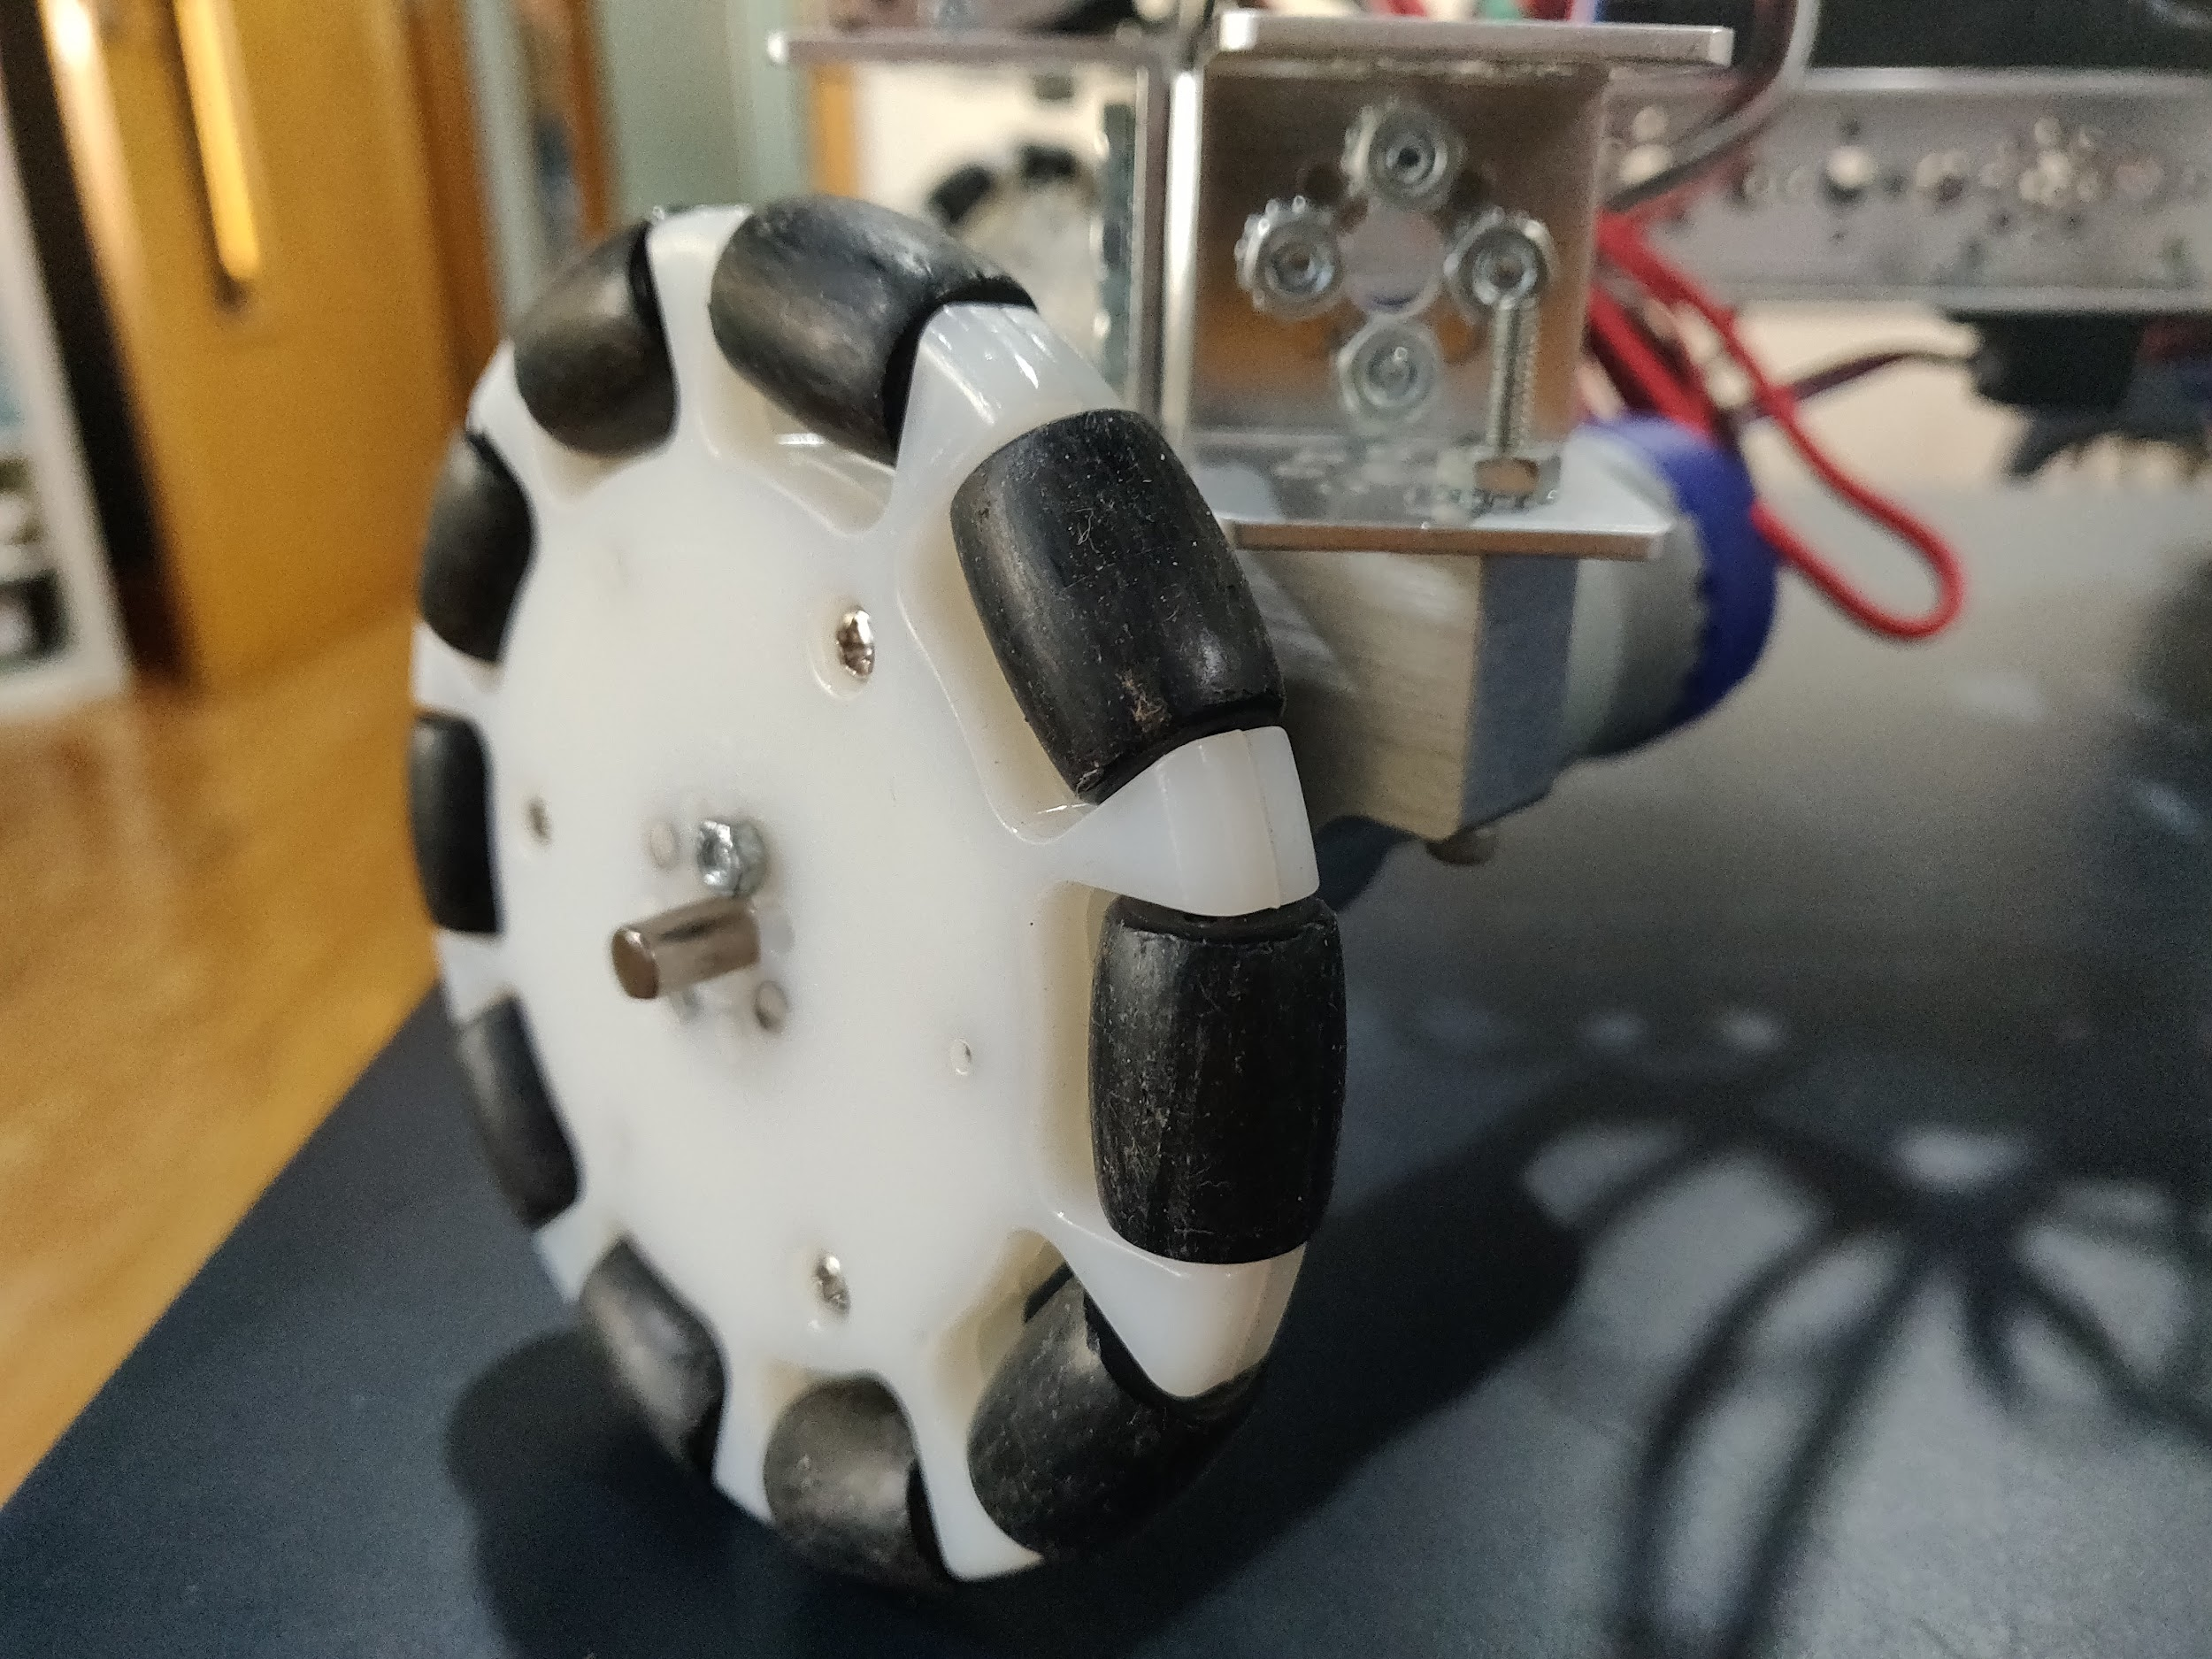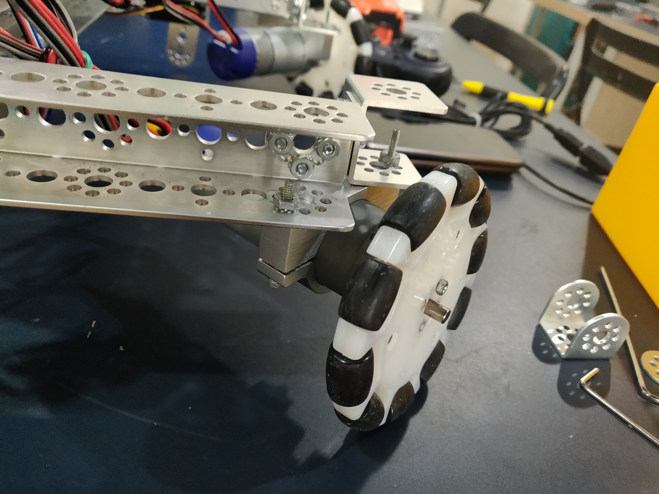

**January 16th, 2020**

| Task:  -Rebuilding the base | Attendance:  -Nathanial Sybico  -Mhd Adnan |
| --- | --- |

| Summary: Today Mhd Adnan and Nathanial came in order to improve the robot base itself. After working on it for a while they realized that the base is too small and that it needs to increase in size. It would’ve been extremely hard to adjust the current base in order to make it bigger. So Mhd Adnan and Nathanial decided to completely dismantle the old base and build a new one from scratch (it wouldn’t be too hard since they already have an idea of how the robot base would look like and its configuration.) By the end of the day, Mhd Adnan and Nathanial were able to finish building the new base completely which is better in size. In addition, they were also able to build a simple arm that runs on a 180-degree servo in order to collect the bricks and bring them to the foundation. |
| --- |

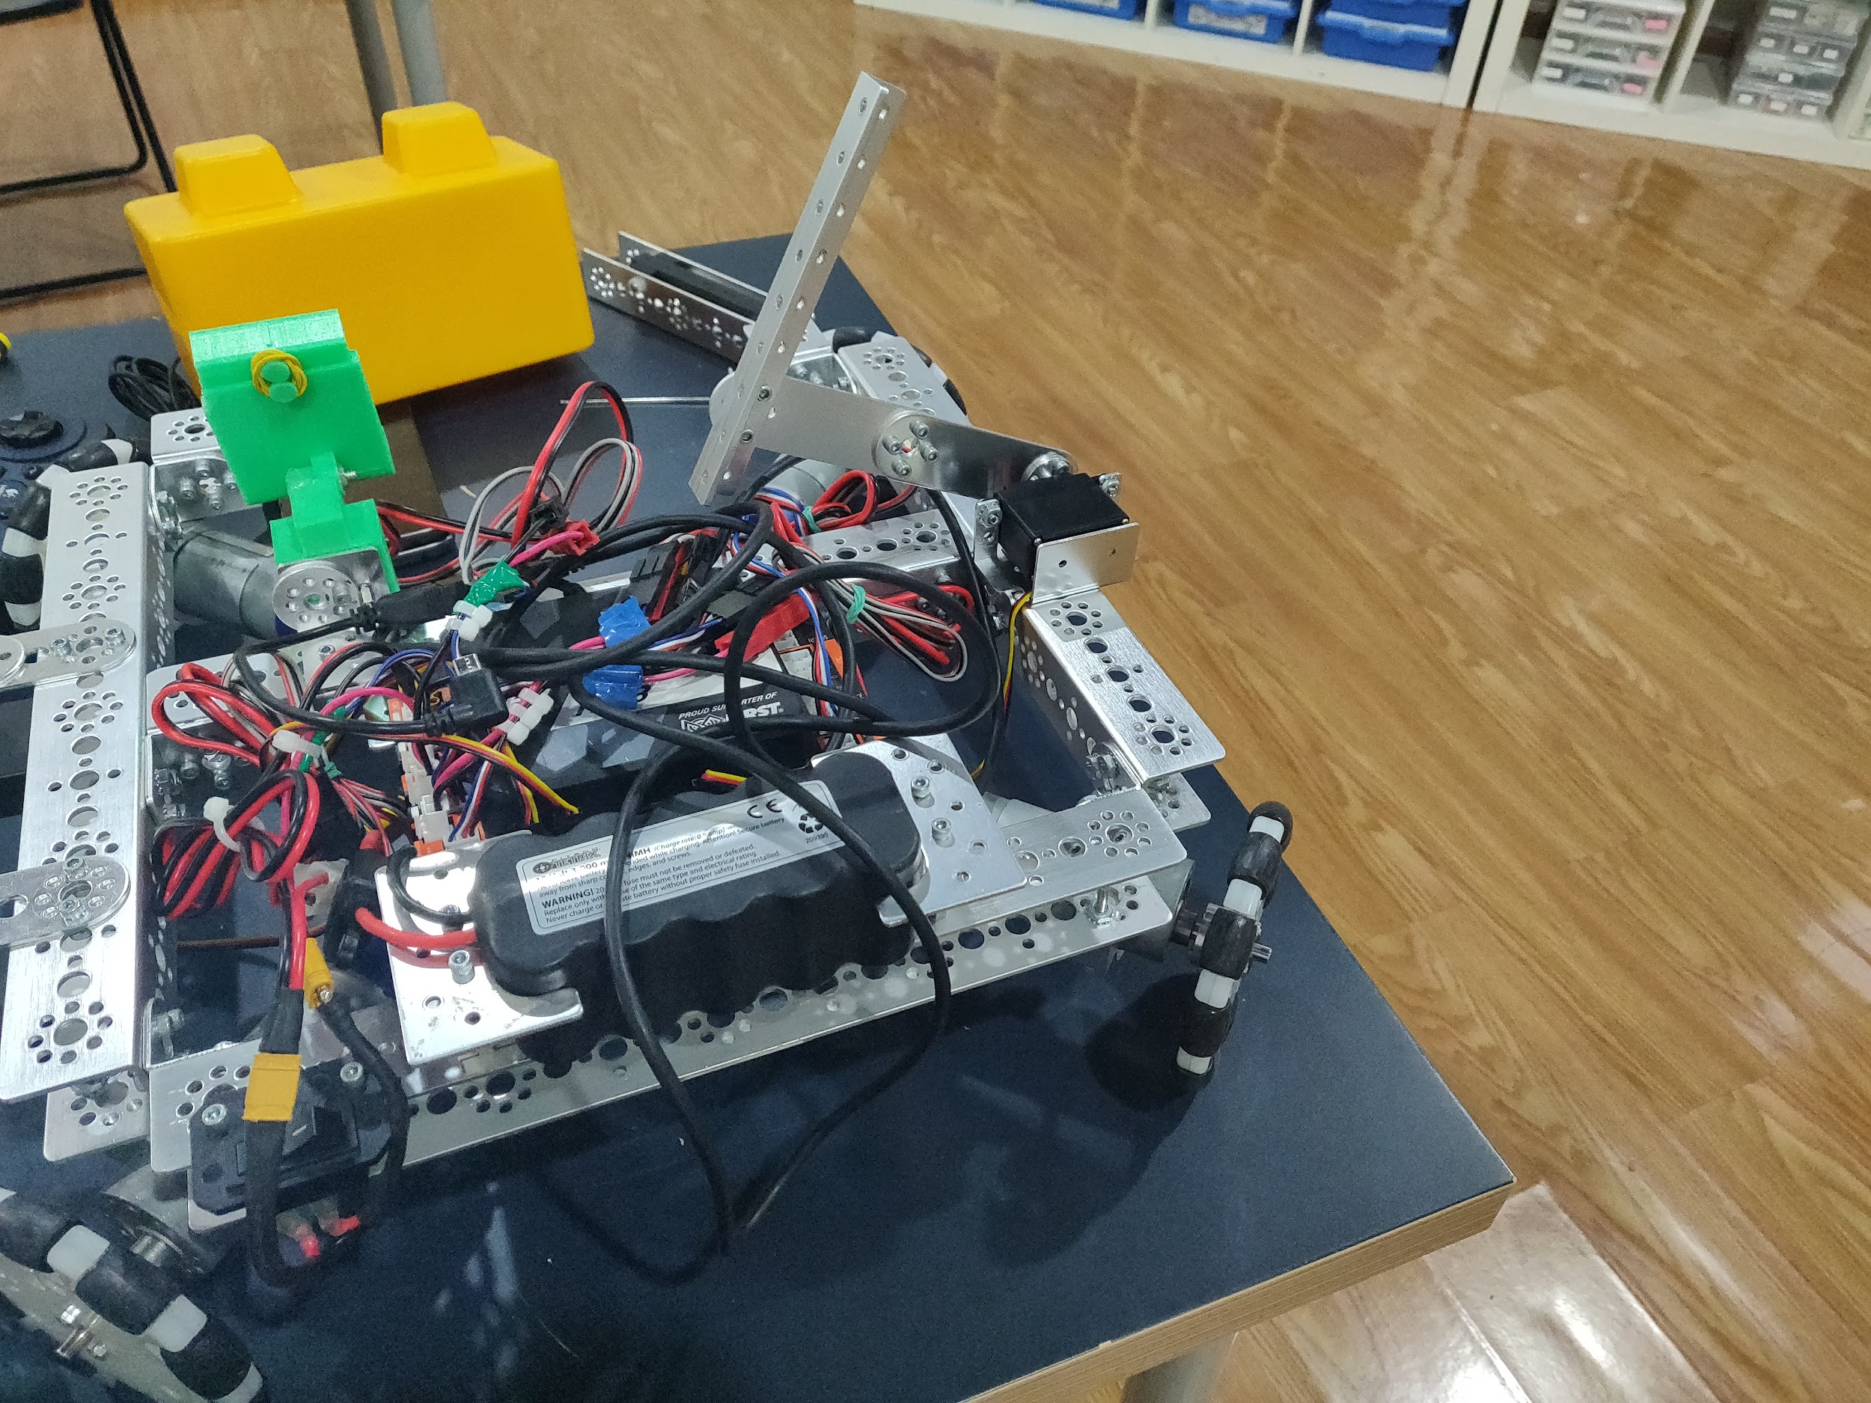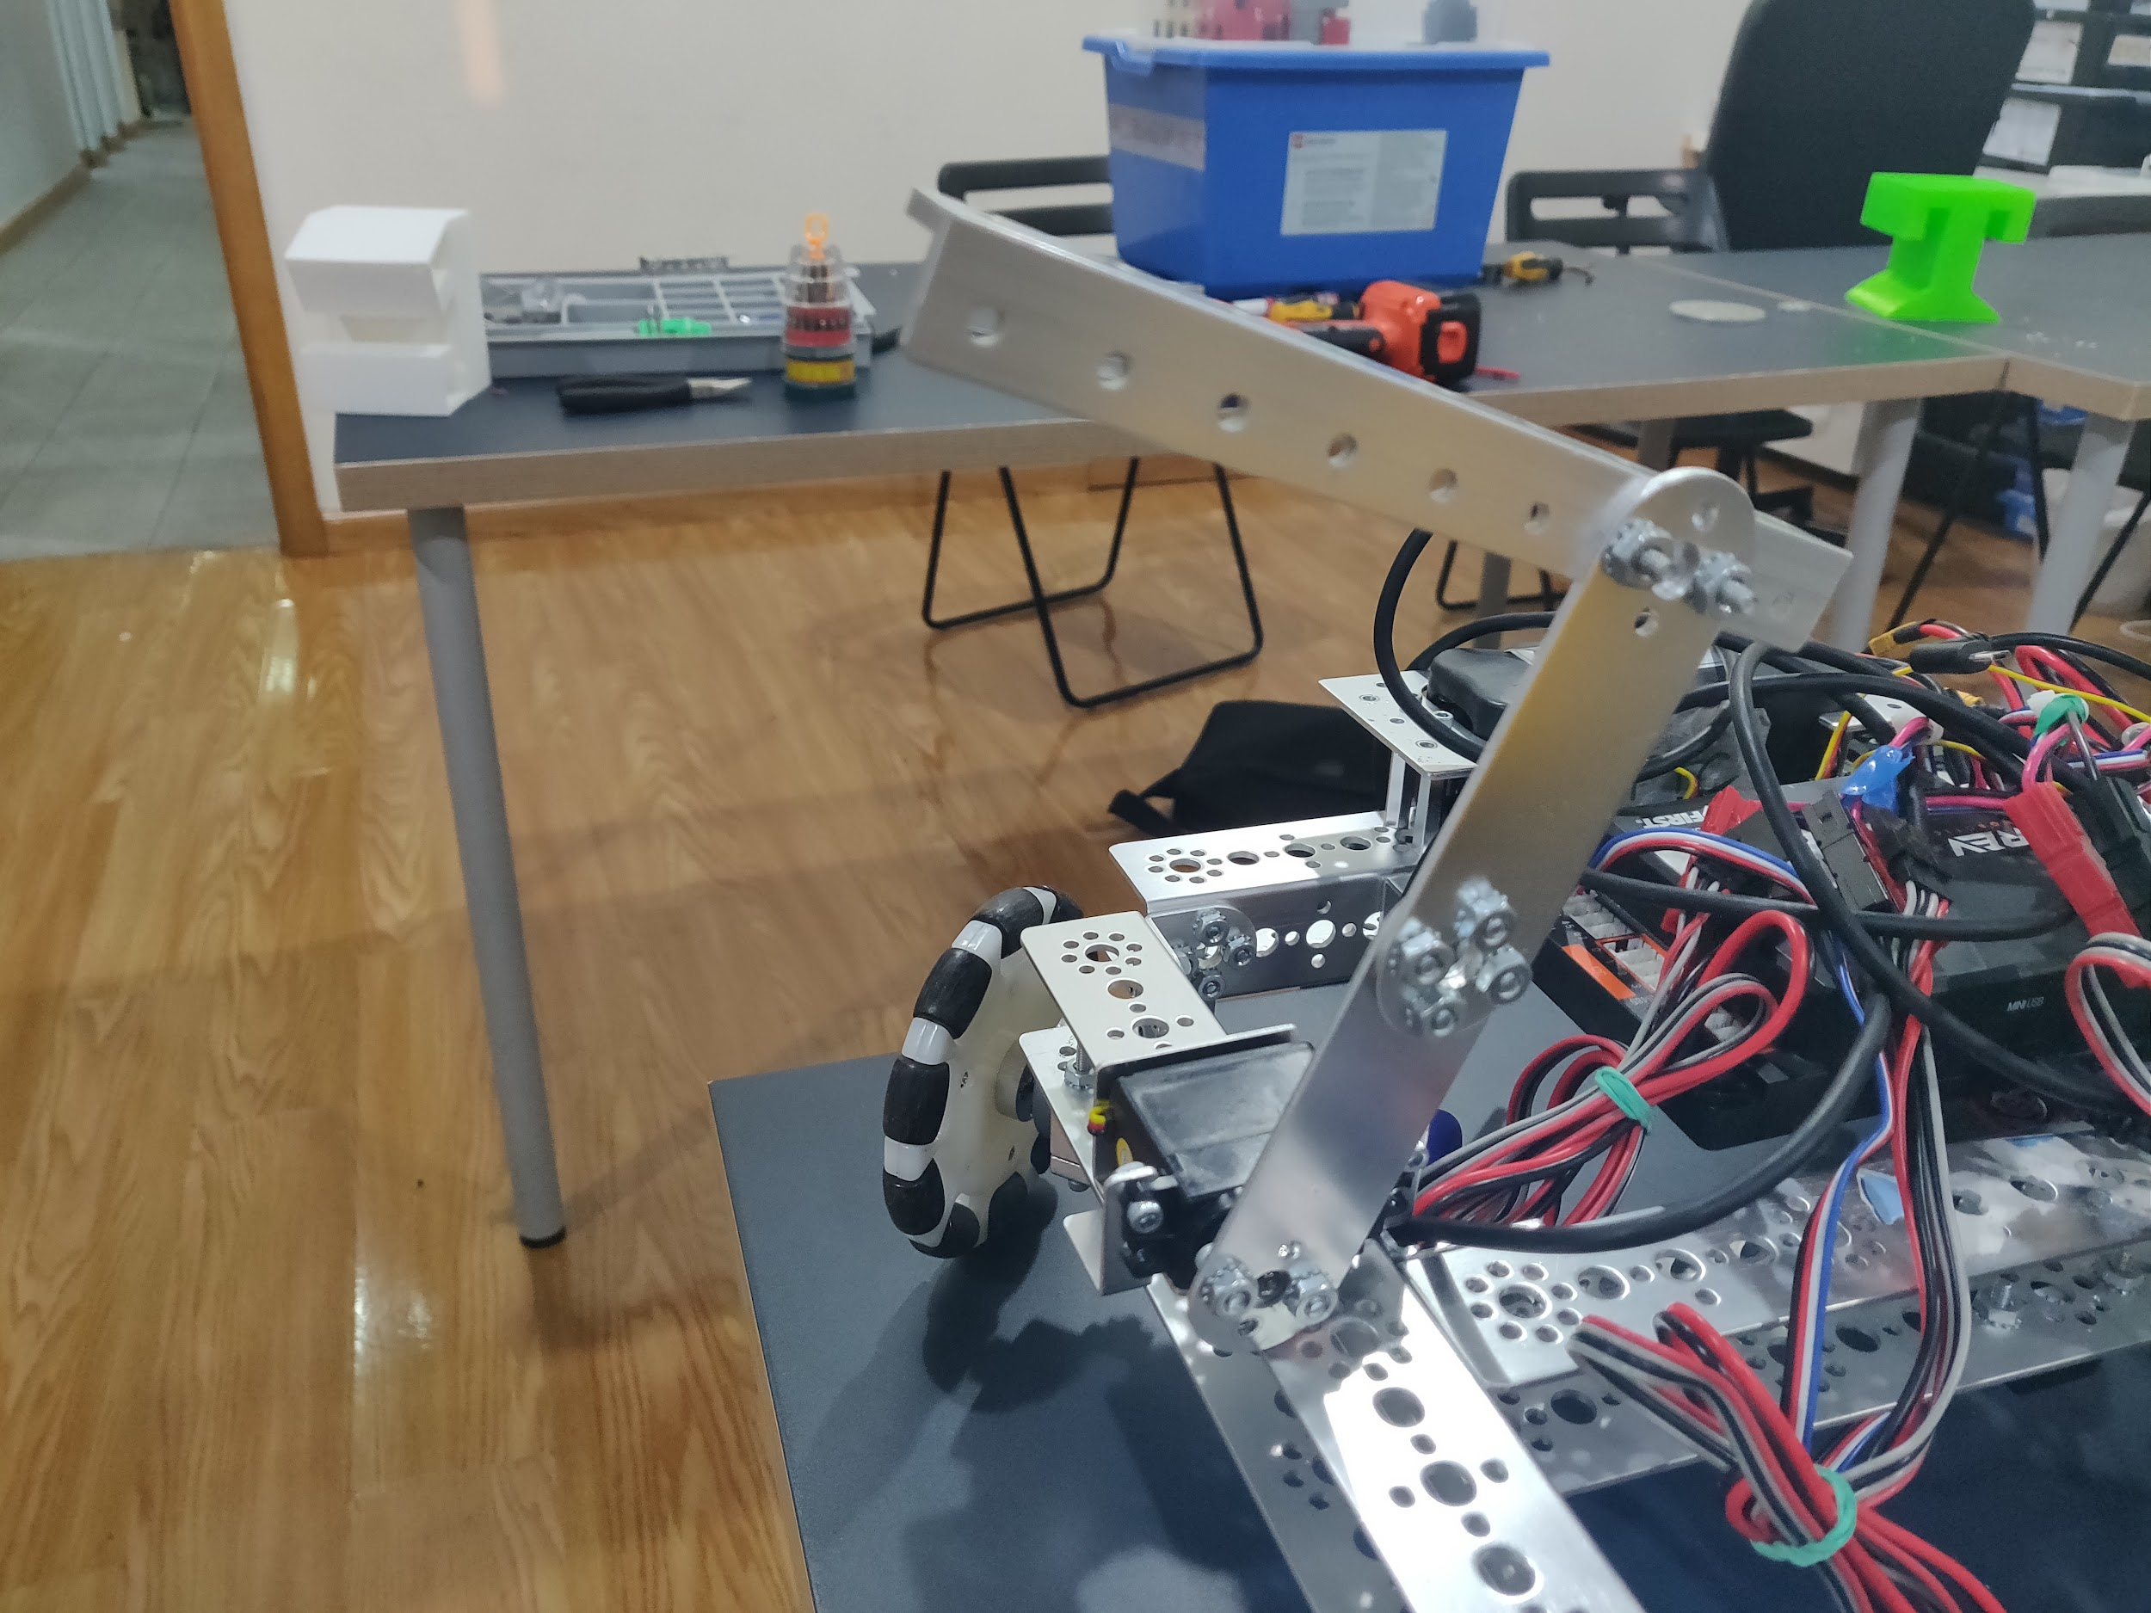

**January 18th, 2020**

| Task:  -sharing the FTC experience to the FLL participants | Attendance:  -Mhd Adnan  -Kreem Essam  -Omar Aljaljuli |
| --- | --- |

| Summary: Today Omar Al Jaljuli, Mhd Adnan, and Kareem met up in Kings school where the FLL competition was taking place. The organizers gave us a stall which we set up our robot and other items on. After we finished setting up people from the FLL competition started approaching us curious to what we had. We explained to the inquirers about the FTC competition and the amazing experience we’ve had up until now, we then explained to them about our robot and how it will be solving the missions. Many people that approached showed interest in joining the competition in the next season. That alone made us feel like we have accomplished something, since thanks to us more people are aware of the competition and that more people will be joining next year. |
| --- |

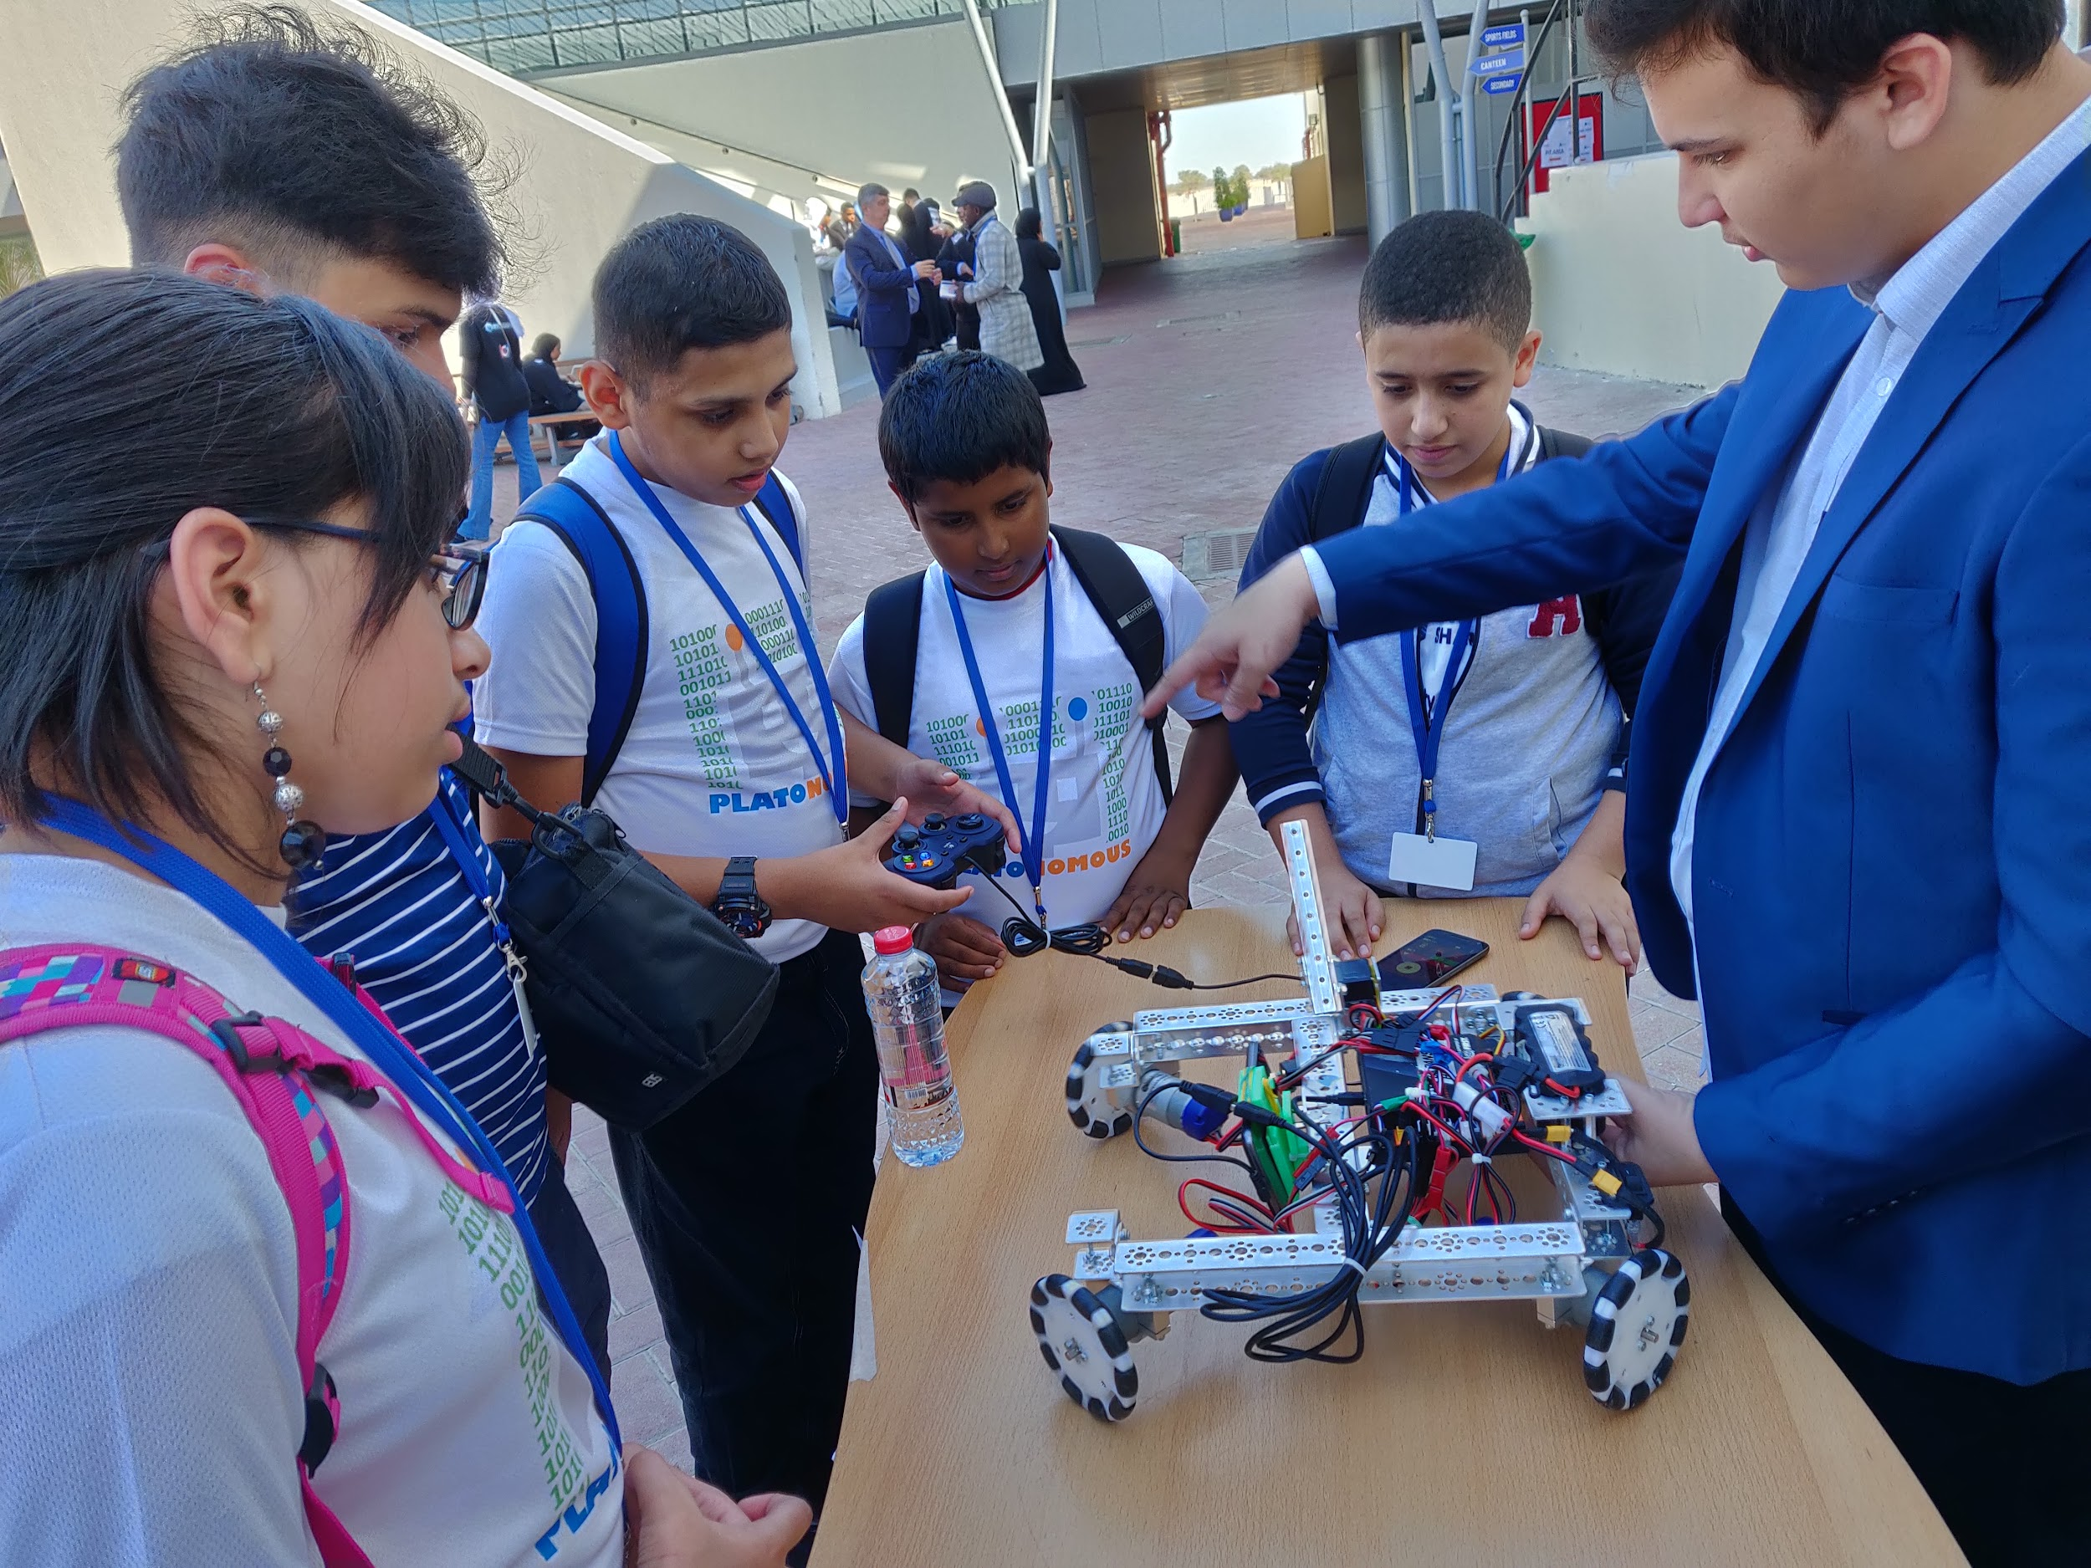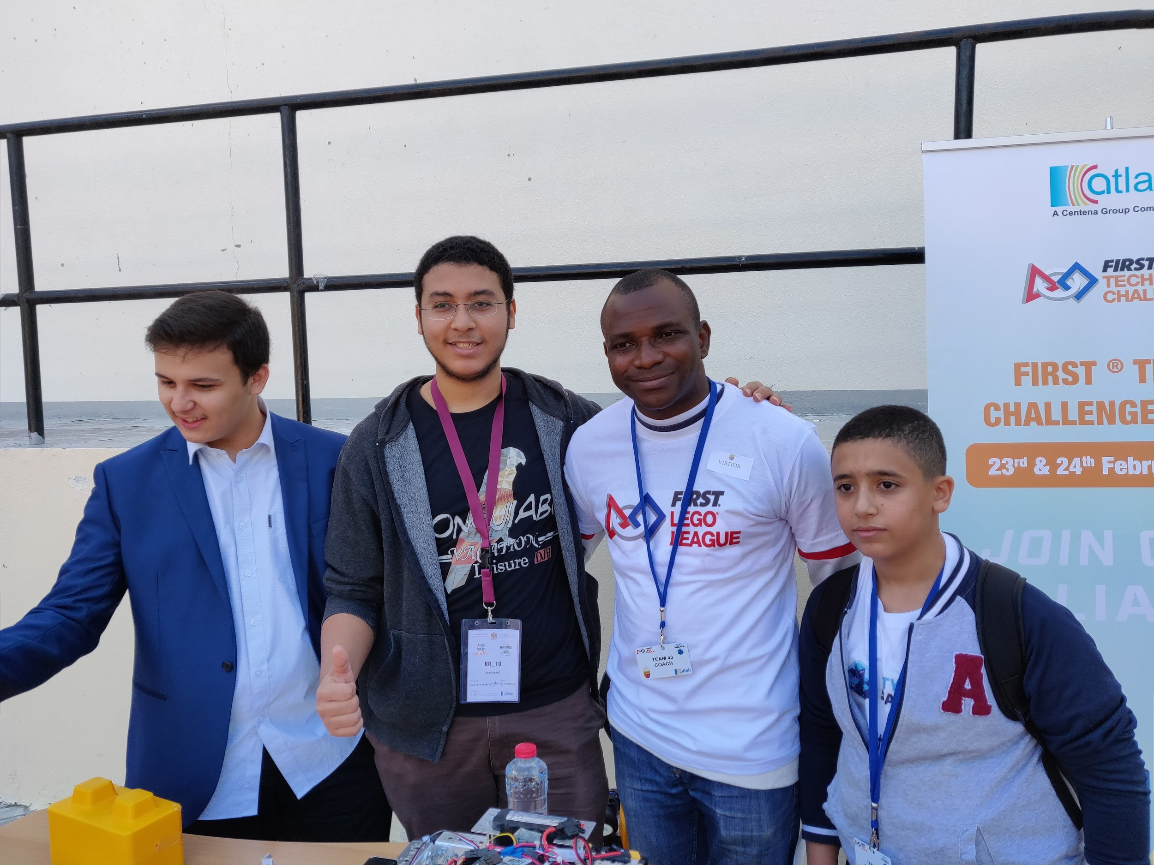

| However, we did not only talk to the FLL participants, since there were times where all the participants were busy, so we decided to fill that time by improving our robot and building attachments. We decided to build an attachment with two servo motors that move the foundation in the autonomous period of the challenge, Nathanial was able to arrive later in the day. As we were showing the FLL participants how our robot moves, one of the motors stopped working. Instead of buying a new one we started looking for the issue in the motor. After some time of opening it and finding what the problem is when we were able to find a piece of solder that entered and stopped the motor from turning, after removing it and putting it back together the motor started working again. |
| --- |

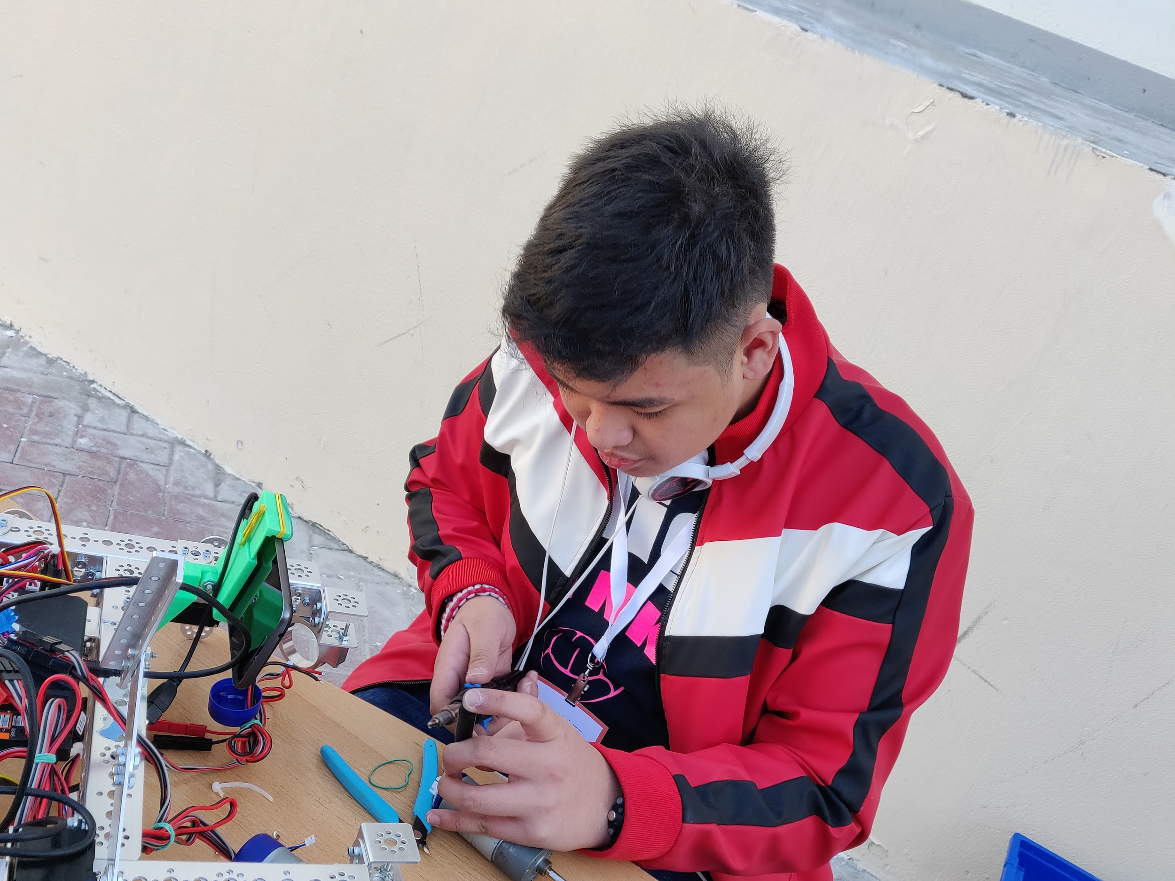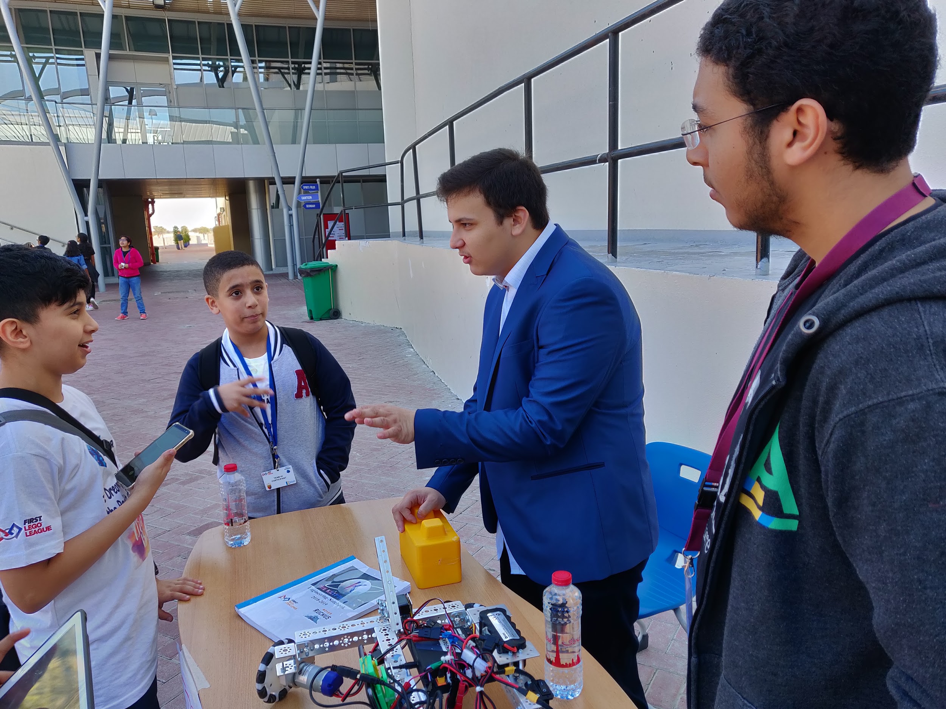

| Nathanial was able to arrive later in the day. As we were showing the FLL participants how our robot moves, one of the motors stopped working. Instead of buying a new one we started looking for the issue in the motor. After some time of opening it and finding what the problem is when we’re able to find a piece of solder that entered and stopped the motor from turning, after removing it and putting it back together the motor started working again. |
| --- |

**January 27th, 2020**

| Task: -To work on a new robot  attachments and  improve  existing ones  -creating team social  media | Attendance:  - Abdulelah Ayman  - Mhd Adnan  - Kareem Essam  - Omar Jihad  - Mohammed Ayesh  - Pranav Jain |
| --- | --- |

| Summary: Today the team worked on the cascading slide attachment (it is the mechanism for the up and down movement of the robot). We were able to make a prototype that worked using a servo motor. We also planned to add another beam to it which will increase the extension height. We also improved the program for controlling the wheels which made them run smoother than before (we also tightened the wheels), our media and sponsor team Omar Alattar, made our team’s Instagram account to become more official named @whh_dubai, he later started posting team progress on the account. |
| --- |

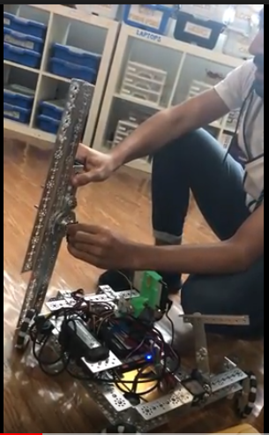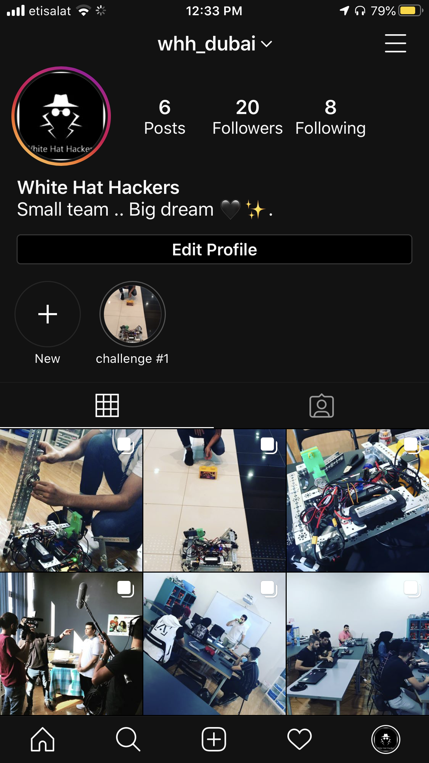

**February 3rd, 2020**

| Tasks:  - working on cascading  slide  - checking the rules to  know building freedom | Attendance:   * Pranav Jain * Omar al Jaljuli * Nathanial |
| --- | --- |

| Summary: the team gathered today to work on the cascading arm slide and improve it. Firstly instead of making the cascading slide consist of two long metal beams, we switched it to consist of 4 medium-sized metal beams. This was done to make sure that it does not exceed the maximum length the robot could be. Afterward, the team discussed what the best method of picking up the blocks would be, half the team thought it would be best to use the cascading slide to pick up place the block onto the foundation, however, the other half of the team thought that it would be a better idea to make a mechanism that would pick up a robot quickly and use the cascading slide to only place the block on the foundation. The second idea was much more efficient, however, it was time-consuming and it would be hard to implement. After further discussion, the team thought it would be best to allow Nathanial to work on the mechanism which would collect the blocks separately from the cascading slide while the rest of the team does their own work. This way not much of the team's time will be wasted but we will also not miss out on a possibly game-changing attachment. |
| --- |

**February 5th, 2020**

| Task:  - fixing the slide  - decreasing the robot  size | Attendance:   * Pranav Jain * Nathanial Sybico |
| --- | --- |

| Summary: Today the team worked on fixing the cascading slide to a base. The base was then attached to the robot. We also strengthened the joint by using beams to connect the robot to the first slide. The cascading slide worked quite well. However, the braided fishing string broke during testing. We will have to find stronger strings for the next time. Moreover, the size of the robot exceeded the maximum dimensions. The team then thought about ways to reduce the dimensions. Some of the ways were to move the arm to a different position on the robot and to make the size of the robot smaller by making the hub vertical. We shall think about the positives and negatives of each idea and implement the best idea next time. |
| --- |

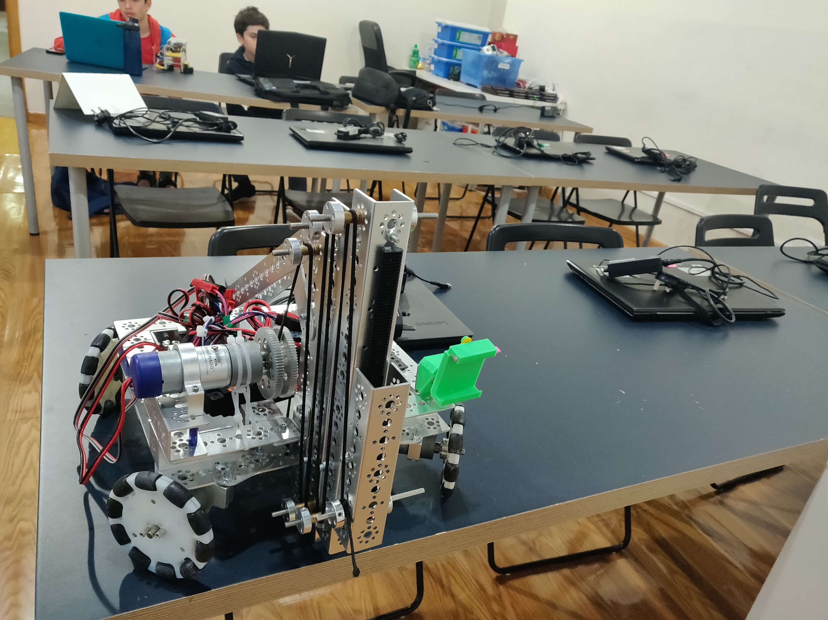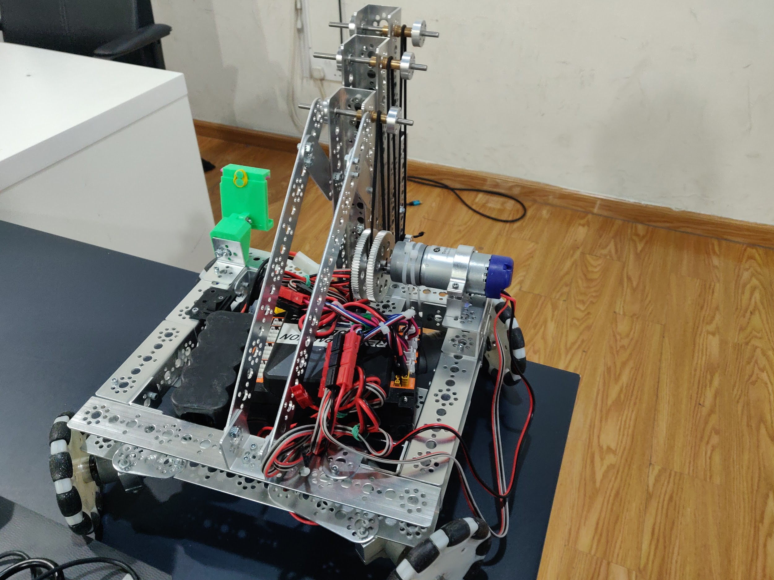

**February 10th, 2020**

| Task:   * putting final touches to   the arm   * programming the robot * learning to use colour sensor * disassemble the robot | Attendance:  -Mhd Adnan  -Omar Jihad  -Moustafa Mohammed  -Kareem Essam  -Abdulelah Ayman  -Mohammed Ayesh  -Pranav Jain |
| --- | --- |

| Summary: at the start of this meeting everything was looking good we were just about to put our final touches, but when we were taking our last measurements it turned out more than 18 inches in length, this forced us to disassemble the robot and make it shorter lengthwise, this process took us about two hours  we couldn’t put the arm in time having to finish the meeting, we just finished the base. |
| --- |

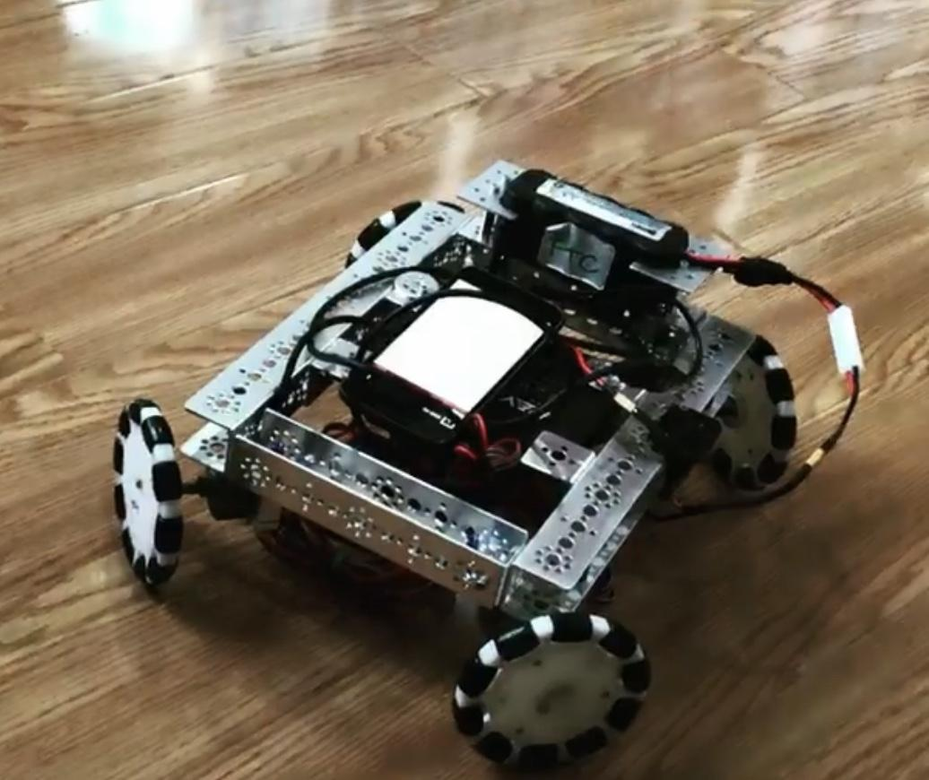

**February 12th, 2020**

| Tasks:  - Resize the robot  - Finding a new cable  for the cascading arm | Attendance:  -Mhd Adnan  -Mohammed Ayesh  -Moustafa Mohammed  -Omar Al Attar  -Abdulelah Ayman |
| --- | --- |

| Summary: the team gathered together today to finish what they started the last meeting, it was to make the robot smaller in size,  while doing this we were thinking about ideas for the gripper, we already made the cascading arm, so the gripper will not be a problem, while on break we went to look for a cable for the cascading arm as all past cables would get stuck or break, we found an elastic shoelace like cable, we bought it, it worked wonderfully, immediately after we ran into a problem with the cascading arm, one of the shafts would not lift up, it turned out it was partly from the code and partly because it was put in too tightly, |
| --- |

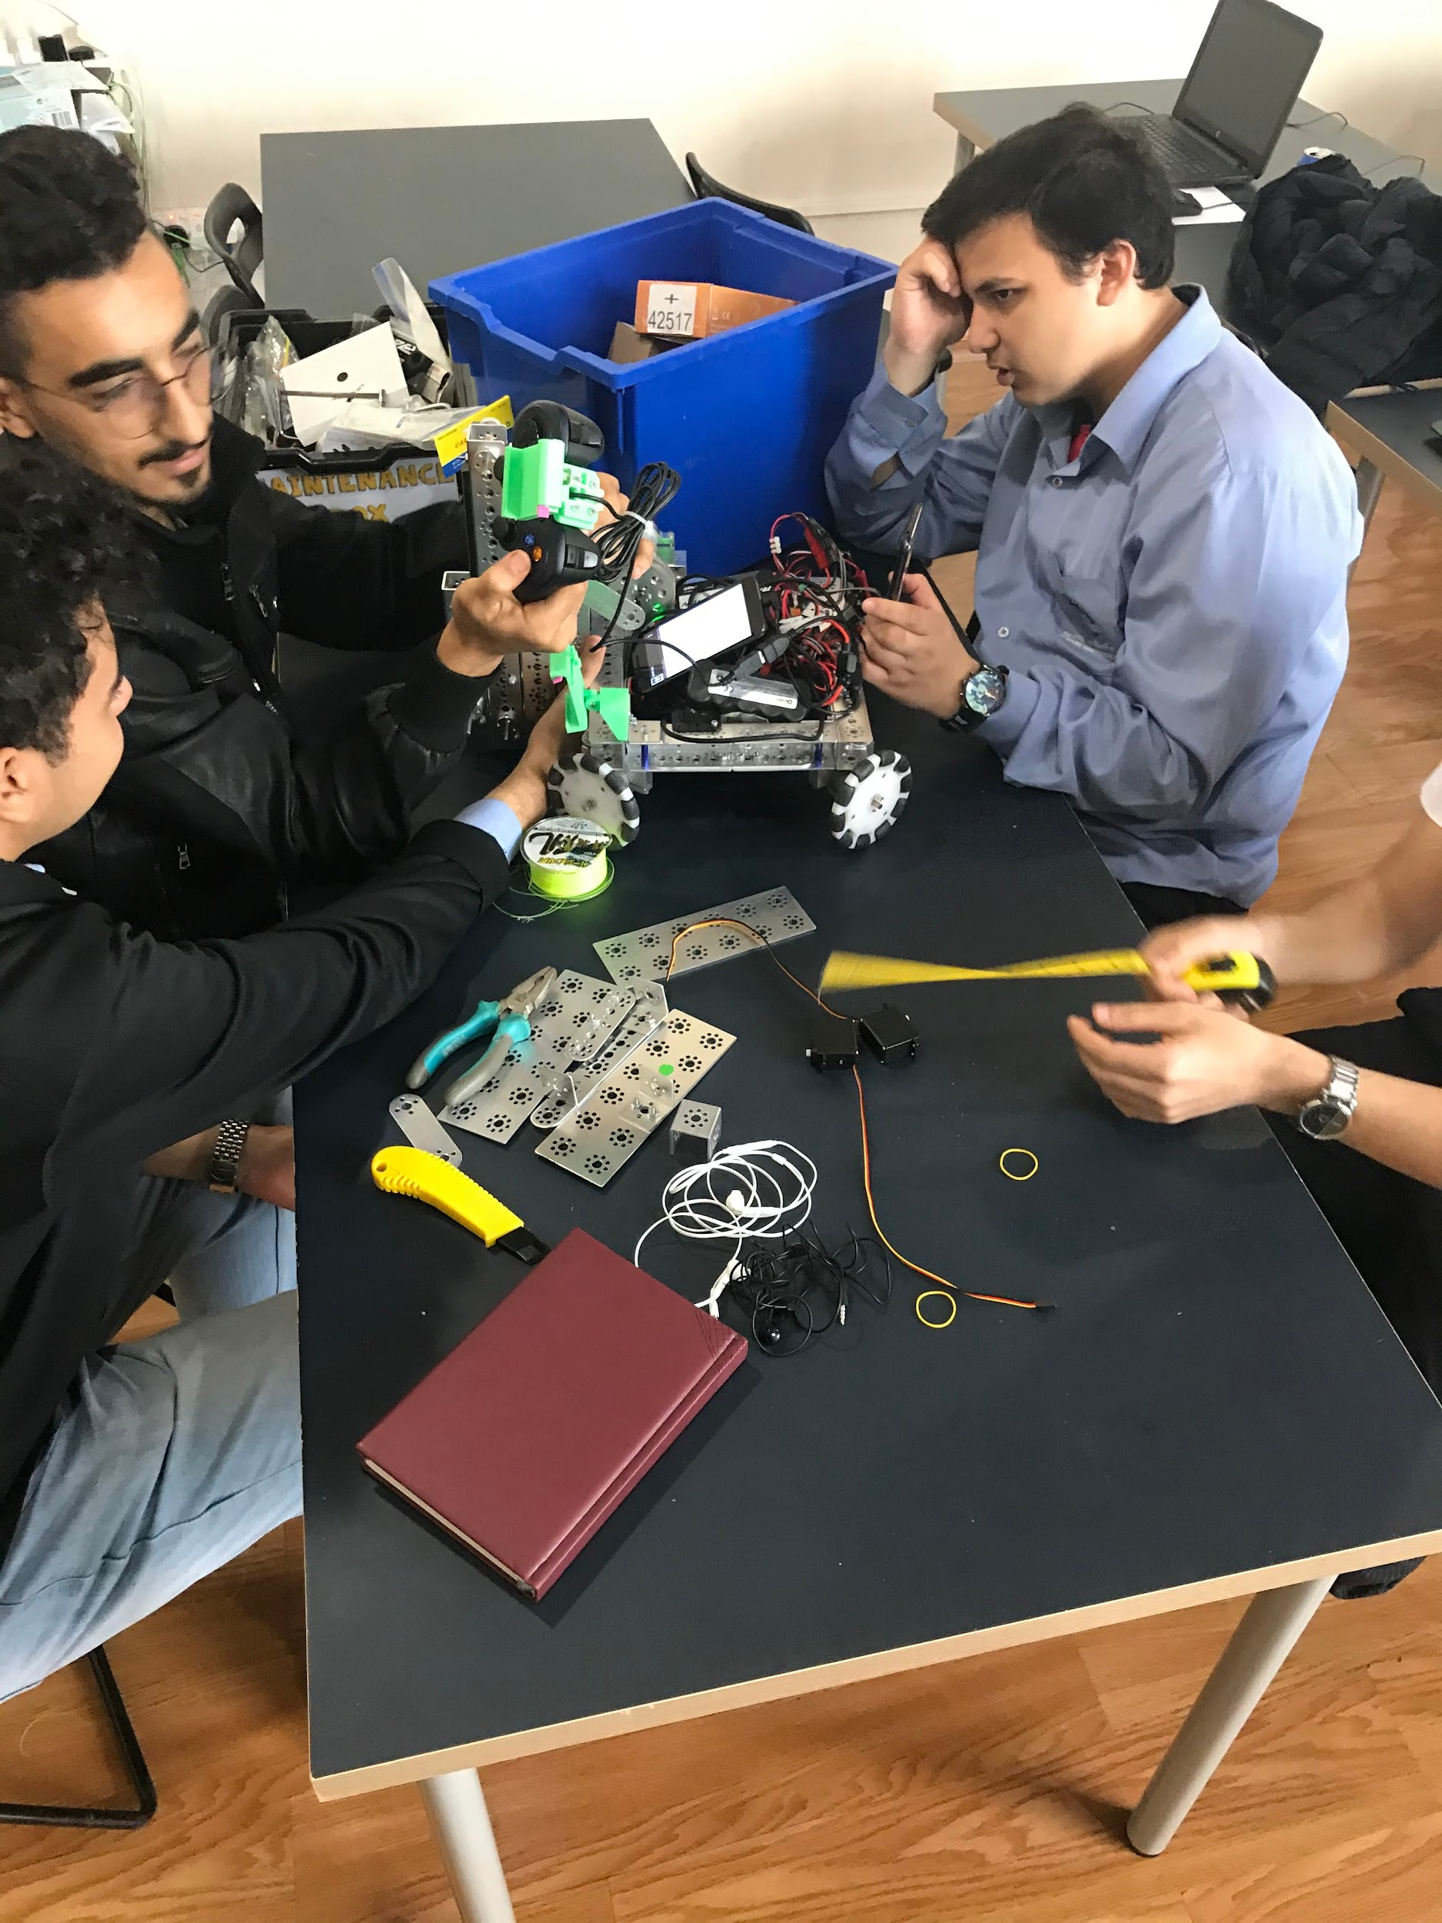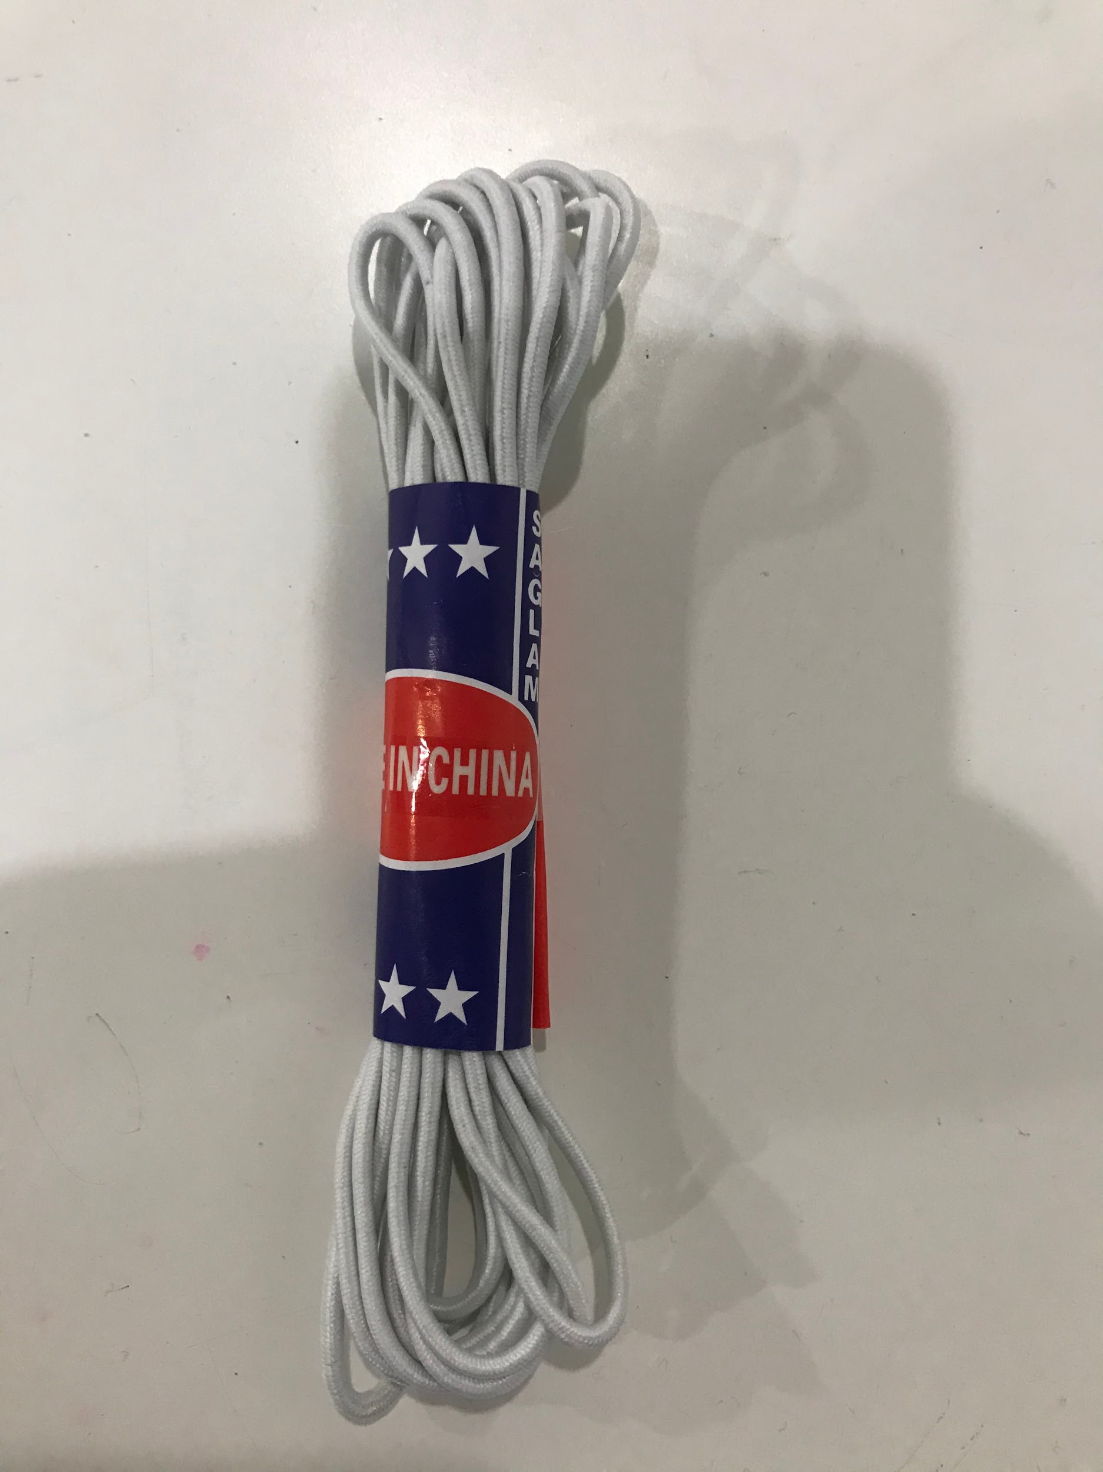

**February 16th, 2020**

| Task:   * complete robot and arm fully * complete capstone design * work on the autonomous program | Attendance:   * Mhd Adnan * Pranav Jain * Kareem Essam * Ziad Essam * Abdulelah Ayman * Omar Al Attar * Omar Al Jaljuli |
| --- | --- |

| Today the team arrived and started working on the robot arm to ensure that it is working and is synchronized to the controller. The team brainstormed different ideas for the gripper and finalized the best idea. A prototype was made and was tested. It was then fitted onto the robot’s cascading slide. The team also used fusion 360 to create the capstone design. Finally, the team programmer was working on the autonomous program and was working on the detection of the skystone. |
| --- |

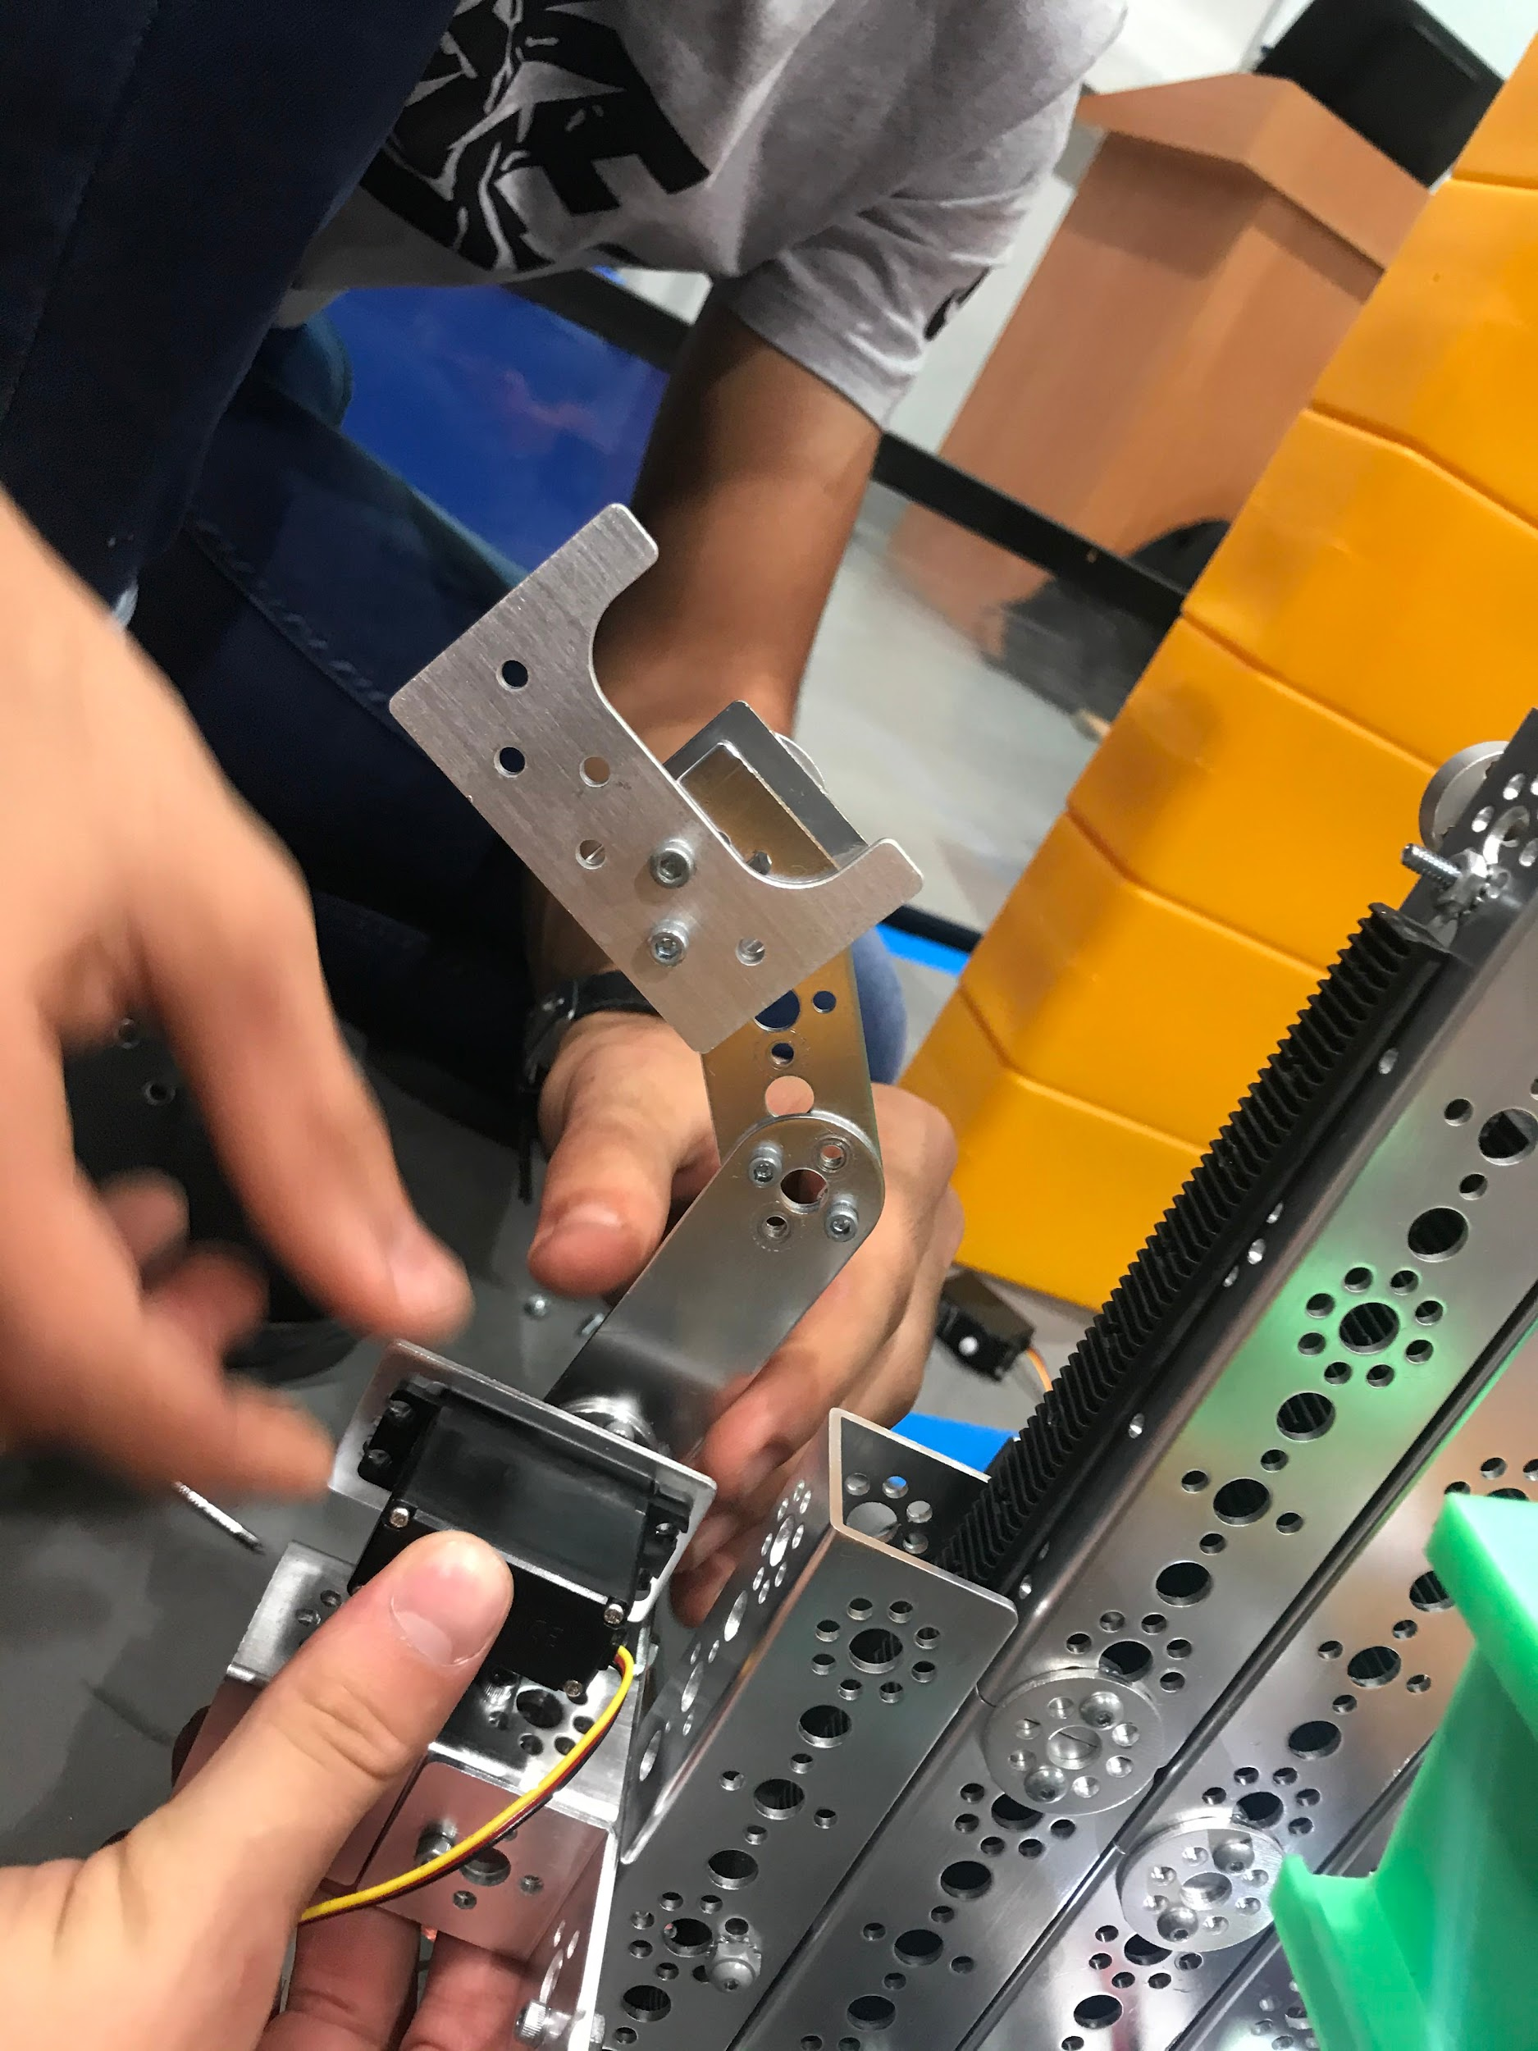

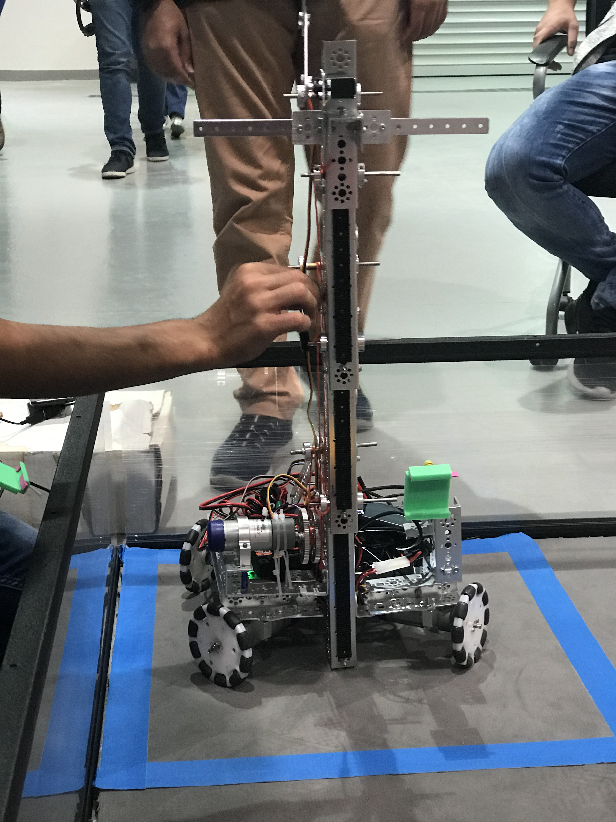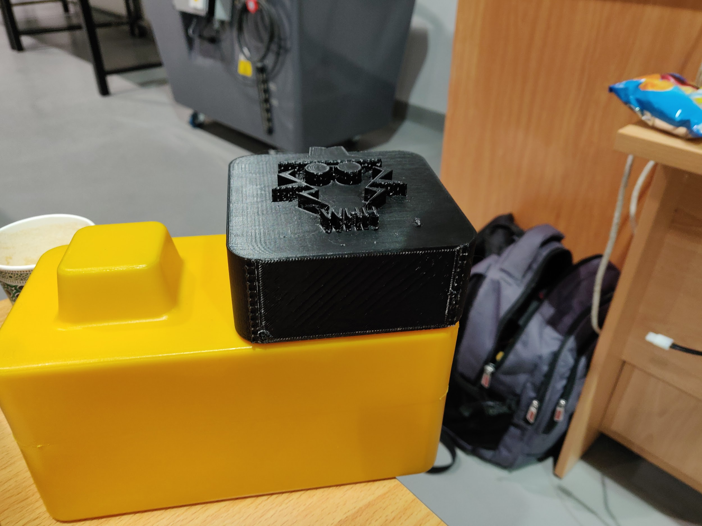

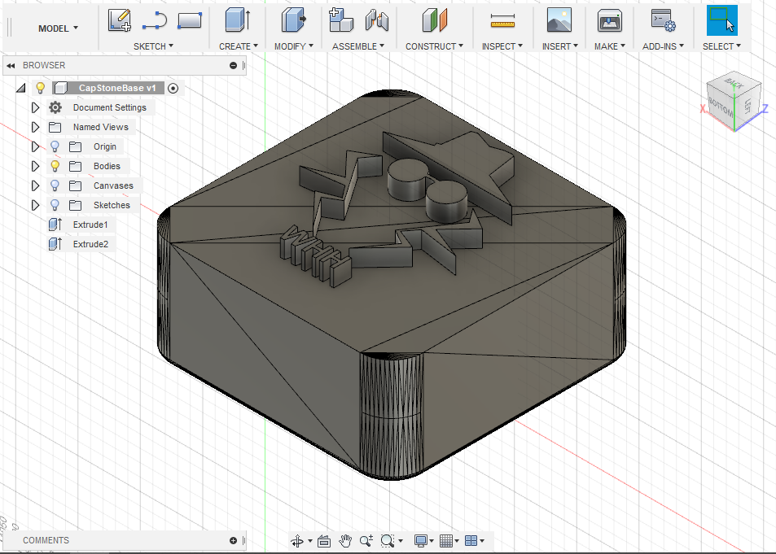



**February 18th, 2020**

| Tasks:   * Finalizing the gripper * Testing the robot on the official match grounds to finalize autonomous code * Choosing our main robot   driver   * working on the presentation | Attendance:   * Mhd Adnan * Pranav Jain * Omar Al Attar * Omar Al Jaljuli * Moustafa Mohammed * Mohammed Ayesh * Abdulelah Ayman |
| --- | --- |

| Summary: Today the team did not meet up in the usual place (Fun robotics center) but instead the team met up in Curtin University lab. The reason for that is that we had booked an appointment to practice on the official FTC mat that is available there. Firstly, the team finalized the gripper on the arm and synchronized it to the controller through the Teleop program. Secondly, the team started testing the autonomous program on the official mat. we met another team who was participating in the competition, we got to know them, also our team leader Mhd Adnan, gave them a phone to use while practicing, also giving them recommendations for phones. We also realized that their robot did not follow some of the rules of FTC, so we reminded them of the rules and suggested some possible changes. At the end, they were friendly people and we wished them good luck. We also worked on our scripts and each person practiced on their part of the presentation by making sure to understand it fully. |
| --- |

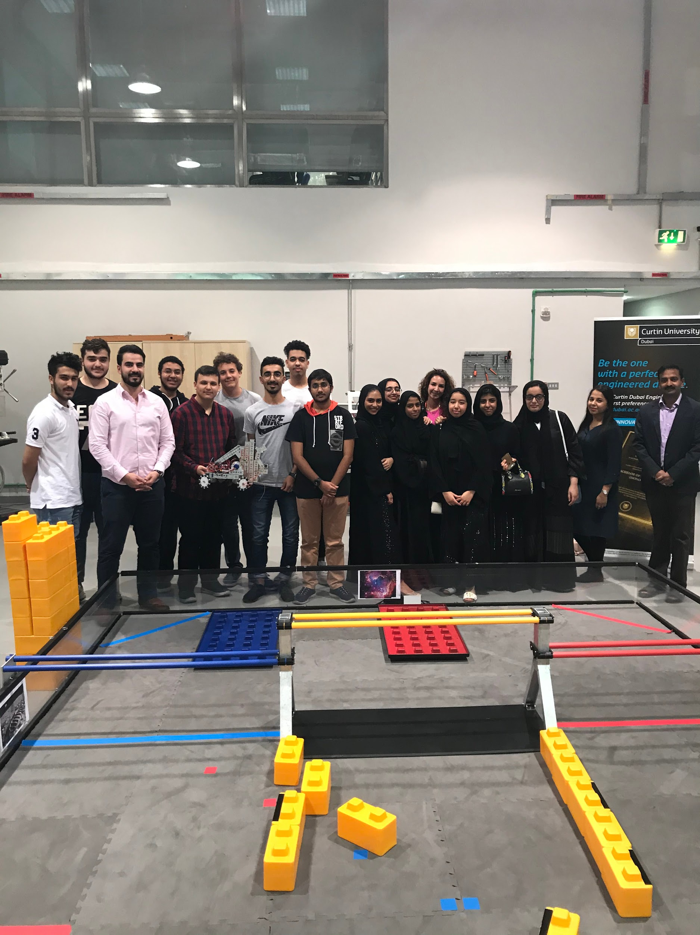

**February 19th, 2020**

| Tasks:   * Working on the autonomous code * working on the presentation | Attendance:   * Omar Al Jaljuli * Mhd Adnan |
| --- | --- |

| Today the team came in and worked on the presentation, after some time and some work it was finalized, and each person in the team was told which slide they were going to be in charge of. After that the team started working on the Autonomous code, however, since we did not have access to the mat we were limited to working on the detection of the Skystone using the Vuforia and trying to pick it up. At the end of the day, some progress was made and the robot was able to detect the skystone and find the distance it has to move to reach it. |
| --- |



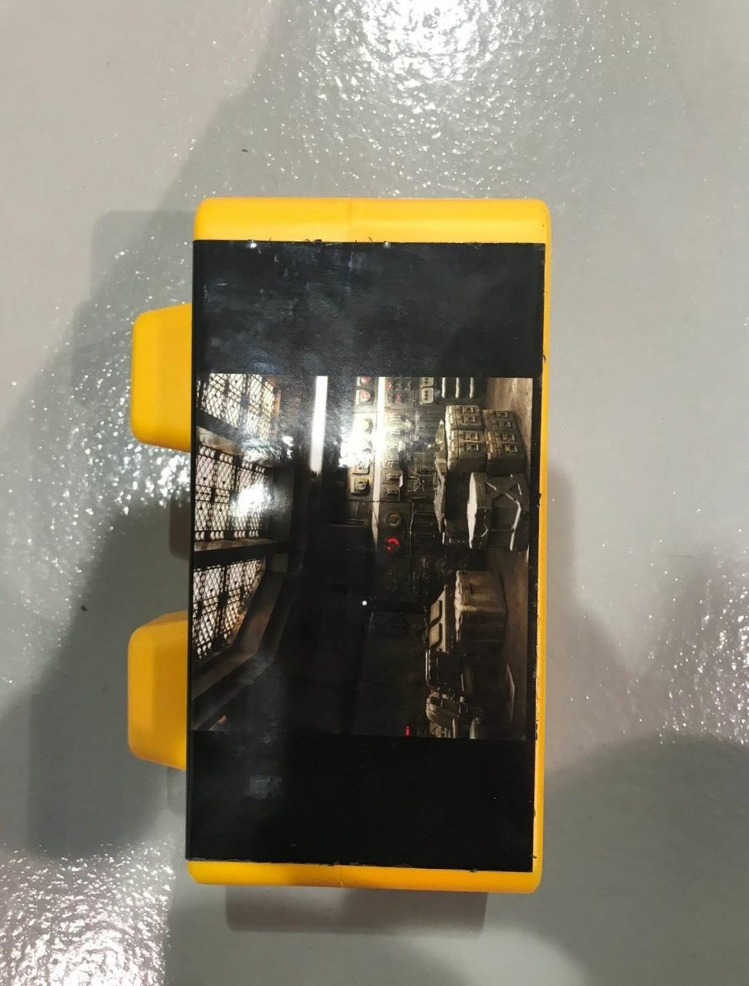

**February 20th, 2020**

| Tasks:   * working on the autonomous * replacing the string on the cascading slide * change the gripper | Attendance:   * Omar Al Jaljuli * Omar Al Attar * Abdulelah * Mhd Adnan * Pranav Jain * Moustafa * Mohammad Ayesh * Kareem * Nathanial |
| --- | --- |

| Today the team once again went to Curtin University to work on the official FTC mat. There was a problem found in the gripper and in the cascading slide. The gripper did not catch the blocks in a satisfactory manner, so the team decided to make some slight changes to make it much more efficient. The problem found in the cascading slide was that the string was too weak to carry all of the slides, we then decided to use a stronger string to make sure that it can carry it without a problem, and just in case we decided to braid three of that string together. After making these changes we worked on the autonomous program and were able to make some progress in it. |
| --- |

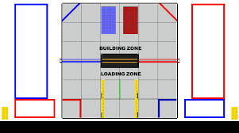

**February 22nd, 2020**

| Tasks:   * Final touches on the design and robot * Finishing the autonomous code * Rehearsing our presentation * Finishing the capstone * Practicing for the Teleop | Attendance:   * Omar Al Jaljuli * Moustafa * Kareem * Abdulelah * Nathaniel * Mhd Adnan * Pranav * Omar Al Attar * Mohammad Ayesh |
| --- | --- |

| Today was the final meeting before the national competition. All the team members had to come to finish what they were working on. Our design and building team worked on finishing all the attachments and making sure that everything is fixed and finished (e.g. wire management). They also worked on finishing the capstone since there was no 3D printer filament so they had to improvise and complete it using cardboard (someone in the team had a 3D printer at home so they said they will try to print it but they were not sure if it would work). Our programming team worked to finish the autonomous code so that we would be able to receive as many points as possible. Our engineering notebook team made sure that they did not miss out on anything and to keep updating the engineering notebook every time something significant happened. Our awards team made sure that all the checklist is complete (e.g. safety gear). Also, the team all came together and made sure to rehearse the presentation in order to make sure that it is organized. |
| --- |

**Designing and building process**

**Robot base:**

In the beginning, we had the idea to make the robot base in a triangle shape since the triangle is the sturdiest shape. However, due to some difficulties our team felt that is was easier and simpler to build a rectangular base.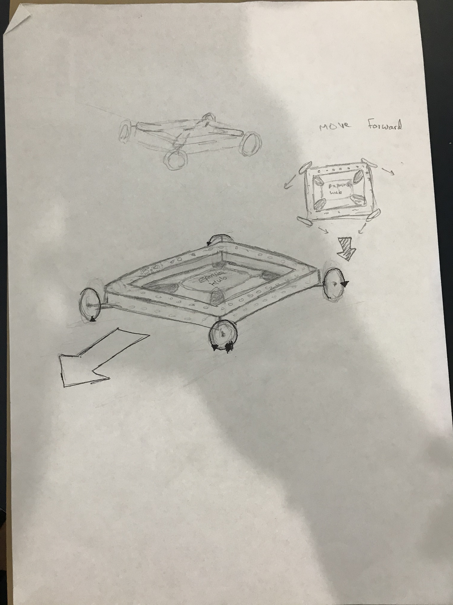

Our base right now is sturdy and strong. It can handle a few numbers of collisions without breaking or being affected significantly.

In the center of our base is the two expansion hubs that are connected to all the motors. That way the expansion hub would not be too far from any motor but the distance will be equal to each motor.

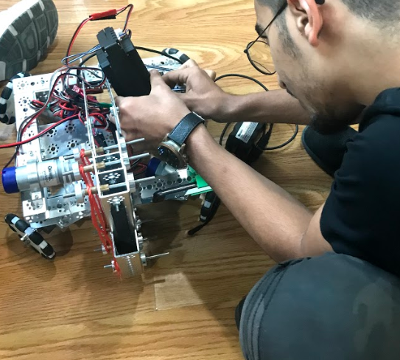

One problem that we have faced in our journey is the lack of resources. However, we were still able to build our robot using only one Tetrix kit which is near impossible. And even with that fact, we were able to make a fully working robot that can collect a large number of points.

**Robot movement:**

after ordering the mecanum wheel, the diameter of the wheels was too small to provide the robot with enough power, after researching studying ways to get the same effect of the mecanum wheels, while only having omnidirectional wheels, mecanum drive goes the same speed directly forwards or directly sideways. This is because the rollers are at a 45-degree angle, the team thought about putting the wheels at an x formation or 45-degree angles, it is called cross drive, it provides us with the same freedom of movement as mecanum wheels, they all classify as holonomic drive which means that it allows you to move in any directions without turning. The Holonomic movement provided by this formation is much more advantageous compared to normal movement since it allows more types of movement.

Normal movement: Holonomic movement:

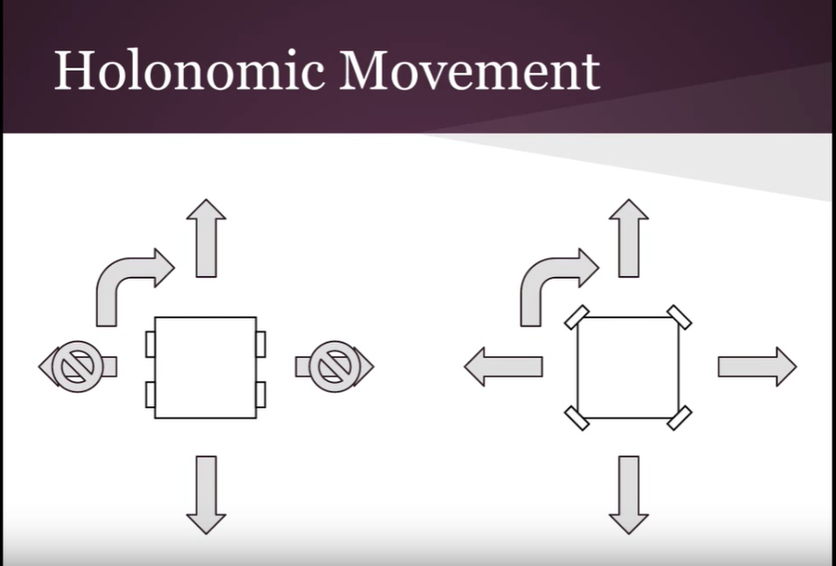



How does the holonomic movement work:

Since these wheels don’t use tires but instead they have smaller wheels that allow them to slide sideways. Utilizing that fact and the use of angles, we are able to make the robot move in many different directions freely.

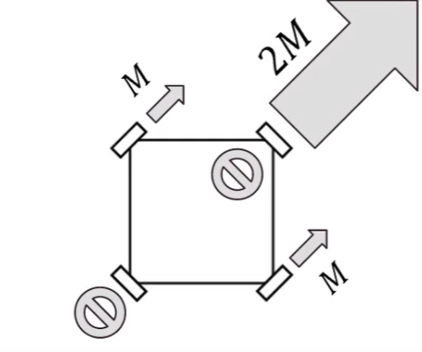

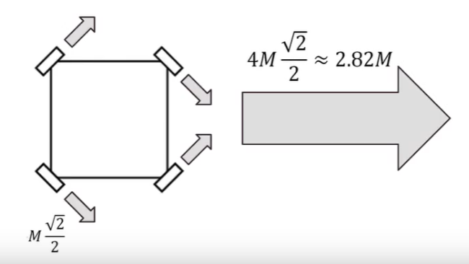

(the reason that it is , is because that is the horizontal component of the speed. The vertical components cancel out for each wheel/motor due to the fact that they contradict each other. That is the reason that the robot is able to move sideways without any vertical movement).

M= the speed produced by one wheel/motor

This shows us the difference in the total speed in two different angular movements.

A diagram that explains how the relative speed differs in each angle:

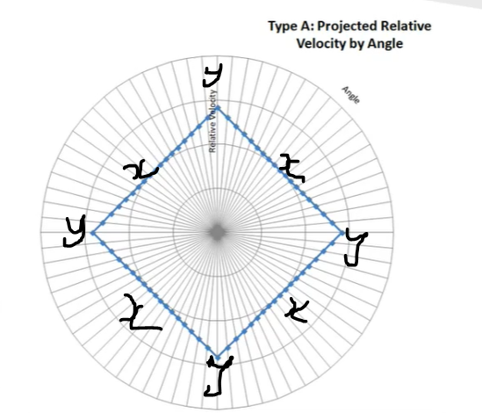

x = angle with lowest speed (45,135,225,315 degrees)

y = angle with greatest speed (0, 90, 180, 270 degrees)

Our sketch of how the robot would be with omnidirectional wheels:

Omnidirectional wheels on our robot:



Our attempt with mecanum wheels that did not work: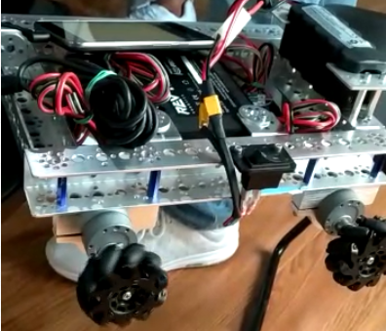

**Arm mechanism:**

The arm of the robot is made up of parts: the cascading slide and the gripper.

The cascading slide:

The Cascading Slide changes the rotational movement of the motor to linear motion. We used the two-string lift system. There are two strings that are used in this system. The first string is connected to the motor, is mounted onto the pulley at the top of the second stage and is fixed on the bottom of the second stage. When the first string is pulled by the motor, it pulls the second stage up. The second string is fixed to the bottom of the first stage, is mounted onto the pulley at the top of the third stage and is fixed on the bottom of the third stage. When the second stage is pulled by the first string, the second string pulls the third stage up at the same time. This stringing process is repeated for the fourth stage.

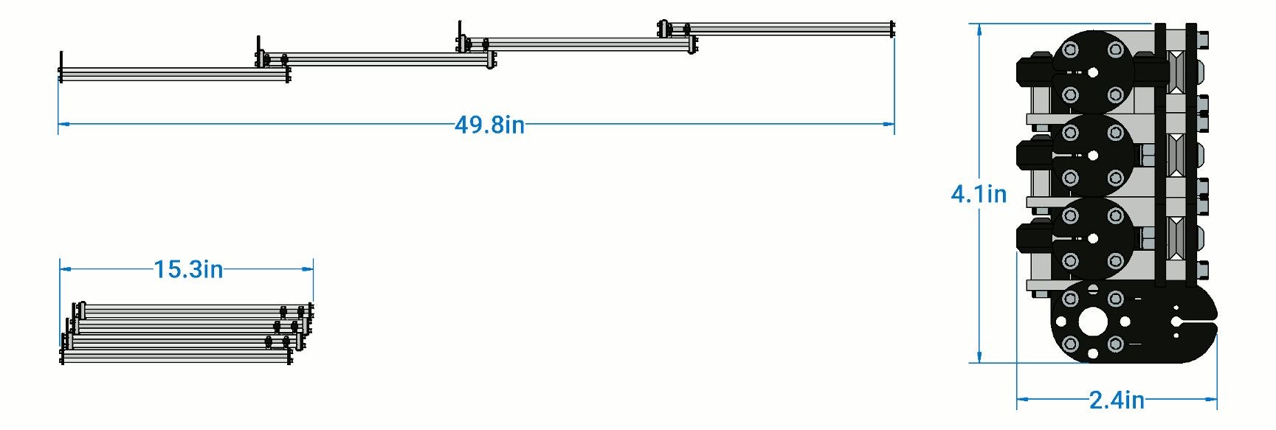

The advantages of using a cascading slide:

Using a cascading slide will allow us to have a small arm initially that does not break the rules of the competition (reference to the dimensions that were given to us by FTC). However, the extension would make the length of the arm increase exponentially and that would allow us to stack many blocks on top of one another.

Our version of the cascading slide:

Since the cascading slide was not able to ship to Dubai, Our team had to be creative about the way that we stack the blocks, so we decided to build our own cascading slide. We did that by using 4 Tetrix beams connected to one another that is also raised using a string that we placed in a strategic matter.



The gripper:

The gripper is fixed on the fourth stage. The gripper has a motor that moves the hand up and down. This part grabs the stones in the game. To increase the grip, foam is added onto the hand. This reduces the chances of the stone to fall while the robot is moving due to the added friction between the gripper and the block.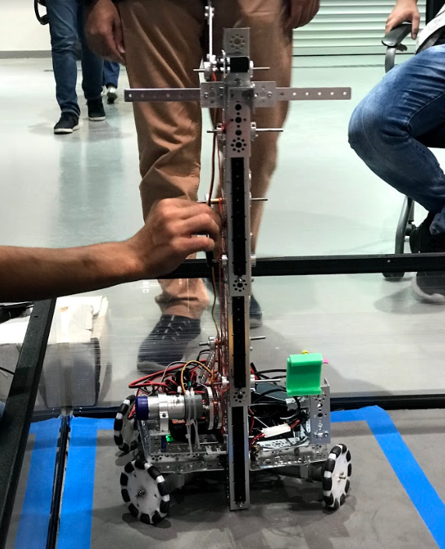

**CAD and 3D modeling:**

The team had three members that were experienced in 3D modeling. We decided to take advantage of that by modeling and printing some of the pieces that we needed instead of purchasing them or making them some other way.

One thing that we modeled and printed was our team's capstone. Our first attempt at printing a capstone was unsuccessful due to the fact that it did not follow the dimensions mentioned in the rules. Although we made sure to make it smaller than the maximum dimensions we found out later that it was also smaller than the minimum dimensions.

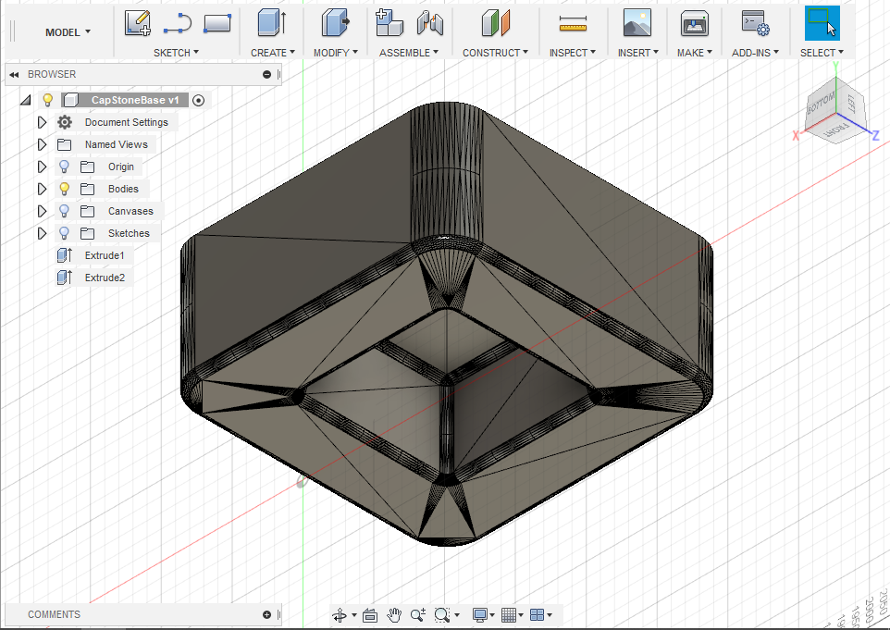



However that was not the only problem, another problem was that it was too wide and that it blocked the gripper when it wanted to carry the stone the capstone was on.

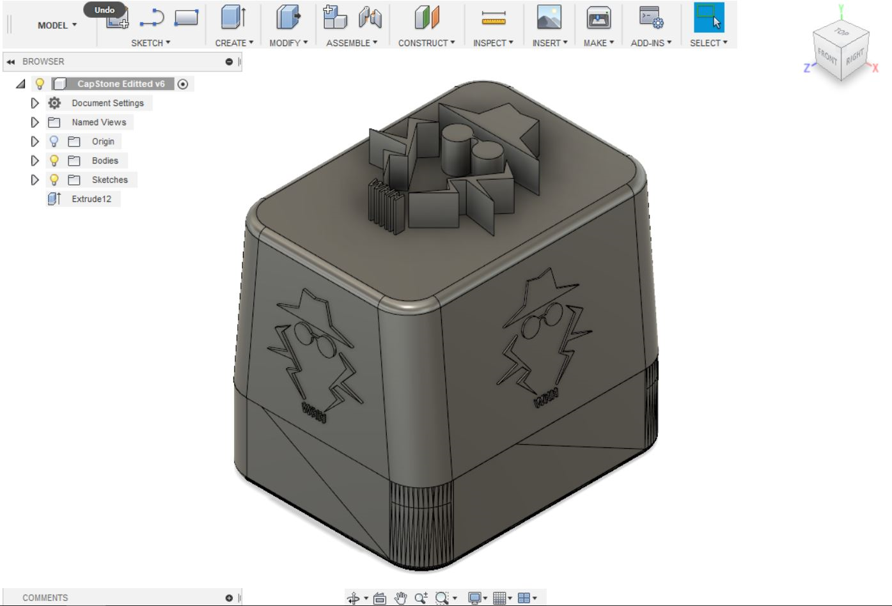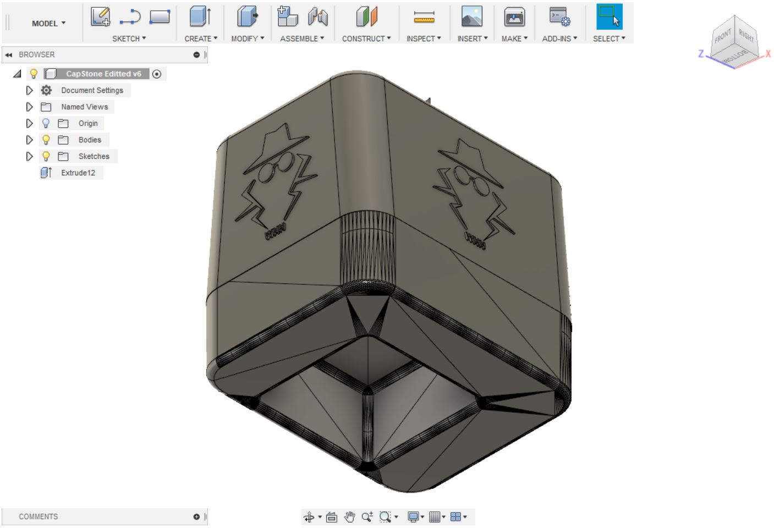

As seen the capstone is more narrow than the previous one and it is taller to obey the dimensions mentioned in the rules. It also has more of our logo.

Another thing that our team modeled and printed was the phone holder on the robot and controller. However, this design was more advanced than the capstone design since it used more than one body and it used joints and connections.

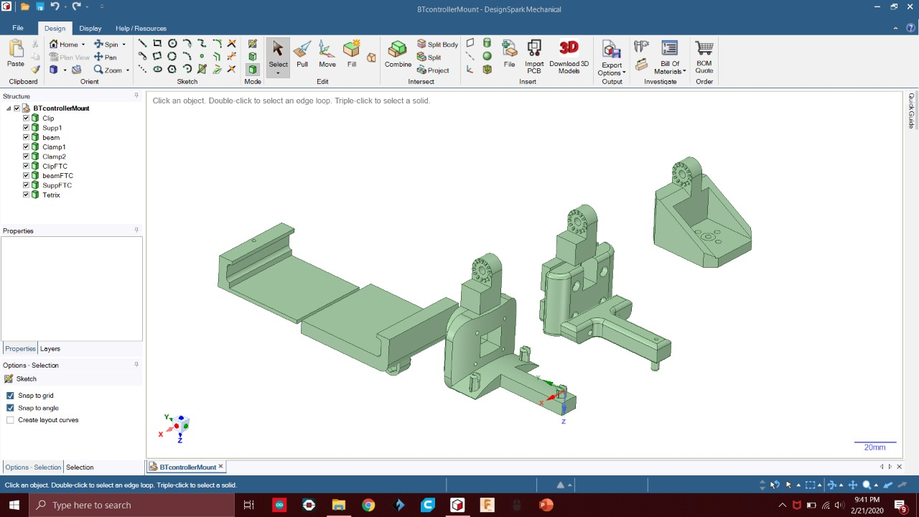



**Program**

We have two sections of programs. The first one is the program that uses Vuforia for the autonomous period of the match. The second one is the program for the Teleop period of the match.

**Teleop:**

For the Teleop we used the software called Android studio. Regarding the holonomic motion that we have built, we decided to use the mecanum wheel algorithm into the holonomic motion. We have initialized and set up three different variables (Pivot, Horizontal, and Vertical). We also did a calculation between them so that they can be used to move the robot in a direction freely without any need for turning. Using the calculation we were able to program them to move using the joystick of the controller. For the gripper of the robot, we programmed the 180-degree servo to be controlled by two buttons on the controller. Because we geared our lifting mechanism we synchronized it through coding to be controlled by the buttons on the controller. This whole program was both simple and efficient since it did not use any complicated techniques and it only used if-else statements. However, it worked better than what we have hoped.

A portion of the Teleop code:

public class Teleop extends LinearOpMode {

private DcMotor left_drive;

private DcMotor Forward_drive;

private Servo servo1;

private DcMotor right_drive;

private DcMotor Backward_drive;

/**

* This function is executed when this Op Mode is selected from the Driver Station.

*/

@Override

public void runOpMode() {

float vertical;

float horizontal;

float pivot;

left_drive = hardwareMap.dcMotor.get("left_drive");

Forward_drive = hardwareMap.dcMotor.get("Forward_drive");

servo1 = hardwareMap.servo.get("servo1");

right_drive = hardwareMap.dcMotor.get("right_drive");

Backward_drive = hardwareMap.dcMotor.get("Backward_drive");

// Put initialization blocks here.

left_drive.setDirection(DcMotorSimple.Direction.REVERSE);

Forward_drive.setDirection(DcMotorSimple.Direction.REVERSE);

servo1.setDirection(Servo.Direction.REVERSE);

waitForStart();

if (opModeIsActive()) {

// Put run blocks here.

horizontal = gamepad1.right_stick_y;

vertical = gamepad1.right_stick_x;

pivot = gamepad1.left_stick_x;

while (opModeIsActive()) {

// Put loop blocks here.

left_drive.setPower(-pivot + (vertical - horizontal));

right_drive.setPower(-pivot + (vertical - horizontal));

Forward_drive.setPower(-pivot + (vertical - horizontal));

Backward_drive.setPower(-pivot + (vertical - horizontal));

if (gamepad2.left_trigger > 0) {

left_drive.setPower(1);

}

if (gamepad2.right_trigger > 0) {

left_drive.setPower(-1);

}

if (gamepad1.a) {

servo1.setPosition(0.5);

}

if (gamepad1.b) {

servo1.setPosition(0);

}

telemetry.update();

}

}

}

Controller 1:

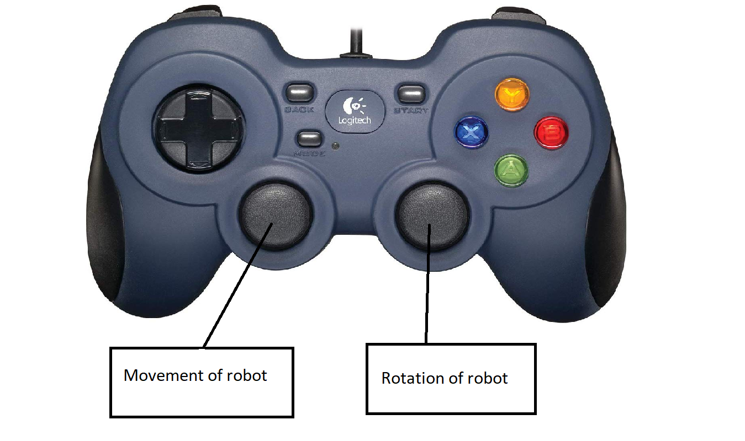

Controller 2: 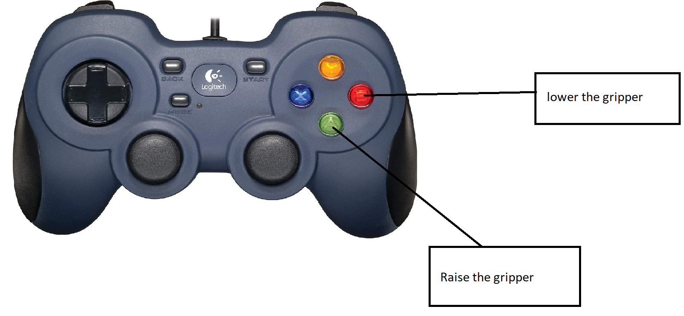

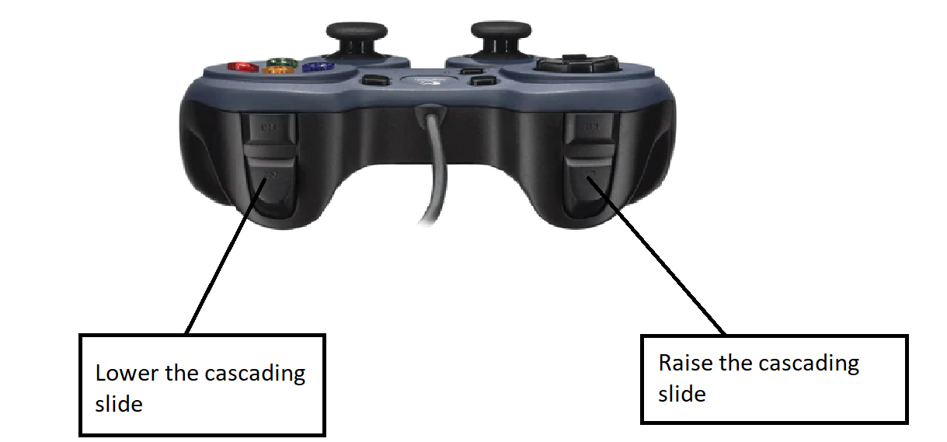

**Autonomous:**

Our main objective of the Autonomous period was to gather as many points as possible to make it less stressful for our teleop players. Firstly, we used the Vuforia program. Vuforia Vuforia is an [augmented reality](https://en.wikipedia.org/wiki/Augmented_reality) [software development kit](https://en.wikipedia.org/wiki/Software_development_kit) (SDK) for mobile devices that enables the creation of augmented reality applications. It uses computer vision technology to recognize and track planar images and 3D objects in real-time. This image registration capability enables developers to position and orient [virtual objects](https://en.wikipedia.org/wiki/Virtual_object), such as [3D models](https://en.wikipedia.org/wiki/3D_modeling) and other media, in relation to real-world objects when they are viewed through the camera of a mobile device. The virtual object then tracks the position and orientation of the image in real-time so that the viewer's [perspective](https://en.wikipedia.org/wiki/Perspective_(visual)) on the object corresponds with the perspective on the target. It thus appears that the virtual object is a part of the real-world scene. We used the Vuforia engine in order to simplify the process of tracking and gathering the keystones since Vuforia will give the values for the x, y, z-axis distance between the robot and the detected block. Using these values the robot is able to plug them in the program and move that amount to successfully reach the block. That way we do not have to leave anything for the imagination (we do not have to predict any values). However, after we've used vuforia, we kept on researching ways on how to navigate to the skystone. First of all, the x y z navigation was too complicated to do, and inaccurate sometimes, on the other hand, figuring out with a simpler way to do it, and after a lot of test and research, we come up with a very effective and smooth code, to do most of the autonomous period missions, also, we're still aiming to get all of them, and we'll try our best to do all of them at once. Finally, to make sure that the program works in all cases, we duplicated it and slightly changed the values so that the program can work on the red side of the playing field as well as the blue side of the playing field. Depending on which side of the playing field we start we will choose which program to run.

A portion of the autonomous code:

/**

* Describe this function...

*/

private void code_1() {

if (isTargetVisible("Rear Perimeter 1")) {

Detection1();

}

}

/**

* Describe this function...

*/

private void code_2() {

my_0_2();

if (isTargetVisible("Rear Perimeter 1")) {

Detection2();

}

}

/**

* Describe this function...

*/

private void code_3() {

Stop_at_blue();

}

/**

* Describe this function...

*/

private void Detection1() {

if (isVisible) {

my_1();

my_2();

my_3();

my_4();

my_5();

my_6();

Stop();

} else {

left_drive.setPower(-0.18);

right_drive.setPower(0.18);

Forward_drive.setPower(0.18);

Backward_drive.setPower(-0.18);

}

}

/**

* Describe this function...

*/

private void Detection2() {

if (isVisible) {

my_1();

my_2();

my_3();

my_4();

my_5();

Stop();

} else {

left_drive.setPower(-0.18);

right_drive.setPower(0.18);

Forward_drive.setPower(0.18);

Backward_drive.setPower(-0.18);

}

}

/**

* Describe this function...

*/

private void Stop_at_red() {

left_drive.setDirection(DcMotorSimple.Direction.REVERSE);

Backward_drive.setDirection(DcMotorSimple.Direction.REVERSE);

left_drive.setMode(DcMotor.RunMode.RUN_USING_ENCODER);

right_drive.setMode(DcMotor.RunMode.RUN_USING_ENCODER);

Forward_drive.setMode(DcMotor.RunMode.RUN_USING_ENCODER);

Backward_drive.setMode(DcMotor.RunMode.RUN_USING_ENCODER);

waitForStart();

h2AsLightSensor.enableLed(true);

sleep(500);

h2AsLightSensor.enableLed(true);

waitForStart();

left_drive.setPower(-0.5);

right_drive.setPower(0.5);

Forward_drive.setPower(0.5);

Backward_drive.setPower(-0.5);

while (opModeIsActive()) {

color = Color.rgb(sensor_lightAsColorSensor.red(), sensor_lightAsColorSensor.green(), sensor_lightAsColorSensor.blue());

if (JavaUtil.colorToSaturation(color) >= 0.6 && JavaUtil.colorToHue(color) > 330 && JavaUtil.colorToHue(color) > 30) {

left_drive.setPower(0);

right_drive.setPower(0);

Forward_drive.setPower(0);

Backward_drive.setPower(0);

sensor_lightAsColorSensor.enableLed(false);

}

telemetry.update();

}

}

/**

* Describe this function...

*/

private void Stop_at_blue() {

left_drive.setDirection(DcMotorSimple.Direction.REVERSE);

Backward_drive.setDirection(DcMotorSimple.Direction.REVERSE);

left_drive.setMode(DcMotor.RunMode.RUN_USING_ENCODER);

right_drive.setMode(DcMotor.RunMode.RUN_USING_ENCODER);

Forward_drive.setMode(DcMotor.RunMode.RUN_USING_ENCODER);

Backward_drive.setMode(DcMotor.RunMode.RUN_USING_ENCODER);

waitForStart();

h2AsLightSensor.enableLed(true);

sleep(500);

h2AsLightSensor.enableLed(true);

waitForStart();

left_drive.setPower(-0.5);

right_drive.setPower(0.5);

Forward_drive.setPower(0.5);

Backward_drive.setPower(-0.5);

while (opModeIsActive()) {

color = Color.rgb(sensor_lightAsColorSensor.red(), sensor_lightAsColorSensor.green(), sensor_lightAsColorSensor.blue());

if (JavaUtil.colorToSaturation(color) >= 0.6 && JavaUtil.colorToHue(color) > 210 && JavaUtil.colorToHue(color) > 275) {

left_drive.setPower(0);

right_drive.setPower(0);

Forward_drive.setPower(0);

Backward_drive.setPower(0);

sensor_lightAsColorSensor.enableLed(false);

}

telemetry.update();

}

}

/**

* Describe this function...

*/

private void Stop() {

left_drive.setPower(0);

right_drive.setPower(0);

Forward_drive.setPower(0);

Backward_drive.setPower(0);

}

/**

* Describe this function...

*/

private void my_0() {

left_drive.setDirection(DcMotorSimple.Direction.REVERSE);

Backward_drive.setDirection(DcMotorSimple.Direction.REVERSE);

left_drive.setMode(DcMotor.RunMode.RUN_USING_ENCODER);

right_drive.setMode(DcMotor.RunMode.RUN_USING_ENCODER);

Forward_drive.setMode(DcMotor.RunMode.RUN_USING_ENCODER);

Backward_drive.setMode(DcMotor.RunMode.RUN_USING_ENCODER);

waitForStart();

left_drive.setPower(1);

right_drive.setPower(1);

Forward_drive.setPower(1);

Backward_drive.setPower(1);

startTime = getRuntime();

while (opModeIsActive() && getRuntime() - startTime < 0.2) {

telemetry.update();

}

left_drive.setPower(0);

right_drive.setPower(0);

Forward_drive.setPower(0);

Backward_drive.setPower(0);

}

/**

* Describe this function...

*/

private void my_0_2() {

left_drive.setDirection(DcMotorSimple.Direction.REVERSE);

Backward_drive.setDirection(DcMotorSimple.Direction.REVERSE);

left_drive.setMode(DcMotor.RunMode.RUN_USING_ENCODER);

right_drive.setMode(DcMotor.RunMode.RUN_USING_ENCODER);

Forward_drive.setMode(DcMotor.RunMode.RUN_USING_ENCODER);

Backward_drive.setMode(DcMotor.RunMode.RUN_USING_ENCODER);

waitForStart();

left_drive.setPower(1);

right_drive.setPower(-1);

Forward_drive.setPower(-1);

Backward_drive.setPower(1);

startTime = getRuntime();

while (opModeIsActive() && getRuntime() - startTime < 0.2) {

telemetry.update();

}

left_drive.setPower(0);

right_drive.setPower(0);

Forward_drive.setPower(0);

Backward_drive.setPower(0);

}

/**

* Describe this function...

*/

private void my_1() {

left_drive.setDirection(DcMotorSimple.Direction.REVERSE);

Backward_drive.setDirection(DcMotorSimple.Direction.REVERSE);

left_drive.setMode(DcMotor.RunMode.RUN_USING_ENCODER);

right_drive.setMode(DcMotor.RunMode.RUN_USING_ENCODER);

Forward_drive.setMode(DcMotor.RunMode.RUN_USING_ENCODER);

Backward_drive.setMode(DcMotor.RunMode.RUN_USING_ENCODER);

waitForStart();

left_drive.setPower(1);

right_drive.setPower(1);

Forward_drive.setPower(1);

Backward_drive.setPower(1);

servo1.setPosition(0.8);

startTime = getRuntime();

while (opModeIsActive() && getRuntime() - startTime < 0.5) {

telemetry.update();

}

left_drive.setPower(0);

right_drive.setPower(0);

Forward_drive.setPower(0);

Backward_drive.setPower(0);

}

/**

* Describe this function...

*/

private void my_2() {

left_drive.setDirection(DcMotorSimple.Direction.REVERSE);

Backward_drive.setDirection(DcMotorSimple.Direction.REVERSE);

left_drive.setMode(DcMotor.RunMode.RUN_USING_ENCODER);

right_drive.setMode(DcMotor.RunMode.RUN_USING_ENCODER);

Forward_drive.setMode(DcMotor.RunMode.RUN_USING_ENCODER);

Backward_drive.setMode(DcMotor.RunMode.RUN_USING_ENCODER);

waitForStart();

left_drive.setPower(-1);

right_drive.setPower(-1);

Forward_drive.setPower(-1);

Backward_drive.setPower(-1);

startTime = getRuntime();

while (opModeIsActive() && getRuntime() - startTime < 0.7) {

telemetry.update();

}

left_drive.setPower(0);

right_drive.setPower(0);

Forward_drive.setPower(0);

Backward_drive.setPower(0);

}

/**

* Describe this function...

*/

private void my_3() {

left_drive.setDirection(DcMotorSimple.Direction.REVERSE);

Backward_drive.setDirection(DcMotorSimple.Direction.REVERSE);

left_drive.setMode(DcMotor.RunMode.RUN_USING_ENCODER);

right_drive.setMode(DcMotor.RunMode.RUN_USING_ENCODER);

Forward_drive.setMode(DcMotor.RunMode.RUN_USING_ENCODER);

Backward_drive.setMode(DcMotor.RunMode.RUN_USING_ENCODER);

sensor_lightAsLightSensor.enableLed(true);

sleep(500);

sensor_lightAsLightSensor.enableLed(true);

waitForStart();

left_drive.setPower(-0.5);

right_drive.setPower(0.5);

Forward_drive.setPower(0.5);

Backward_drive.setPower(-0.5);

while (opModeIsActive()) {

color = Color.rgb(sensor_lightAsColorSensor.red(), sensor_lightAsColorSensor.green(), sensor_lightAsColorSensor.blue());

if (JavaUtil.colorToSaturation(color) >= 0.6 && JavaUtil.colorToHue(color) > 210 && JavaUtil.colorToHue(color) > 275) {

left_drive.setPower(0);

right_drive.setPower(0);

Forward_drive.setPower(0);

Backward_drive.setPower(0);

sensor_lightAsColorSensor.enableLed(false);

}

telemetry.update();

}

}

/**

* Describe this function...

*/

private void my_4() {

left_drive.setDirection(DcMotorSimple.Direction.REVERSE);

Backward_drive.setDirection(DcMotorSimple.Direction.REVERSE);

left_drive.setMode(DcMotor.RunMode.RUN_USING_ENCODER);

right_drive.setMode(DcMotor.RunMode.RUN_USING_ENCODER);

Forward_drive.setMode(DcMotor.RunMode.RUN_USING_ENCODER);

Backward_drive.setMode(DcMotor.RunMode.RUN_USING_ENCODER);

waitForStart();

left_drive.setPower(1);

right_drive.setPower(-1);

Forward_drive.setPower(-1);

Backward_drive.setPower(1);

startTime = getRuntime();

while (opModeIsActive() && getRuntime() - startTime < 0.3) {

telemetry.update();

}

left_drive.setPower(0);

right_drive.setPower(0);

Forward_drive.setPower(0);

Backward_drive.setPower(0);

}

/**

* Describe this function...

*/

private void my_5() {

left_drive.setDirection(DcMotorSimple.Direction.REVERSE);

Backward_drive.setDirection(DcMotorSimple.Direction.REVERSE);

left_drive.setMode(DcMotor.RunMode.RUN_USING_ENCODER);

right_drive.setMode(DcMotor.RunMode.RUN_USING_ENCODER);

Forward_drive.setMode(DcMotor.RunMode.RUN_USING_ENCODER);

Backward_drive.setMode(DcMotor.RunMode.RUN_USING_ENCODER);

waitForStart();

left_drive.setPower(1);

right_drive.setPower(1);

Forward_drive.setPower(1);

Backward_drive.setPower(1);

servo1.setPosition(0);

startTime = getRuntime();

while (opModeIsActive() && getRuntime() - startTime < 0.5) {

telemetry.update();

}

left_drive.setPower(0);

right_drive.setPower(0);

Forward_drive.setPower(0);

Backward_drive.setPower(0);

}

/**

* Describe this function...

*/

private void my_6() {

left_drive.setDirection(DcMotorSimple.Direction.REVERSE);

Backward_drive.setDirection(DcMotorSimple.Direction.REVERSE);

left_drive.setMode(DcMotor.RunMode.RUN_USING_ENCODER);

right_drive.setMode(DcMotor.RunMode.RUN_USING_ENCODER);

Forward_drive.setMode(DcMotor.RunMode.RUN_USING_ENCODER);

Backward_drive.setMode(DcMotor.RunMode.RUN_USING_ENCODER);

waitForStart();

left_drive.setPower(-1);

right_drive.setPower(-1);

Forward_drive.setPower(-1);

Backward_drive.setPower(-1);

startTime = getRuntime();

while (opModeIsActive() && getRuntime() - startTime < 0.4) {

telemetry.update();

}

left_drive.setPower(0);

right_drive.setPower(0);

Forward_drive.setPower(0);

Backward_drive.setPower(0);

}

/**

* Check to see if the target is visible.

*/

private boolean isTargetVisible(String trackableName) {

// Get vuforia results for target.

vuforiaResults = vuforiaSkyStone.track(trackableName);

// Is this target visible?

if (vuforiaResults.isVisible) {

isVisible = true;

} else {

isVisible = false;

}

return isVisible;

}